For immediate release:

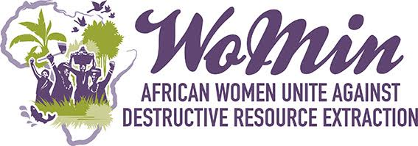

GOLD EXTRACTION AND WOMEN’S STRUGGLE FOR SURVIVAL IN BURKINA FASO

WoMin African Gender and Extractives Alliance, in collaboration with Organisation pour le Renforcement des Capacités de Développement (ORCADE), proudly launches its Participatory Action Research (PAR) on the impacts of industrial scale mining on women artisanal miners and farmers in Kalsaka, Burkina Faso. The Kalsaka Participatory Action Research project led by ORCADE, with technical and financial support from WoMin, forms part of a wider nine-country WoMin research project which aimed to deepen analysis on the gendered impacts of the extractives industries in Africa. The Burkina Faso research analyzes the specific ways in which both the industrial and artisanal mining industry impacts upon women’s living conditions and social status.
Kalsaka, home to one of the country’s largest industrial exploitation sites, is ORCADE’s first research piece in a unique project which aims to build a national analysis addressing the question of women working within small and large-scale mining projects.
Burkina Faso is rich in resources with gold, zinc and manganese being the most extracted minerals. Burkina Faso’s mining sector is made up of large-scale extractive projects owned by mining companies and small-scale artisanal mines, small mines and gold panning. With six large industrial mines extracting gold and zinc, the country is trying to harness the economic potential from extraction to increase its exports, fight poverty and stimulate growth and job creation. The Kalsaka research aims to explore the impacts of this development agenda.
Before Amara Mining opened an industrial extraction site in Kalsaka, a hundred kilometres away from Ouagadougou, the majority of its population relied on agriculture and gold panning for their livelihoods. The community’s initial hopes that the mine would generate business and employment, as promised, were rapidly crushed. Fatima, a 30-year-old woman explains, “Amara Mining stole our fields and prevented us from doing gold panning. My husband had to go find work in town and left me with our five children. I don’t know how to feed them anymore”. Indeed, land that was previously used for field cultivation and livestock was expropriated from peasants living on the mine’s perimeter. Gold panners were evicted with landowners complaining about low levels of compensation.
The establishment of the Kalsaka industrial mine has been an absolute tragedy for the community causing much socio-economic unrest and increased levels of poverty. Women, who were already significantly vulnerable, are now worse off. The majority of the women are illiterate and most depended on local landowners to access land to grow cereal and vegetables. Surplus produce was sold onto the market, with additional revenue earned through gold panning.
The expropriation of lands and the gold panning interdict have left women with no income and purchasing power at a time when the mine caused a surge in the cost of living. This is harshly compounded by the absence of husbands and sons who’ve had to leave their households to seek work elsewhere. “My husband went to look for work in town and rarely comes back to the village. I cannot afford the five children I take care of by myself”, says Aminata, a 28-year-old local woman.
In spite of this onslaught, women have started initiatives to survive. Some rent out parcels of non-expropriated land or partner with male gold panners who have managed to keep a foothold. The women work all day for payment of a 50kg bag of dirt from which they can keep whatever gold they find. In their struggle for survival, the women of Kalsaka have also started other income-generation activities, such as livestock farming and fabric dying. These groups, made up of women without any professional qualifications, need various types of training support to increase their activities. In the long run, they will be able to earn an income, possibly finding new vocations to leave gold panning and supplement agriculture.
While gold extraction has significant impacts on the country’s growth, communities who live by the industrial operations experience no improvements in their lives. In Kalsaka and elsewhere, people have been getting significantly poorer. It is hoped that a new mining code adopted in 2015 will ensure redistribution in gold extraction communities to enable local development.
Mr. Jonas Hien, Executive Director of ORCADE, together with members of the Kalsaka community, will present the Participatory Action Research report at the launch which takes place on Thursday, 11 February, 9am at the Hotel Relax in Ouagadougou.

Media contacts :
Odette Napina
ORCADE- Burkina Faso
Cell: + +226 70 33 32 69
Fixe: +226 50 36 20 89
Email: orcade.info@gmail.com

Connie Nagiah
WoMin-South Africa
Cell : +27 082 7300 653
E-mail : connie.nagiah@womin.org.za

WoMin, a regional alliance of women’s organisations and movements leads the Participatory Action Research in partnership with Organisation pour le Renforcement des Capacités de Développement (ORCADE).

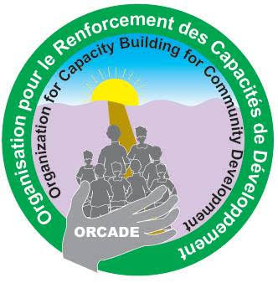
For more information please visit www.womin.org.za

