Company Engagement Questions:
KnowTheChain Information and Communications Technology Sector benchmark
Companies can use these questions to provide additional information relevant to KnowTheChain’s benchmarking of companies commitments and programs targeted at addressing human trafficking and forced labor in the supply chain.

Please note that answers to these questions will be made publicly available on the website of Business & Human Rights Resource Centre (BHRRC), one of the partners in KnowTheChain. The project will maintain a strict standard of only including information provided via a company’s public website or BHRRC’s website in the evaluation.

Please send your answers to Annabel Short, Program Director, Business & Human Rights Resource Centre: short@business-humanrights.org, with a cc to Megan Wallingford, Senior Advisor, Advisory Services, Sustainalytics: megan.wallingford@sustainalytics.com.
We encourage companies to answer as many of the questions as possible. You may wish to focus particularly on those for which your company currently does not have information available on its website.
Name of company: TSMC
Name of respondent: Harry Chen
Position of respondent: Investor Relations Senior Administrator
Respondent’s contact information (email): harry_chen@tsmc.com

Documents
1. Please share links to any policy statements, reports, or other documents that you would like to be taken into account in a review of your company’s approach to managing forced labor risks in the supply chain.
TSMC is committed to upholding workers’ rights and respects internationally proclaimed human rights; its commitment to human rights for both employees and the supply chain is stated on its corporate website: (1) http://www.tsmc.com/english/csr/human_right.htm; and (2) http://www.tsmc.com/english/csr/eicc_membership.htm.

The Company is currently developing its Human Rights Policy and it is being reviewed by TSMC's high Executives at this stage. The document will be released publicly on the Company's website once the document is approved.

TSMC Supplier Code of Conduct: https://supply.tsmc.com.tw/sncdata/Supply_Online_Supplier%20Code%20of%20Conduct.pdf
TSMC CSR Policy: http://www.tsmc.com/download/csr/csr_policy_e.pdf
TSMC Safety and Health Policy: http://www.tsmc.com/download/csr/TSMC_Safety%20and%20Health%20Policy_En.pdf

Commitment and governance
Awareness and commitment
2. Has your company made a formal commitment (e.g. adopted a policy) to address human trafficking and forced labor? Please include a link to the commitment.
As the world’s largest dedicated semiconductor foundry, TSMC is committed to ensuring that working conditions in its supply chain are safe, that workers are treated with respect and dignity, and that business operations are environmentally responsible and conducted ethically. In reflection of this commitment, TSMC in December 2014 became an applicant member of the Electronic Industry Citizenship Coalition (EICC), the largest coalition of electronics companies committed to supporting the rights and wellbeing of workers and communities affected by the global electronics supply chain. Two relevant press releases that demonstrate the company’s commitment are available below:
http://www.tsmc.com/tsmcdotcom/PRListingNewsAction.do?action=detail&newsid=THWQHIST&language=E
http://www.tsmc.com/tsmcdotcom/PRListingNewsArchivesAction.do?action=detail&newsid=THHIISST&language=E

Supply chain standards
3. Does your company have a supply chain standard that requires suppliers to uphold workers' fundamental rights and freedoms, including the elimination of forced labor? Please include a link to the standard, and provide information on how frequently the standard is updated.
Note on EICC membership: Many ICT companies are members of the Electronics Industry Citizenship Coalition, EICC. If your company is a member and provides a link from its own website to the latest version of the EICC Code (i.e. version 5.1 effective January 1, 2016), then that code will be considered by KnowTheChain in reviewing the company’s supply chain standards.
In 2015, TSMC established its own Supplier Code of Conduct based upon the EICC Code of Conduct. The two Codes are largely identical, but TSMC’s Code includes additional provisions it deems necessary, such as making sure that suppliers have a child labor remediation procedure in place. The latest version of TSMC’s Code is aligned to version 5.1 of the EICC Code, meaning recruitment fee is now strictly forbidden.
TSMC Supplier Code of Conduct: https://supply.tsmc.com.tw/sncdata/Supply_Online_Supplier%20Code%20of%20Conduct.pdf

To ensure that the Supplier Code of Conduct stays relevant to evolving issues and trends, it is defined in TSMC’s procedure that the Code needs to be reviewed at least once every two years. In fact, the Code has seen three revisions since its inception, each time getting more stringent than before.

Management
4. Who within your company is responsible for the implementation of your company's supply chain policies and standards relevant to human trafficking and forced labor? Please indicate the committee, team or officer, and describe their scope of responsibility.
Within the company, the EICC task force shoulders the responsibilities to enforce the Code in the supply chain. The task force is a team effort involving multiple divisions including Supply Chain, Operations, Human Resources, Environment, Safety and Health (ESH), Public Relations, Investor Relations, Customer Service, and Legal. Members of the task force meet regularly to address priorities and chart necessary course of action. To enforce managerial accountability, the task force reports to two Senior Vice Presidents who respectively lead the Supply Chain division and the CSR Committee, and the latter in turn reports the company’s CSR progress to the Board of Directors regularly. The taskforce also distributes a quarterly bulletin to all the internal stakeholders to report progress and escalate issues.

Different from many other companies, the task force operates under the coordination of the Supply Chain division and such an arrangement is deliberate. In a relative sense, TSMC believes that the risks associated with its suppliers are higher and the Supply Chain division is naturally the ideal candidate for driving supplier performance elevation.

Training
5. Does your company conduct training programs for internal decision-makers and suppliers on risks, policies and standards related to human trafficking and forced labor? Please describe.
TSMC’s Supply Chain personnel are the key internal stakeholders because they lead the on-site audits in Taiwan to verify suppliers’ compliance with a multitude of standards, including those related to human trafficking and forced labor. To ensure that they have the necessary skills and knowledge the perform the roles adequately, in 2015 alone four separate training workshops (on the Supplier Code of Conduct, general audit skills, effective labor audits, and working hours and wages review) were carried out for more than 25 division members.

Meanwhile, TSMC also understands that many of its suppliers, especially those small in scale, remain unfamiliar with the Code expectations. To bridge the gap, TSMC hosted a number of outreach and training sessions for its suppliers in 2015 and will continue to do so in the future.

- Outreach for Suppliers on EICC at 2015 TSMC Supply Chain Management Forum

- 2015 Environmental, Health and Safety Training for Suppliers
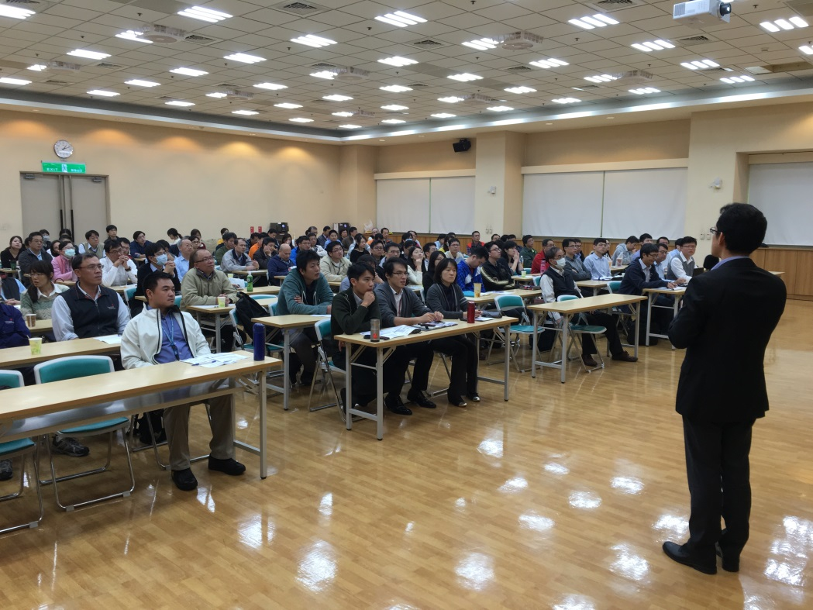

Stakeholder engagement
6. In the last three years, has your company engaged a) with local stakeholders such as NGOs, trade unions or policy makers or b) in multi-stakeholder initiatives on human trafficking and forced labor, especially as it relates to the supply chain? Please describe with whom your company has engaged, the purpose of the engagement, and your company's role.
The company maintains an open communication channel with external stakeholders through members in Investor Relations, Public Relations, ESH, and HR functions who are also represented in the EICC taskforce. That said, given that human trafficking and forced labor are not a major issue in TSMC’s supply base, they are hardly raised by local NGOs, trade unions, or policy makers. In recent years, given TSMC’s extensive expansion and environmental footprint, the many dialogues they had with TSMC focused primarily on environmental protection and waste management.

Traceability and risk assessment
Traceability and risk assessment
7. Please describe your company's supply chain tracing and risk assessment processes. Include any specific examples of when your company has conducted forced labor risk or impact assessments focused on a particular commodity, region or group.
The number of TSMC’s suppliers is large and the industries they represent diverse, and as such a methodical risk management process becomes indispensable. In the first step of the process, all the major suppliers representing the top 80% of procurement spending are requested to complete the EICC SAQ (Self-Assessment Questionnaire) at both the corporate and facility levels so that TSMC can gain an understanding of social and environmental risks. Subsequently the process goes beyond this limited group of suppliers by measuring the geographic risks and product risks of all other suppliers. Last but not least, concerns brought to us via our grievance channel or external stakeholders are factored in to draw up a composite yet holistic risk map.

Transparency
8. Does your company disclose a) identified forced labor risks b) the names and locations of first-tier suppliers, and c) some information on suppliers beyond the first tier? If yes, please provide a URL.
(What’s provided below is available in the 2015 CSR Report due to be published by the end of May 2016. At the moment, the URL is not available yet.)
In 2015, the top 80% of procurement spending went to 24 major suppliers manufacturing for TSMC in 83 facilities worldwide. It is worth pointing out that the vast majority of them are located in Japan, the United States, and Western Europe – developed regions generally associated with better social and environmental standards and performance. In addition, given the limited and diminishing pool of suppliers in the semiconductor industry, reasonable assurance could be obtained that these suppliers are also the main suppliers of other semiconductor companies who have joined the EICC earlier. Low risk aside, improvement efforts focusing on these suppliers would likely be duplicative and redundant in nature.

- Major Suppliers and Their Supplying Facilities
Supplier | Headquarters Location | Assessment Score – Corporate | Locations of Supplying Facilities | Assessment Score – Facility
A | Allentown, PA, USA | 97.5 | Banwol, S. Korea | 90.7
B | Santa Clara, CA, USA | 94.8 | 1) Austin, TX, USA, 2) Gloucester, MA, USA, 3) Kalispell, MT, USA, 4) Santa Clara, CA, USA, 5) Rehovot, Israel, 6) Changi, Singapore | 85.9 - 91.9
C | Veldhoven, Netherlands | 95.2 | 1) Veldhoven, Netherlands, 2) San Diego, CA, USA, 4) Wilton, CT, USA, 3) New Taipei, Taiwan | 90.3 - 93.3
D | Ludwigshafen, Germany | 99.6 | Taoyuan, Taiwan | 95.7
E | Aurora, IL, USA | 94.5 | 1) Mie, Japan, 2) Kaohsiung, Taiwan, 3) Hsinchu, Taiwan, 4) Tainan, Taiwan | 94.3 - 95.2
F | Tokyo, Japan | 90.3 | 1) Kumamoto, Japan, 2) Kanagawa, Japan | 92.5 - 93.4
G | Billerica, MA, USA | 84.2 | 1) Kedah, Malaysia, 2) Burnet, TX, USA, 3) Danbury, CT, USA | 81.1 - 88.3
H | Yunlin, Taiwan | 76.8 | Yunlin, Taiwan | 81.7
I | Tokyo, Japan | 87.5 | 1) Mesa, AZ, USA, 2) Hukou, Taiwan, 3) Shizuoka, Japan | 90.8 - 96.5
J | Tokyo, Japan | 94.4 | 1) Ibaraki, Japan, 2) Yamaguchi, Japan | 92.1
K | Tokyo, Japan | 90.0 | 1) Leuven, Belgium, 2) Sunnyvale, CA, USA, 3) Mie, Japan, 4) Saga, Japan | 88.2 - 94.1
L | Tokyo, Japan | 98.6 | 1) Ibaraki, Japan, 2) Chandler, AZ, USA | 93.4 - 94.7
M | Milpitas, CA, USA | 95.3 | 1) Migdal Ha'Emek, Israel, 2) Milpitas, CA, USA, 3) Serangoon, Singapore | 89.3 - 91.1
N | Fremont, CA, USA | 83 | 1) Livermore, CA, USA, 2) Tualatin, OR, USA | 87.0 - 88.2
O | Munich, Germany | 87.7 | 1) Alpha, NJ, USA, 2) Medford, OR, USA, 3) Taoyuan, Taiwan, 4) Taichung, Taiwan | 88.1 - 89.6
P | Kyoto, Japan | 86.5 | Shiga, Japan | 93.8 - 94.4
Q | Tokyo, Japan | 93.7 | Niigata, Japan | 93.7
R | Tokyo, Japan | 93.7 | 1) Vancouver, WA, USA, 2) West Lothian, UK, 3) Selangor, Malaysia, 4) Fukushima, Japan, 5) Hsinchu, Taiwan, 5) Fukui, Japan, 6) Gunma, Japan, 7) Niigata, Japan, 8) Nagano, Japan | 85.2 - 94.6
S | Munich, Germany | 96.5 | 1) Bavaria, Germany, 2) Saxonia, Germany, 3) Portland, OR, USA, 4) Tampines, Singapore | 94.5 - 96.1
T | Tokyo, Japan | 92.6 | 1) Phoenix, AZ, USA, 2) Albuquerque, NM, USA, 3) Miyazaki, Japan, 4) Saga, Japan, 5) Nagasaki, Japan, 6) Hokkaido, Japan, 7) Yamagata, Japan | 91.9 - 93.2
U | Saint Peters, MO, USA | 93.1 | 1) Saint Peters, MO, USA, 2) Tochigi, Japan, 3) Novara, Italy, 4) Cheonan, S. Korea, 5) Selangor, Malaysia, 6) Kedah, Malaysia, 7) Hsinchu, Taiwan | 85.3 - 95.5
V | Minato, Tokyo, Japan | 89.5 | 1) Kumamoto, Japan, 2) Miyagi, Japan, 3) Iwate, Japan, 4) Yamanashi, Japan, 5) Chaska, MN, USA, 6) Billerica, MA, USA | 83.8 - 92.1
W | Boston, MA, USA | 91.0 | North Reading, MA, USA | 89.7
X | Kanagawa, Japan | 91.6 | Fukushima, Japan | 91.9

When the assessment scope was expanded to include all the suppliers of TSMC, another picture emerged. Overall, the manufacturing operations of these suppliers took place in over 20 countries all over the world. Among them, China, Malaysia, and Taiwan fell into the higher-risk category as defined by a third party service provider. Put simply, labor conditions in particular remain a concern with these three countries. According to China Labor Watch, the issues of child labor and inadequate working conditions continue to plague many Chinese factories. Verité in a recent report pointed out that forced labor “can indeed be characterized as widespread” in Malaysia’s electronic sector. The situation with Taiwan is rather different in that the main problem lies with the ingrained culture of long working hours, based in part to the Taiwan Human Rights Report published by the U.S. Department of State. All considered, suppliers operating in these countries were classified as “target suppliers” who were then subject to stringent audit requirements.

- Countries in which TSMC’s Suppliers Operate
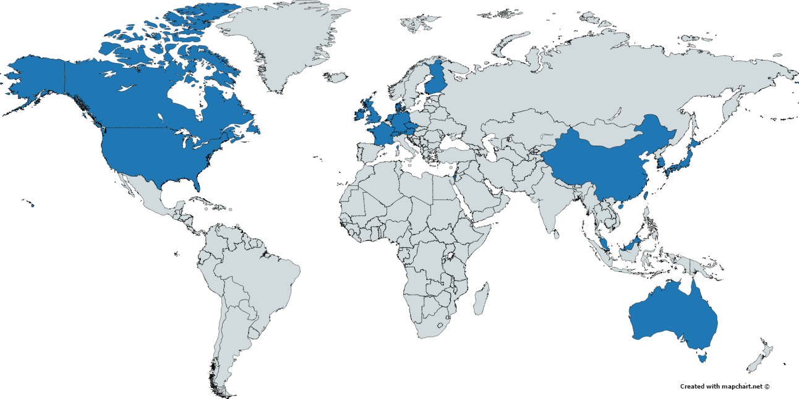

- Suppliers* Operating in China and Malaysia
Supplier | Facility Location
A | Ningbo, China
B | Shanghai, China
C | Yongchun, China
D | Hangzhou, China
E | Kedah, Malaysia
F | Selangor, Malaysia
G | Kedah, Malaysia and Selangor, Malaysia
* Manufacturing for TSMC’s facilities in Taiwan

Although the EICC is primarily concerned with suppliers directly relevant to production, on-site service providers such security, wafer transportation trucks, shuttles, canteen, facility suppliers, in TSMC’s opinion, deserve special attention because their workers are more vulnerable to having their entitlements denied and more often than not they lack the capacity to secure them. As part of TSMC’s commitment to uplift society, TSMC would expand its labor audits to include these suppliers and this would translate to at least 50 additional audits in 2016. Working hours and wages review will be one of the focus areas of these audits primarily because TSMC has in the past received relevant complaints from supplier employees. To this end, TSMC has developed its own working hours and wages assessment template that is consistent with both the Taiwan Labor Code and the Supplier Code of Conduct.

Purchasing practices
Purchasing practices
9. Does your company make an effort to avoid purchasing practices that increase the risk of human trafficking and forced labor in the supply chain (e.g. short-term contracts, excessive downward pressure on pricing, sudden changes of workload?) Please elaborate.
Over the years, TSMC has taken a number of measures to mitigate the risk of human trafficking and forced labor in the supply chain. They include:
- Increase purchasing localization rate: Based upon TSMC’s risk assessment and audit findings, the risk of human trafficking and forced labor with its suppliers in Taiwan is not high. Coupled with the fact that proximity greatly facilitates supplier management, TSMC has over the past years expended a large amount of efforts to increase the localization rate. For material suppliers alone, the rate has seen a 35% increase from 2010 to 2015.
- Go direct: Whenever possible, TSMC strives to establish direct trade relationship with manufacturers. The presence of agents complicates the monitoring and management of actual manufacturers.
- Limit the supplier pool: TSMC consistently rationalizes the supplier pool to facilitate deeper relationships, particularly with those that have had a good track record. On the flipped side, the process to introduce a new supplier has tightened a great deal over the past years; now every potential supplier will have to be reviewed and approved by a management committee to ensure the supplier is qualified on all fronts.

Supplier selection
10. Does your company assess risks of forced labor at potential suppliers prior to entering into contracts with them? Please describe.
As explained earlier, the management committee that reviews every single new supplier takes many factors into consideration, including the supplier’s willingness to endorse the Supplier Code of Conduct compliance agreement. If evidence is available that the supplier is engaging in egregious labor practices, the application will be denied.

11. How does your company take into consideration the capacity of suppliers to meet fluctuating demands?
TSMC understands that fluctuating demands can mean that workers are pressed to work longer hours to meet shipping deadlines. As such, TSMC provides a 6-month rolling forecast for items it regularly purchases. For new items, particularly those related to a new technology ramp, TSMC starts the communication process with suppliers at least one year ahead to make sure that they have enough time to establish new capacity and/or hire new workers.

Integration into supplier contracts
12. Does your company integrate its supply chain standards addressing forced labor and human trafficking into supplier contracts?
All suppliers are required to sign a compliance agreement and agree to be bound by the TSMC Supplier Code of Conduct before they could do business with TSMC. On top of that, TSMC also integrates labor, ethics, and ESH considerations into its supplier scorecard and awards program. The scorecards are reviewed by a dedicated management committee on a quarterly basis, and the performance ratings are the centerpiece of TSMC’s annual supplier awards nomination criteria.

Cascading standards
13. Does your company have a process to cascade standards on forced labor down the supply chain (e.g. requiring first-tier suppliers to ensure that their own suppliers implement standards that are in line with the company's standards)? Please describe.
In the aforementioned compliance agreement, TSMC obliges its direct suppliers to ensure that the Code requirements are met by their sub-suppliers, contractors, and service providers. Implementation verification takes place during actual on-site audits, mainly by checking whether the suppliers have their own supplier code of conduct that covers necessary labor standards, and whether they have a process to communicate code requirements to their suppliers and to monitor their compliance to the code.

Recruitment
Recruitment approach
14. Please describe you company's recruitment approach, including whether your company requires recruitment agencies in its supply chain to uphold workers' rights, whether it has a policy on direct employment, and whether it requires suppliers to disclose to the company the recruiters that they use.
TSMC itself does not hire migrant workers, and all the workers of the company are direct hires. Recruitment agencies for workers are simply non-existing.
With suppliers, TSMC forbids them to engage in forced labor practice or charge any recruitment fees. TSMC does not require them to disclose the recruiters they use.

Recruitment fees
15. Please describe your company’s approach to recruitment fees, including whether your company requires that no fees be charged during recruitment processes, and whether and how it ensures that fees paid are reimbursed.
This is a non-issue. As explained above, TSMC does not hire migrant workers, nor does it engage the service of recruitment agencies for its workers. To reinforce the stance, it is defined in the company’s hiring policy that “any actions of charging candidate fees or deposits are prohibited”.

Recruitment audits:
16. Does your company audit recruiters to assess risks of forced labor and human trafficking?
The non-presence of recruiters for workers obviates the need of so-doing.

Worker voice
Communication of policies to workers
17. Please describe how your company communicates its human trafficking and forced labor related policies and standards to workers in its supply chain.
TSMC’s Supplier Code of Conduct is published on the company’s website as well as its supplier portal called TSMC Supply Online. The Code is also available in Chinese, the main language spoken locally, to increase its accessibility for workers in the supply chain.

Worker voice
18. Please describe how your company engages with workers outside of the context of the factories in which the (they instead?) work (whether directly or in partnership with stakeholders).
Communication with workers primarily takes place during on-site audits in the form of interviews. TSMC's position in supporting internationally-proclaimed human rights standards, as well as our continuous effort in maintaining an open communication channel with external stakeholders are the driving force for a higher level of awareness among our suppliers on issues relating to human rights.

Worker empowerment
19. Please elaborate on whether and how your company encourages its suppliers to ensure workplace environments where workers are able to organize, including through alternative forms of organizing where there are regulatory constraints on freedom of association.
As stipulated in the compliance agreement, suppliers shall respect the right of all workers to form and join trade unions of their own choosing, to bargain collectively and to engage in peaceful assembly. This is one of the mandatory checklist items in the audits TSMC personnel conduct.

Grievance mechanism
20. Please describe your company's grievance mechanism, including whether it is available to suppliers' workers, and how it is communicated to suppliers' workers.
TSMC values two-way communication and is committed to keeping open and transparent communication channels between the management levels, subordinates, and peers. The comprehensive communication channels provided by our company are detailed in the following chart:
TSMC’s grievance channels are not available to suppliers’ workers. Consistent with EICC’s expectation, the company requires its suppliers to make available grievance channels for their own workers so that they are able to raise any concerns without fear of retaliation. Once again, Implementation verification takes place during actual on-site audits.

Monitoring
Auditing process
21. Please describe your companies auditing process including whether the process includes a) scheduled and non-scheduled visits, b) a review of relevant documents, and c) interviews with workers.
To ensure suppliers fully integrate TSMC’s Supplier Code of Conduct into their operations and to ultimately empower them to take responsibility for their supply chain, on-site audits are regularly conducted. Based upon the risk assessment performed, in 2015 TSMC focused its audit resources on the “target suppliers” who were subdivided into two groups called local and foreign. Suppliers in Taiwan were audited by TSMC personnel, whereas suppliers in China and Malaysia were requested to conduct EICC VAP audits by engaging certified third-party auditors who are familiar with local laws. During each audit, plant inspections, document reviews, and interviews with management and employees are carried out. The company does not conduct non-scheduled visits.

Audit disclosure
22. Does your company disclose a) the percentage of suppliers audited annually b) the percentage of unannounced audits c) information on who carried out the audits, and d) a summary of findings, including details of any violations revealed? Please provide a URL.
(What’s provided below is available in the 2015 CSR Report due to be published by the end of May 2016. At the moment, the URL is not available yet.)
Every on-site audit in Taiwan was led by a Supply Chain member and supported by associates from Human Resources, Legal, ESH, Waste Management, and Industrial Safety and Environmental Protection (ISEP) divisions who are experts in their respective fields.
As an integral part of the overall supplier management process, a total of 60 on-site audits were performed in 2015 to ensure suppliers’ compliance with a multitude of standards, including those on labor, ethics, environment, safety, and health. The number of audited facilities for the year represented more than 65% of all facilities producing materials for TSMC in Taiwan. The following tables summarize the audit results and findings.

Category | Average Score | Average Number of Non-compliances per Audit
Labor & Ethics | 72.0 | 3.7
Environmental, Safety and Health | 71.9 | 9.8

Category | Common Non-compliances
Labor & Ethics | - Lack of documented policy forbidding working hours in excess of 60 per week (including overtime, except in emergency situations) and working for seven consecutive days.  - Staffing policy did not explicitly prohibit forced labor and child labor; age verification during recruitment was not thoroughly enforced.  - Lack of comprehensive grievance procedure that protected the identity of employees to ensure non-retaliation.  - Lack of regular training and promotion with anti-corruption rules for employees.  - Although nearly all suppliers had a basic anti-corruption clause in their work rules for employees, a few of them explicitly defined the criteria of gift giving and receiving.
Environment, Safety and Health (ESH) | - Lack of clear ESH rules and equipment maintenance procedures, resulting in haphazard implementation.  - Lack of risk assessment and mitigation efforts to address climate change.  - Improper classification, declaration, and storage of waste.  - Engagement of disreputable waste disposal vendors due to the lack of vendor background checks.

At the time of this writing, TSMC has guided the 7 suppliers in China and Malaysia in completing the EICC SAQ at both the corporate and facility levels. They are now in the process of getting the VAP audits executed by 4Q16 as demanded by TSMC.

Remedy
Corrective action plans
23. Does your company have a process for creating corrective action plans? Please describe this process and the elements of a corrective action plan.
For audits performed by TSMC personnel, each non-compliance unearthed triggers a Corrective Action Request (CAR), and depending on severity a CAR may be labeled as Priority or Regular. To facilitate the closure process, every single CAR is registered and tracked on a web-based system accessible also to the company’s suppliers. Obviating the need to track manually, the system dispatches reminders and alerts to owners whenever necessary. Remediation timeline can vary based on many factors, but in general suppliers are given one to six months to implement correction action plans. For certain non-compliances such as life-threatening working conditions, immediate action is demanded. Regardless of severity, all non-compliances must be remediated and a CAR can only be closed when rectification evidence is provided and documented in the tracking system. As of February 2016, the closure rate for all the CARs registered in 2015 stood at 80%.

Remedy
24. Does your company have a process to provide remedy to workers in its supply chain, including for responding to instances of forced labor and human trafficking? If yes, please provide examples of outcomes of this program.
Defined in the audit manual, TSMC absolutely does not tolerate certain breaches of compliance such as underage and forced labor. Such violations, if found, must be stopped and corrected immediately, and will be reported to relevant authorities whenever applicable. In addition, they will also be immediately escalated to supplier CEO. If however a supplier is still not committed to change after the actions, further remedial actions including business volume reduction or even business relationship termination will be taken by TSMC. In the 60 audits TSMC conducted in 2015, the company found no instances of forced labor and human trafficking.

