Oil-Workers’ Rights Protection Organization Public Union (OWRPO PU)

Evaluation on fire at stationary deep sea platform No.10 in “Guneshli” field of State Oil Company of Azerbaijan Republic on December 4, 2015

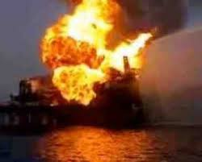

January 2016

Content
1.About organization
2. Foreword
3. Introduction
4. Terrible accident in the country’s history of oil industry
4.1. The information about the 10th platform
4.2. Accident
5. Evacuation
6. Public awareness
6.1. SOCAR and the Ministry of Emergency Situations kept silent
6.2. Mysterious lists
6.3. The cuntry’s media on the day of accident
7. How many wells on fire- different numbers.
8. Damage caused to “Azneft” PU
9. When the fire can be turned off?
10 The opinion of the expert group.
10.1. Why the employer did not follow the law?
11. Ecological situations.
12. Psychological help
13. Result
14. Reference sources

ABOUT ORGANIZATION
Oil-Workers Rights Protection Organization (OWRPO) was established in 1996 by a group of specialist working in oil sector in order to protect human rights working in oil and gas sector of Azerbaijan and to create control of civil societies over the project implemented in the energy sector of the country. (See: www.nhmt–az.org).
Mission of the organization
OWRPO fights for the protection of human rights in energy sector, use of financial flows related with energy sector for the benefit of the society and organization of public control in this field.

2. FOREWORD
Expert group of Oil-Workers’ Rights Protection Organization Public Union ( OWRPO PU) carried out evaluation related to fire at stationary deep sea platform No.10 in “Guneshli” field of State Oil Company of Azerbaijan Republic.The information published in the media and on official websites, expert opinions, and different interviews have been used for the evaluation.
OWRPO expresses its appreciation to the experts who participated in the preparation of the document.
3. INTRODUCTION
Each year OWRPO mentions in its annual report about death and injuried of a large number of employees in oil sector of the country as a result of violation of article 207 (Employees shall have the right to work under safe and healthy conditions)of Labor Code, Article 215 (Employer Occupational Safety Obligations), Article 219 (Training of Occupational Safety Experts and Employees), Article 222 (Conditions for Providing a Healthy and Safe Workplace), Article 238 (Responsibility of Employers on creation of conditions for protection of healthy and safe work), and the 2nd amendment to the Labor Code.
In recent years, as a result of these law violations, a large number of workers died and went missing as a result of accidents just only in the State Oil Company of Azerbaijan Republic (SOCAR):
- 2 employees of the company died, and one seriously injured in the 14th platform of “Guneshli” offshore field of SOCAR on September 28, 2011. According to preliminary information, the incident occurred as a result of violation of safety rules.
- Accident occurred during exploration drilling in platform of "Bulla-Deniz" gas-condensate field in Azerbaijani sector of the Caspian Sea on August 17, 2013. Fully extinguish the fire in the well in 80 kilometers from Baku lasted three months. SOCAR was able to extinguish the fire with the joint efforts of experts of US Boots & Coots Service Company and with the support of firefighter ships.
- In March of 2014, a former pier collapsed in the Oil Rocks (in Cvonovo 203). 4 people fell into the water. 3 of them were rescued and one died.
- On October 23, 2014 Collapse happened in 441st platform in the area of Oil and Gas Department named after Narimanov located in 40 kilometers south of Baku. According to SOCAR, at the time 37 employees from 41 oil-workers’ in the platform were evacuated. 3 of missing 4 bodies of the employees were found in 2 kilometers from the platform. One employee has not been found yet. 30 people were working in the area at the time.
-At the end of October 2014, pier in N.Narimanov oil and gas production platform of Azneft PU collapsed. No one was injured
-On November 7, 2014, as a result of collapse of 60-meter long between 310th and 312nd platforms in the 2nd mining area of Narimanov Oil and Gas production of Azneft PU 5 employees fell into the sea. 3 of them were rescued, 2 died.
-On December 4, 2015, as a result of hurricane study room in 501st platform of Neft Dashlari Oil and Gas production of Azneft PU collapsed and 3 employees fell into the sea. Their bodies have not been found yet.
-Fire happened at stationary deep sea platform No.10 in “Guneshli” field of State Oil Company of Azerbaijan Republic on December 4, 2015. Severe weather conditions and a strong hurricane took the lives of 12 employees, 19 employees were missing, and 32 people were injured.
4. TERRIBLE ACCIDENT IN THE COUNTRY’S HISTORY OF OIL INDUSTRY
4.1. Brief information about the 10th platform
There are 13 offshore platforms in “Guneshli” fileld which belongs to 28 May Oil and Gas Production of State Oil Company of Azerbaijan Republic (SOCAR). Platform No.10 was built in 1984. In 2077 5th and 10th platforms were suspended for overhaul. According to “Azneft” PU exploitation term of the platform is 50 year. There are 30 wells on the platform. 2 of them are not working. There are contradictions in the information on how many of them are gas or oil wells. In 2015, 920 tons of oil per day and 1 million m3 of gas were extracted from platform No.10. The wells are in operation for a long time, so oil is raised to the platform due to layers of technical associated gas from other platform.
4.2. Accident
While looking at the chronicle of the accidents in the offshore oil production platforms in recent years in Azerbaijan, there wasno such serious incident which took place on December 4, 2015. Severe weather conditions and a strong hurricane took the lives of 12 employees, 19 employees were missing, and 32 people were injured. On December 4, north wind speed was 38-40 meters per second, wave height in the open sea was more than 8 meters. In the evening wind did not brake the same direction and strengthened and the wave reached a height of 9-10 meters.
At about 17:40 the giant waves broke the support line of submarine gas pipe running with 110 atmospheric pressure in deep sea platform No.10 in “Guneshli” field of State Oil Company of Azerbaijan Republic, resulted damage to pipe line and fire broke out.
In order to avoid complications that may arise,all oil and gas communication systems coming to deep-sea platform No.10closed and exploitation of 28 oil and gas wells which are in operation in the platform were suspended. However, because of technological systems and the residual gas in the pipe the fire is still ongoing. For a while the fire passed to oil and gas wells in the platform.
4.3. Why the fire broke out?
It is clear form the conversation with the oil-workers that, as aresult of discharge of clamp in the pipe line there gas leak happened. The incident was reported to the center by giving telephone message 1 day ago. But they were told not to stop the production. Employees say that it was possible to minimize human losses. By limiting certain cases, employees would be taken off immadiately.
5. EVACUATION
15-25 minutes after the accident had happened, "Vikhr-9" fire boat of Ministry of Emergency Situations which was in the queue "Guneshli", and then in a small time slot of "Vikhr-5" fire boat, "Avior" diving, "Samir Guliyev" tugs tried to approach the platform.At the same time, "Topaz-Diqnizi", "Endeavour", "Protektor", "Lenkoran" ships which were in queue in “Azeri-Chirag-Guneshli” filedsthat are all equipped with modern navigation system were involved in the firefighting and rescue operations.
However, because of the strengthening of the hurricane the actual height of the wave reached to 9-10 meters and none of the ships could not approach the platform.This, in turn, made impossible to lower the lifeboats into the water and to take towed by ships. As well as the continuous pumping of water made difficult to extinguish the fire.
In accordance with the guidelines and the evacuation plan, in order to get rid of fire and explosion the workers got into two rescue boats in the platform and let down the boats. Boats were lowered to a distance of approximately 10 m above sea level.
As a result of strong wind and strikes by high waves at approximately 22:45 hook of one of the rescue boats opened and the boat fell into the sea together with the men in. By means of nearby ships it was able to take out1 dead and 3 injured workers the sea.
It was risky and dangerous to evacuate employees in the second rescue boat in the dark and squally weather conditions, so it was decided to continue the evacuation in backlit. On December 5, despite the continuation of the severe weather conditions anoperation to evacuate workers in the second rescue boat was carried out. So, at 08: 02 2 helicopters of the Ministry of Emergency Situations with 15 firefighters in the board were involved in the palce of incident.
But because of high temperature helicopters failed landing on the platform, and landed on platfroms No.3 and 5. A little later, a group of rescuers of the Ministry of Emergency Situations with the helicopter owned by "Azal" CJSC company, while the other group with “Muslum Magomayev” ship owned by "Azerbaijan State Caspian Sea Shipping Company" CJSC landed on the platform and evacuating 26 people from the boat and 3 from the platform were able to take them to the ship.
Thus, totally 32 people were rescued, and 1 dead body pulled from the water. During the observation an empty boat was found about 50 km to the south, nearby ships were informed about it by the State Maritime Administration.
6. PUBLIC AWARENESS ABOUT THE INCIDENT
6.1. SOCAR and the Ministry of Emergency Situations kept silent
Fire incident happened at 17:40 and shortly after Oil-Worker’s Rights Protection Organization Public Union placed information on their facebook page about the incident. Although Azerbaijan media shared information according to this page, SOCAR and the Ministry of Emergency Situations "preferred" to keep silence till the midnight. And at night, it was reported:
-“Powerful storm on December 4 that took place at about 17:40 damaged gas line in 10th platform of “Guneshli” field, resulting in a fire. First of all, the measures started evacuating the employees in the platform. The height of the wave creates serious problems for ships approach to the platform.”
Then according to ANS TV and SOCAR, all workers in the area of fire have already been removed from the platform:
-“Appropriate measures are taken for the evacuation of all employees. All of them are in safe area.Rescue boats approached the place of incident. Waves caused by strong winds create difficulties in rescue operation. Thus, the height of wave reached to 8-10 meters.No one was injured and died as a result of the incident.42 people were on the platform at the time of the fire.”
Note: A day after the incident there was a huge gap in the informing the public about the happenings. In general, the provision and management of information related to the accident indicated that all branches of the government are not ready to emergencies.To rescueall workers, the false information about the situation under control, and then mysteriously information about the searchof missing workers, finally, the lack of knowledge about the missing workers are indication of confuse the management of thesituation.
6.2. Mysterious lists?!
There was a problem in the fullness of the list submitted by SOCAR to public after 1 day.On December 6, "Azneft" were reported in the press conference that 63 people were in the platform during the accident. While it was possible to save 33 workerst, 1 person died and 29 people were missing.
The list presented to the public was still incomplete. First, although the complete list of survivors was given, it was difficult to obtain full official information about missing and those who died. Secondly, the position of oil-workers’ is not mentioned in the list. Experts and witnesses say that the presence of some of the workers in that weather was unlawful. Thus according to caspianbarrel.org it became known in the press conference held in "Azneft" PU that 15 people of 63 workers were member of the crew crew of were construction and drilling.SOCAR plans to drill 4 wells on the platform, and it's because they carry out this work on the issues. Otherwise, the number of staff should be 48 people.
List of Socar employees in the platform at about 19:00 On December 5:
Survived workers:
1. Məmmədov Allahverdi İmran o. 29.07.1976
2. Mustafayev Elşən Elxan o. 04.11.1983
3 .Əliyev Gündüz Əmir o. 11.12.1955
4. Abbasov Mais Məşədibaba o. 14.02.1970
5 .Kərimov İlqar Ağali o. 10/09 1964
6 .Əliyeva Məlahət Mirələm q. 01.11.1971
7 .Mehdiyev İsmayıl Ələkbər o. 26.04.1976
8 .Orucov Rəman Atakişi o. 13.04.1985
9 .Şahbazov İltifat Dursun o. 27.02.1959
10 .Abbasov Heydər
11 .Cabbarov Sadiq
12 .Mikayılov Seymur Mirsəməd o. 30.07.1980
13 .Məlikov Ehtiram Əliş o. 30.03.1975
14 .İbrahimov Rəşid Eynulla o. 15.12.1964
15 .Əsgərov Telman Məmmədağa 28.08.1962
16 .Hüseynov Rəşid Ağahüseyn o. 04.07.1971
17 .Qarayev Coşqun Möhsün o. 20.10.1981
18 .Paşayev Əzimzadə İsa o. 04.06.1956
19 .Məmmədov Malik Gülhəsən o. 17.07.1958
20 .Rəcəbov Mərdan Abid o. 16.12.1959
21 .Quliyev Əlirəhman Hüseynağa o. 30.01.1982
22 .Dadaşov Ədalət Yusif o. 16.04.1971
23 .Babayev Bəhruz Əli Abbas o. 26.07.1977
24 .Rüstəmov Tahir Səfər o. 28.01.1963
25 .Sarıyev Vidadi Fikrət o. 25.02.1981
26. Alanurov Xayyam Bahlul 02.12.1984
27. Cəfərov Faiq Əbdülhüseyn o. 13.04.1973
28 .Əliyev Ənvər Əmiraslan o. 27.01.1968
29 .Yusibov Roman Yaşaroviç 20.03.1985
30 .Yusifov Mahal Söhrab o. 16.04.1970
31 .Əhmədov Asif Xavər o. 23.06.1985
32 .Tarverdiyev Kamran Takıb o. 23.06.1971
Axtarışı davam etdirilənlər:
1 .Qasımov Mübariz Dilqəm o. 21.01.1958
2 .Rzaxanov Edik Rivazin o. 15.01.1983
3 .Babazadə Tural Fətəli o. 01.09.1993
4 .Quliyev Əzizağa Nöhbala o. 16.09.1953
5 .Rəsulov Elşad Balaoğlan o. 24.03.1971
6 .Qasımov Bayram Mirzəağa o. 20.03.1978
7 .Abdullayev Adil Ələkbər o. 19,02,1953
8 .Əbdüləzizov Əbdüləziz İsmayıl oğlu 30.01.1954
9 .Şirəliyev İzzət Qəmbər o. 10.05.1973
10 .Nəcməddinov Qəmərşah Nəcməddin o. 20.09.1978
11 .Niyazov Seyfəddin Abil o. 09.02.1968
12 .İskəndərov İnqilab Osman o. 29.11.1957
13 .Mayborda Oleq Akimoviç 21.11.1971
14 .Əhmədov Çanbaxış Əhməd o. 21.02.1962
15 .İbrahimov Xalid Bəşir o. 12.08.1971
16 .Həsənov Zaur Vahid o. 24.12.1975
17 .Cəriyev Vəli Kiçikağa o. 22.04.1967
18 .Hüseynov Bəhlul Sirac o. 25.11.1969
19 .Səmədov Xoşbəxt Xanış o. 26.09.1981
20. Xəlilov Zaur Arif o. 15.09.1975
21 .Sahmarov Sahib Güloğlan o. 02.08.1973
22 .Əliyev Əyyub Xəlil o. 22.07.1973.
(.aağıda SOCAR-ın saytında yer alan siyahının şəkli)
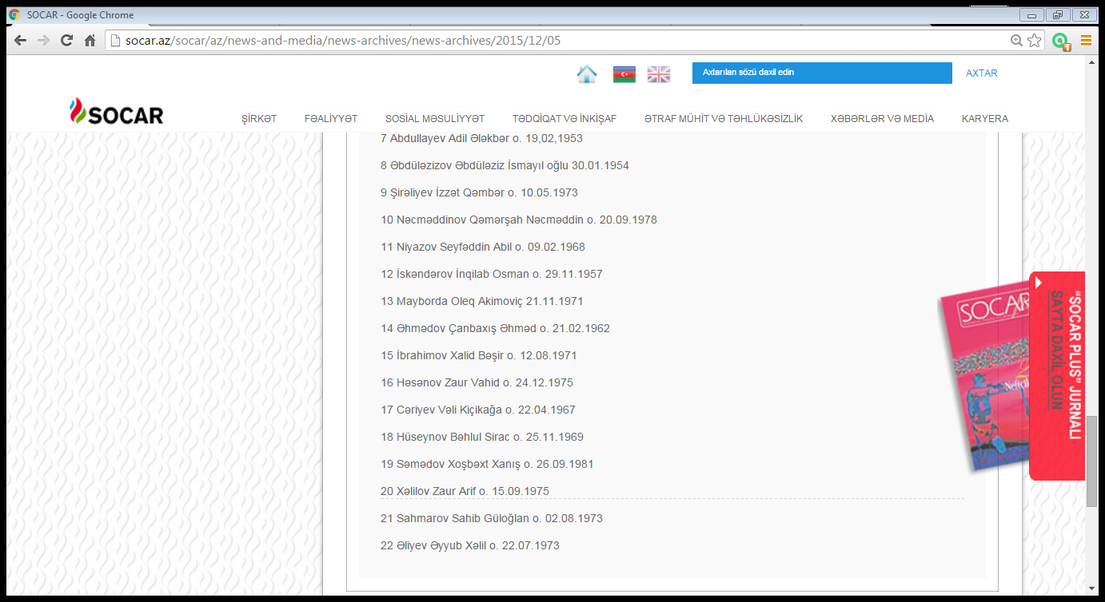

As it is seen, there are totally 54 people in the list presented on December 5 in the evening. But on that day, "APA" news agency presented a full list of 30 people who went missing during the night.The list includes the name of Tagiyev Fuad Tahir born on 23.02.1981, Mahmudov Aga Izzat 24.03.1968, Guliyev Fakhraddin Khanjan 05.01.1957, Babayev Mikayil Ismayil 06.11.1963, Mayilov Samir Jahangir 07.03.1984, Isgandarov Habil Tagi 05.03.1965, and Gasimov Iman Shura born on 01.12.1967.
Generally, the information about missing and dead workers is scattered. Where it is observed?
- Although it is informed that 3 of oil-workers fallen into the sea were rescued, and one’s body found, there is no information on their identity. Their name and surname are not mentioned at all.
- Mass media presents a full list of missing 30 people on December 5. But on the website of SOCAR on that date names of 22 people are mentioned. And the names of 7 people are mentioned among dead bodies found on December 7 and 27 as a result of search.
One of the most regrettable things is that, despite a long time out of the event, exact and full list has not been disclosed for the public. This kind of information disclosed to the public shows that the commission is not working properly, or the relevant authorities do not feel responsible to submit it.
It is impossible to get a list of the dead.Based on the information in the media we were able to find the name of 11from 12 and draw up the list. (The most recent data available on January 12, 2016) Currently, the oil-workers considered to be dead:
1. Tağıyev Fuad Tahir oğlu
2.Mahmudov Ağa İzzət oğlu
3.Quliyev Fəxrəddin Xancan oğlu
4. Babayev Mikayıl İsmayıl oğlu
5.Mayılov Samir Cahangir oğlu
6.İsgəndərov Habil Tağı oğlu
7.Qasımov İman Şura oğlu.
8.Həsənov Ramiz Nüsrəddin oğlu
9.Quliyev Əzizağa Nöhbala oğlu
10.Abdullayev Adil Ələkbər oğlunu
11.Qasımov Mübariz Dilqəm oğlu
Here is the latest list of the missing oil workers:
- Rzaxanov Edik Rivazin o.
- Babazadə Tural Fətəli o.
- Rəsulov Elşad Balaoğlan o.
- Qasımov Bayram Mirzəağa o.
- Əbdüləzizov Əbdüləziz İsmayıl
- Şirəliyev İzzət Qəmbər o.
- Nəcməddinov Qəmərşah Nəcməddin o
- Niyazov Seyfəddin Abil o.
- İskəndərov İnqilab Osman o.
- Mayborda Oleq Akimoviç
- Əhmədov Çanbaxış Əhməd o.
- İbrahimov Xalid Bəşir o.
- Həsənov Zaur Vahid o.
- Cəriyev Vəli Kiçikağa o.
- Hüseynov Bəhlul Sirac o.
- Səmədov Xoşbəxt Xanış o.
- Xəlilov Zaur Arif o.
- Sahmarov Sahib Güloğlan o.
- Əliyev Əyyub Xəlil o.

- There was contradictory information about missing worker, Hasanov Zaur Vahid. Thus, on December6, 2015 “Qafqazinfo” (http://www.qafqazinfo.az/sosial-3/daha-bir-neferin-meyiti-cixarildi-131178) shared information according to Khalig Mammadov, vice-president of SOCAR, the dead body of Hasanov Zaur Vahid was removed from the eater. His body was handed over to his family.
However, the name of Zaur Hasanov is mentioned among missing workers in the information shared on December 8 by APA” IA, on December 13 by ANSPRESS (http://m.apa.az/az/news/407663) according to “Azneft” PU”. Even the media prepared an extensive report about the family of the worker as "missing oil-worker".
If to believe this scattered information, then we can say that, 32 people survived, 12 people died and 19 workers went missing in the accident.
6.3. The country’s media on the day of accident
As seen in the news, despite a couple of passed, reliable information on the number of workers who are on the platform is not given. In media officially 42, unofficially 84 people were reported to be there.
During the incident, one of the regrettable moments was that the initial information about the deaths had taken place in the world press.So, on December 5, "Reuters" IA, by removing the article on tragedy, reported that 32 people died and 42 people had been rescued in the fire.
The agency shared this information according to Mirvari Gahramanli, chairperson of Oil-Workers’ Rights Protection Organization. : “one of the employees said that, totally 84 people were in the platform.”
Arif Aliyev, chairman of “New Generation” Azerbaijan Journalists Union in a statement to research team of OWRPO said that, there is common problem: “Some part of Azerbaijan media depends on the government circles. At such moments, if it is instructed that not to disseminate information without official information, then the media don’t share any information. Secondly, the organizations which are relatively independent actually have not access to information sources.”
A.Aliyev believes that, right of people to obtain information is violated: “The Azerbaijani people should have access to information in their own mass media. It is their constitutional rights. Of course, the information on foreign media is not detailed. They are not interested in the details of the incident but the essence. Therefore, there is general information.”
In addition, we can speak about the issue of information security.Information obtained from external sources can serve a certain purpose.In this case, it is second-rate information. The main reason is to make internal media be silent.”
7. How many wells on fire- different numbers.
There are contrasting points in the disclosed figures on number of oil and gas wells. Thus, at the press conference on December 6,2015 Khoshbakht Yusifzade,vice-president of SOCAR stated that, there are 30 wells in the burning platform. 2 of them are not working, and 26 of them are oil, and 4 are gas wells.
Vice-President also said that, here1 million m3 of gas per day, and 950 tons of oil is produced. “During the fire there is cross-bar at the beginning of the oil wells. The fire breaks out if one of the cross-bar doesn’t operate. It is not abig problem. Even though, it can be turned off today or tomorrow.”
The vice-president said that, that the outbreak of fire has no relation to the platform in terms of safety issues. Because all indicators of the platform, meet the requirements such as the exploitation of oil wells and gas-condensate wells, and other technical and support facilities located there. Otherwise, it would not have been able to exploit a platform in 1984 in the open sea built so far.
Some doubts around the blast are no exception. In particular, there was enough information in media on provocation committed by foreign forces. However, K. Yusifzade unequivocally rejects this possibility: “It is nto provocation. If it was diversion, something would be replaced on the platform. Strong wind and waves lasting 27 hours shook and broke the pipe.”
At the press conference on December 18, 2015 Deputy Director of the National Environmental Monitoring Department of the Ministry of Ecology and Natural Resources Matanat Avazova talked about 7 gas wells. M. Avazaova stated that, “the fire in the second gas well in 10 platform of “Guneshli” field was extinguished; the third well is being extinguished. The fire in other 4 wells continues. At present there is not fire in the oil wells.
She informed that, there are totally 30 wells in 10th platform in “Guneshli” field, 2 of them are not working, 21 of them are oil and 7 are gas wells.
Apparently, the Ministry of Ecology and Natural Resources indicate the number of gas wells 7, but SOCAR 4. It becomes clear from information SOCAR shared on January 16, that fire in 3 gas wells was extinguished.
8. Damage caused to “Azneft” PU
Ilham Shaban, head of the Organization of Oil Research Center, classified the loss in the statement to OWRPO. According to the expert, there are a couple of losses in such kind of fires: the resource, namely the loss of energy, loss of human and capital losses.
“Failure of equipment in the platform is considered to be a capital loss.The equipment was damaged as aresult of explosion and subsequent long-term fire, as well as the rescue operations.The cost for recovery of platform also can be consideredas loss of capital.
It is possible extinguish the fire with carbon dioxide, because the gas in 4 wells is condensate. But then it will fall into the sea. Combustion, in fact, prevents the flow of oil into the sea and does not cause pollution of the sea surface. Therefore, this processs should be regulated.As the fire is extinguished the closing of the wells in the platform should be implemented immadialtely. One of the main difficulties is that, the platform is situated in the depth of the sea, 100 meters from the shore.”
-Till the extinguish of gas wells 1 million m3 of gas per dayincurred losses:
“1 million m3 of gas was produced there in a day. So, 335.8 million tons of oil and 365 m3 of gas are being produced in ayear. If to take into consideration that, the fire lasted for more than 40 days, then we can talk about the loss of up to 40 million m3 of gas.In other words, according to the official statement of “Azneft", we can calculate the volume of gas burning every day. Oil wells got slight losses. It would be impossible to produce oil because of old wells there. Since the forst day of the fire oil extraction stopped. Restoration work will cost several million dollars.”
“Duirng the fire in “Bulla” the platform has burnt completely. But in “Guneshli, accommodation module has not been damaged. Even, facilities used in oil and gas processing are in place. Oil-workers were afraid that, the platform could explode and eventually dissipated.
9. WHEN THE FIRE CAN BE TURNED OFF?
According to Yusifzadeh it is clear that, it would be possible to extinguish the fire in 2-3 days. But although a month passed after the occurrence of the incident it could not be extengusihed completely. If it was possible to close automatically the opening of the wells with crossbars then why the leap happened to toher wells?
Ilham Shaban stresses that a strong wind damaged the gas pipeline in the platform, and there as a result of the high-pressure fire occurred: “Spark can emerge at any place where 110 atmospheric pressure gas erupt from the hole. The fire passed to oil wells, the residual oil burnt after technical gas stopped to be filled in the wells. But then the fire diffused to gas wells, and they are burnt gushing, that is with pressure form the layers. Therefore, an American company was invited to extinguish the fire.”
“Although gas is not given to oil wells, it doesnt mean that, the process of emergence of oil from thelayer to the opening of the well stopped. This process should be gradually weakened and stopped. According to experts, if you take into account that the layers have entered a period of the "old age", then the process will continue a bit.Alsowhile the fire is weakening use measures of mechanical methods should be strengthened in order to extinguish the fire.”
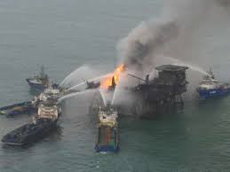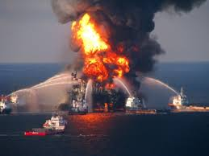
6 aircraft of the Ministry of Emergency Situations and the experts of Boots and Coots” company of US have been involvedin extinguishing the fire. At present, work is underway to extinguish the fire in 3 gas wells. According to the latest report of SOCAR, on January 16 it was possible to extinguish the fire in one of the dangerous gas wells.
At the same time, information about missing workers to all ahips in Caspian Sea water territory through the State Maritime Administration. Relevant agencies of Turkmenistan and Iran, as well as all the ships at sea, also were informed about the missing.
10. The opinin of the expert group
In general, in case of research the violation of safety regulation is observed. As mentioned above, 15 people from 63 were the construction and drill team members.
According to 2nd annex to Labor Code of Azerbaijan Republic,
4. If at sea, the following work shall be stopped under the following circumstances:
4.1. at force 4 wind conditions or greater: construction, installation, and dismantling work using crane ships on separate platforms;
4.2. at force 4 wind conditions or greater - loading and unloading barges and crane ships at bays near permanent offshore jackets and trestles;
4.3. at force 8 wind conditions or greater - at all drilled wells, operations to lift instruments from wells;
4.4. at force 6 wind conditions or greater - work on permanent offshore jackets to service production wells;
4.5. at force 6 wind conditions or greater - work on the major underground overhaul of wells on individual platforms and breakwater platforms;
4.6. at force 8 wind conditions or greater - work on the floor of the platform or breakwater platform flooring;
4.7. at force 8 wind conditions or greater - work under the floor of the platform or breakwater platform flooring;
4.8.at force 4 wind conditions or greater - all kinds of welding work in the form of downhand welding;
4.9. at force 3 wind conditions or greater - all kinds of welding work in the form of vertical welding;
4.10. at force 3 wind conditions or greater - all kinds of welding work in the form of overhead welding;
4.11. at force 5 wind conditions or greater - construction, installation, and dismantling without craft on separate platforms;
4.12.at force 4 wind conditions or greater - installation work with a breakwater construction crane;
4.13.at force 5 wind conditions or greater - pile driving;
4.14. at force 4 wind conditions or greater - dismantling of offshore oil field structures;
4.15. at force 5 wind conditions or greater - during assembly, disassembly of rigs and raising (lowering) of masts on individual offshore platforms;
4.16. at force 5 wind conditions or greater - work to repair or replace cross arms, connecting arms, rope suspensions for rocker machines, to replace rollers, pulleys on a rig or mast, pulley rigging, underwater measurements or well flow rate measurements;
4.17. at force 5 wind conditions or greater - work to raise the masts of mobile units for underground current and major overhaul of wells on breakwater platforms;
4.18. at force 10 wind conditions or greater - work on all drilled wells, except to flush and cool tools.
On the day of incident, what was the force of wind according to wind speed and wave height? According to official reports, the speed of windwas 38-40 meters per second, the waves reached a height of 9-10 meters.
So, according to Bofort scale the strength of the wind that day changed between 10-11 points, that was a very powerful storm. (Photo Bofort scale)

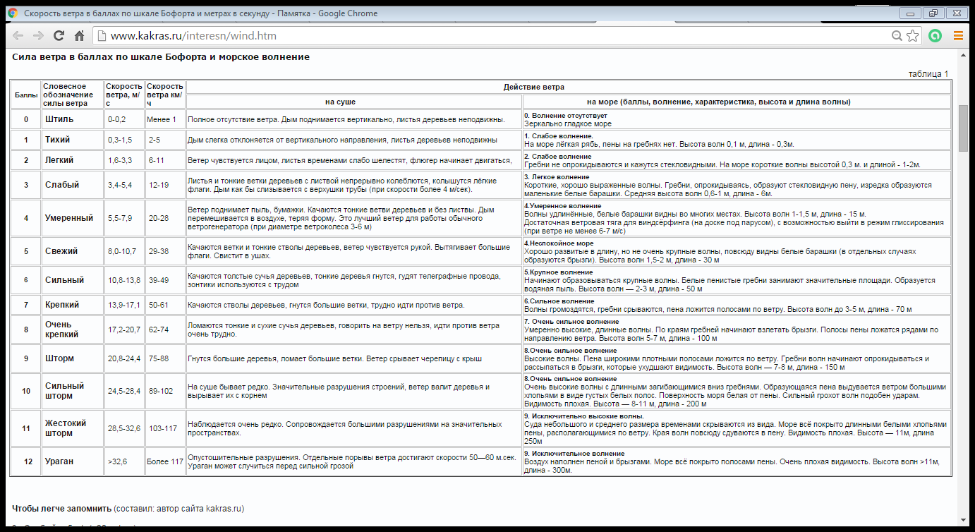
Under the law, at force 10 wind conditions or greater the work on all drilled wells, except to flush and cool tools shall be stopped. Even at force 8 wind conditions or greater work at all drilled wells, operations to lift instruments from wells, work on /under the floor of the platform or breakwater platform flooring shall be stopped.
10.1 Why the employer did not follow the law?!
In such weather 15 member of the construction and drill team to be there is against the law. They were brought for drilling 4 wells. For example, Ilgar Karimov Agali works as a crane operator on the platform.However, according to Labor Code, construction, installation, and dismantling work using crane ships on separate platforms shall be stopped. If they have been notified in advance about the weather, then Ilgar Karimov should not be in the platform.
In a statement to the press, Mirvari Gahramanli, head of OWRPO considers important the clarification of this issue: “Before rainy,windy days and hurricane SOCAR, “Azneft”, “28 may” Oil and Gas Production Department, including platforms all received telephone message. Therefore, platforms should be ready for expected weather condition. All this should be strictly controlled and execution work must be done at a high level.The question arises: should people be transferred beforehand? No. Because, oil and gas extraction is incessant work. Secondly, people must be in closed and safety environment. The question arises: why in a such squally and windy day construction-installation and drilling workers were there? If they came in advance, why didn’t return ? But it is impossible to stop the work and empty the platform. In all cases, if the commission answers to these questions, there will be clarity.”
Unfortunately, SOCAR had not presented the position of 63 people, so it was difficult to carry out extensive analysis. The only thing that is known, 18 people were from “28 May” OGPD, 5 people from Caspian Catering Service, 2 people from Complex Drilling Trust and Transport Department, 15 from Oil and Gas Construction Trust , 2 from The Caspian Sea Fleet, 1 from meteorology and etc. The heads of departments are obliged to give an explanation to society and the families of killed and missing oil workers: why they didn’t send away the employees if they received information about hurricane?
- Another safety rules were violated during the rescue operations. As aresult of gas explosion, power system was cut in the platform, the lights went out.This time workers on the platform getting in the two rescue boats attempted to leave the scene in accordance with the instructions. But according to experts, the staff didn’t use only two boats and accommodation block; it means thatat the moment there was panic, lost control; most of the firefighters have not been able to wear rescue vests. As a result, they failed to act in accordance with the instructions. Mirvari Gahramanli, chairperson of OWRPO states that, training on code of conduct in emergency situations to oil-workers was at alow level. They should be held once a week on security training.
In general, according to experts in this field, in hurricane the order on getting in the boats during evacuation was wrong.Because there is higher probability of struckingboats againstplatform poles, how it happened and put an end to the lives of many people.
In such cases, the best evacuation plan option is to use the building provided for a living inthe platform.During construction of the buildings resistance in the fire, accidents and earthquake were taken into account. There is also a little square for the helicopter on the living block. If the workers had to wait for rescuers out there, they would easily get in the helicopter. This is why 3 oil-workers survived. Experts say that, boats are intended for evacuiation only in calm weather.
If these were followed, then the number of casualties would be minimum, even it could not be.
-“One of the major doubts is about the quality of the boats. There are charges that, The South Korean boats could be second-hand, and they have not been regularly checked related to malfunction of technical rules. Ilham Shaban, head of Oil Research Center reported to OWRPO that, SOCAR intends to buy new technologies in order to minimize human losses in such accidents in the future: “SOCAR plans to order custom systems released into the water at an angle of 45 degrees. In case of incident by pushing of a button it can fall and slip 15 meters beyond the platform. It is more reasonable. "

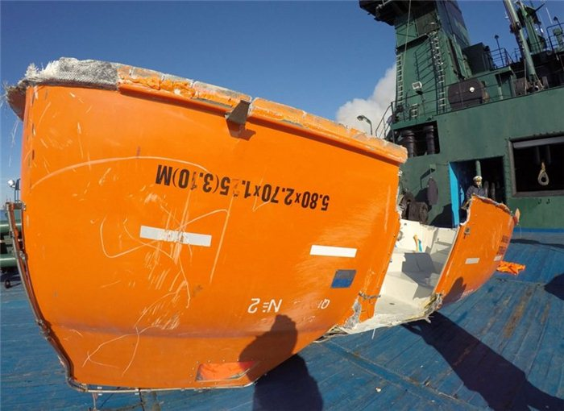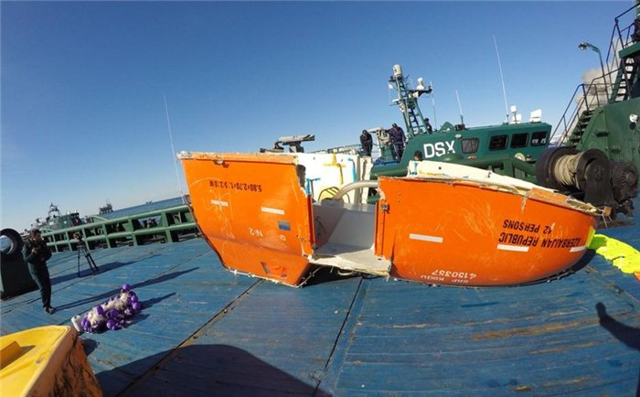
11. ECOLOGICAL SITUATION
One of the main points of concern is emergence of environmental problems.During fire toxic waste is thrown into the sea and the air. And this threatens the flora and fauna of the sea. In order to avoid possible oil spills and environmental problems that may arise as a result of the accident, a working group of experts of Ministry of Emergency Situations, Ministry of Ecology and Natural Resources, SOCAR and BP was established. At the same time, images of the satellite filming through radar type satellite owned by "Azerkosmos" OSC and the Canadian MDA "Radarsat-2" over Caspian Sea are presented to the working group on a daily basis.
"RIA" Novosti "agency reports that, during the filming from" Sentinel-1A "radar satellite on December 13, after a fire in “Guneshli "field the contaminated areas in the Caspian Sea in are growing."The data during the filming shows that, on December 13 the contaminated area is 300 square kilometers “- "the Skaneks" company said.
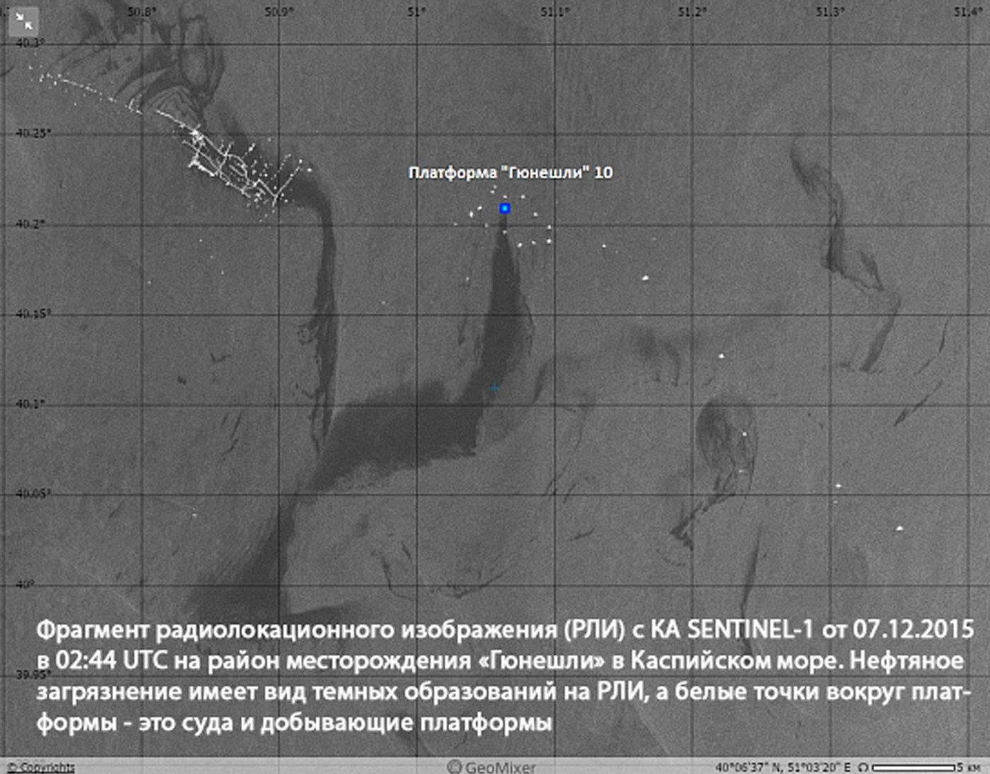
Oil-polluted are is in the dark color in the picture. The white spots around the platform are the ships and production platforms. According to data received from "Sentinel-1A”satellite on December 7 the total area of contaminated partwas 200 square kilometers. Apparently, the contaminated area is expanding rapidly.
At that time, the working group clarified that the long-term dynamics of the analysis in the Caspian Sea shows that the level of pollution don’t differ from the background indicators.Not only Azerbaijan is engaged in oil production in the Caspian Sea. Other littoral countries still in some cases use the old Soviet-era technology and, therefore, there are oil spots in the Caspian Sea regularly.
OWRPO sent survey to Ministry of Ecology and Natural resources on the current situation and what they plan in the case of excess oil pollution at the sea. In response to the request, the ministry said that after the incident of fire in the deep offshore stationary platform No 10 in order to study the potential impacts to the environment monitoring and observation is carried out in the area by the experts of relevant departments of the Ministry:“The expedition team regularly conducts observations in the place of incident, around the platform, as well as in the water area near the oil field through the helicopters and the ship, according to meteorological situation on the predetermined coordinators take water samples for analytical work, and continues monitoring to determine adverse effects on the biological resources of the Caspian Sea.”
Physical, physical-chemical, eco-toxicological and biological analyzes were carried out on the taken water samples. According to the results of analyzest concentration limit of water samples was determined to be maximum 2-3 times more than norm, and from ecotoxicological point of view toxic substances were not found in.According to monitoring conducted,harmful effects have not been observed around the fauna and flora of the sea. Monitoring and analysis are ongoing.” Ministry also noted that because of complete burning of natural gas from the wells during the fire, harmful effect on the atmosphere relatively reduced, and it is the same as harmful substancesinto the atmosphere from burnt gas in thermal power stations and flares: “Therefore till the accident is eliminated carrying out the appropriate technical measures gas combustion ecologically is more dangeorus.
The observations, analyzes and experiments in this field allow us to say that, in the case of oil spill it is possible to ensure the timely collection of oil through delivering known coordinators by means of bon intakes and special technique to equipped ships , and to avoid environmental problems by implementing other preventive measures determined in accordance with the current situation.
According to the conclusion of experts of Oil-Workers’ Rights Protextion Organization on environmental opinion,usually a hydrocarbon leak occurs during such accidents which haveserious adverse impacts on the environment: “"Soon after the occurrence of the accident, a number of news agencies already have a certain amount of information about the oil spill. For example, "RIA Novosti" informed that, according to the data obtained by radars in space, 300 square meters contaminated area was observed on December 13.
After the accident in “Guneshli "oil field oil spill area is increasing and satellite images prove it.
On December 13, 2015 the next filming was carried out by “Sentinel-1A” space radar satellite.From the images oil pollution of the sea observed in the northern part of “Guneshli” field.
Space radars filming allows to determine with high accuracy oil spill region and the source.The pictures of 300 square meters of oil spill area taken by “Skaneks” Company appear as matte (black) colored spots. The white spots around the platform are the ships and production platforms. According to data received from "Sentinel-1A”satellite on December 7 the total area of contaminated partwas 200 square kilometers. There is smoke emission observed from the platform No.10 in "Guneshli" field in optical filiming thorugh Suomi NPP satellitedated December 14, 2015.
Subsequently, a working group consisting of specialists from the Ministry of Emergency Situations, Ministry of Ecology and Natural Resources, SOCAR, BP carried out observations by means of specially equipped ships and helicopters in the place of accident.Significant spots proving oil spill nearby “Guneshli” and “Neft Dashlari” fields and in the surrounding areashave not been found. At the same time, in accordance with international practices, filming from space radar and optical recording was carried out to detect oil spills andpollution in the sea. Despite reports in the media about the oil spill at the seaas a result of an accident in the platform No.10, analysis of records by Canada's "MDA" Company through "Azerkosmos" JSCand “Radarsat-2" satellite confirmed the results of the monitoring group.”
Experts note that this kind of contradictory statements causes confusion between public. Information about “Seriously spots proving oil spill in the area of “Guneshli” and “Neft Dashlari” fields have not been found " provided by SOCARto how degree reflects the fact?
. According to experts of the OWRPO monitoring process in the Caspian Sea should be continued and the civil society representatives, independent experts should be involved in this process: “Because experience in the world's oil production shows that, oil and gas condensate spills during such accidents have negative impacts on the environment.”
It is known that oil layer as a result of 1 liter oil spill deprive 40 thousand litersof sea water of oxygen. 1-ton oil spill pollutes the sea surface in the area of 12 square kilometers. Oil layer on 1 ha of sea surface destroy more than 100 million fish larvae. (http://ref.by/refs/97/37972/1.html).
1 ton of oil pollution of water bodies create 12 square meters oil layer in water basin and block the path of the oxygen incoming from the atmosphere. However, the proliferation of plankton which that is fish feeding stops, resulting in the mass destruction of fish and other sea creatures. All of these can cause serious adverse effects on biodiversity and fauna of the Caspian Sea.
It should be noted that Cardium ciliatum molluses live inthe Caspian Sea. These molluscs in de dimension of 2.5 cm carry out the role of “sanitary”. So in search of food and oxygen during a day they are able to digest 15 liters of water and remove.These living organisms do not absorb the oil in the water, removing by means of slime leave in the bottom of the sea.Therefore, in order to clean up oil pollution in the Caspian Sea it is very important to conduct research on the use of these mollusks.
At the same time, during the fire fighting in platforms it should betaken into account that, due to the impossibibility of reliable closure of the well gas in layers of gas reservoirs can completely be emitted, this can cause emission of large volumes of greenhouse gases into the atmosphere.The devastating effect of the unburned natural gas on the atmosphere (СО2) is 20 times stronger than carbon monoxide.Therefore, for environmental protection from possible accidents and hydrocarbon spills, the state and local authorities should develop a remedial action plan in advance; the tasks to be accomplished are put forward and responsible people are assigned for implementing these tasks.Typically, biologists, lawyers, firms specializing in cleaning, rehabilitation specialists on living organisms, officials from the local authorities are involved these studies.
12. PSYCHOLOGICAL HELP
According to reports released by the Ministry of Health and SOCAR, injured people are rendered psychological help.Even neüs reported that, in the night of incident team of doctors of Ministry of Health was sent there. However, the attitude to the relatives of oil-workers in front of the central office of the commission established that night in the shooting recorded by the media allows us to say the opposite: no doctor, not a psychologist; people are waiting news in front of office in cold weather, whose health becae worse were helpless, they üere treated unkindly.
In fact, in such situations, how the relatives, family members should be treated?
Psychologist Azad Isazadeh notes that, in such incidents psychological staff should be created: “Here are a few directions. First, psychological assistance should be rendered to those who were rescued. Later, their relatives should be assisted.At the same time, psychological importance of the report giventhe population is great. This, of course must be managed by the center. But above-mentioned were organized scattered in the platform. Neither the media nor the injured and the relatives of oil-workers have been rendered psychological assistance ".
A.Isazade also added that, in such cases the relatives of oil-wrokers’ should be kept in touch and gathered in a room: “There are two forms of the psychological help to be rendered them. Firstly, they should be rendered social assistance. Hot tea and tohers should be organizaed for the families. If they had been served, they would be assured consciously that, their relatives in the place of incident are also served in such a way. But when they see that, no one takes care of them even in a peaceful situation, they are treated unkindly, and then they are concerned that, their relatives are helpless completely. This is purely psychological, subliminal communication.When people are treated kindly, psychologists work with them, and they are regularly informed they are relatively relaxed.At the same time stir and panic are prevented. These are the usual initial measures have been adopted all over the world.Lists of both survivors and the missing persons, as well as relatives should renewed.”
The injured had to be provided with a doctor immediately, as well as psychologists. If they got psychological help their wounds would be healed more quickly. But so much time passed. “Any psychologists had not worked with those injured”- psychologist says.
The contribution of Azerbaijan government is based on materiality rather than moral factors. Provoding families of the missing oil workers with one-time financial assistance they consider their work completed. It should be noted that, according to the relevant order of the president (http://e-qanun.az/framework/31497), it was decided to pay a one-time financial assistance in the amount of 5 thousand AZN by SOCAR, and 15 thousand AZN by the government to accident victims and family members of those died.
Unfortunately, injured and disabled people deprived of with psychological or financial aid, they were completely ignored. However, psychological state of most of them is in poor situation. In addition, financial difficulty worried the family heads of injured. Although government officials disclosed about giving compensation, the complaint of oil workers allows saying that it remains as a word.
For example, Bakhtiyar Alekperov, working in the 10th platform said in hisn statement to Meydan TV: “Gas pipeline suddenly exploded.I was walking and looking at wells. It exploded as soon as I fell. I barely saved my life. I get rid of with the help of God.”
After spending 18 hours in the boat, worker Aziz Aliyev was brought to the hospital's burn unit. Since he has been brought to the hospital, Health Minister Ogtay Shiraliyev, the Azerbaijani Ombudsman Elmira Suleymanova and the leadership of the Trade Union visited him.
But SOCAR management had not interested in his pain.
“No one from administration came and interested. No one came to know how is their 33-years worker, except Trade Unions- Bakhtiyar Alexkeberov said.”
“Bakhtiar after the accident was 1st group disabled has lost the ability to work. While working although he had compulsory insurance he had not been paid yet. Worker who gets 1000 AZN received 600 AZN with fraction after the accident: “I am paid 1000 AZN salary. But this month I was paid 600 AZN. 4 days of them were our working days before the accident. If to calculate 65 AZN for each 4 days, it is 260 AZN. Bulletin was paid 350-400 AZN. It is also less. I have a family. This money does not satisfy. We have burnt; at least we want to be paid our salary. “
Salim Muslumov, Minister of Labor and Social Security said that, after the accident in “Guneshli”
field the families of those died in the incident and those who lost the ability to work will be paid insurance.
54 year old Bakhtiyar Alekberov was healthy and hale worker. From December 4 he was the first group disabled. Hands, feet, and head received burn injuries. There are traces of the 4th degree burns on his hands. However, he doesn’t want to be treated and rest at home, but wants work because of needs. And he guesses that, he will not be able to work with these hands in the filed where he worked 33 years: “I want nothing from the government, at least want my salary to be paid. “YapiKredi” Bank calls me every day. My wife says that, he is is under anesthesia, lies. They say that, he had a child, he can come and pay. They called us 3-4 times. They say if something happened to him, his child can come and pay the loan. But my child doesn’t work anywhere. How can I get this money?!”
13. RESULT
- SOCAR from the first day doesn’t present the full list of missing, died and survivors. Their positionis not mentioned. This list has not been submitted yet.
- There are controversial moments in the figures disclosed related to numbers of oil and gas wells.
- Safety rules were seriously violated. According to Annex 2 of the Labor Code of Azerbaijan Republic delivery of the majority of workers on the platform shall be deferred, maintenance and construction work shall be stopped in stormy weather. Directly reposnible are heads of “28 May” OGPD, Complex Drilling Trust, Transportaion Department, Caspian Ctaering Service and etc.
- During the rescue oil workers were not given proper instructions.
- There were contrasting opinions about the quality of the boats in the society and social network; serious study is needed with the participation of civil society.
- There was contradictory information about the wells located in the platform. SOCAR informs about 4 gas, 24 oil wells, Ministy of Ecology and Natural resources about 7 gas and 21 oil wells.
- Although “28 May” OGPD management was informed about gas leak, no remedial measures were taken by them.
- In addition to the casualties, economic losses are growing as long as the fire continues. Every day 1 million m3 of gas incurring loss. In addition, the restoration of the platform, re-launch the process of wells extinguishing the fire will cause the company and the state to spend a lot of money.
- In a period of reduced oil revenues, it can be considered enough large expense for the government. Unfortunately, the public is not informed about the volume of losses.
- There was conflicting information in local and international observations about ecological consequences. OWRPO experts consider that, the possibility of environmental problems as a result of the fire is strong.
- On the day of accident contact with families of oil workers, their informing about the incident, their arrangement in closed room in windy weather (provision with tea and coffee) were badly organized. Intolerance facts have been observed against the families. They should be provided with psychological support because of stress they lived. Unfortunately, neither survived oil workers, nor their families and relatives of died, missing workers have been provided with psychological help.
- The injured workers have not been provided with financial assistance. On the contrary, the salaries have been cut because of non working days due to the accident.

Note;
- On 5 December 2015 the State Commission consisting of 14 members was established in connection with the accident in deep sea stationary platform No.10 in “Guneshli” oil field with the decree of Azerbaijani President Ilham Aliyev.
Criminal case has launched under Article 225.2 (The same act, which on imprudence brought to death of a victim or other heavy consequences ) of the Criminal code of Azerbaijan Republic in Investigation Department of the General Prosecutor for Serious Crimes, the investigative group was established consisting of employees of the Ministry of Emergency Situations and General Prosecutor's Office.
Carrying out necessary and urgent investigative actions on a criminal case causes of the accident and appropriate expertise for the work to determine the damage caused have been appointed, as well as the necessary procedures are carried out.

14. Reference sources
1. https://www.meydan.tv/az/site/interviews/9950/M%C9%99n%C9%99-platformada-84-n%C9%99f%C9%99rin-oldu%C4%9Funu-dedil%C9%99r.htm
2. https://www.meydan.tv/az/site/opinion/11233/''G%C3%BCn%C9%99%C5%9Fli''d%C9%99-yanan-i%C5%9F%C3%A7inin-maa%C5%9F%C4%B1ndan-k%C9%99silib-(V%C4%B0DEO).htm
3. socar.az
5. http://www.azadliq.info/108878.html
6. http://www.cbc.az/az/video/all-videos/dvlt-neft-irkti-xilaedici-qayn-xsusiyytlrini-nmayi-etdirdi
7. http://report.az/hadise/gunesli-yataginda-xilas-edilen-neftci/
8. http://www.azadliq.org/content/article/27410012.html
9. http://contact.az/docs/2015/Analytics/120600139010az.htm#.VqEtbPmLTDd
10. http://www.azadliq.info/108878.html

11. http://www.azadliq.org/content/guneshli-yangin-socar/27407466.html
12. http://caspianbarrel.org/?p=37101
13. http://caspianbarrel.org/?p=37148
14. https://www.youtube.com/watch?v=2_XbzOOwUgE
15. http://anspress.com/index.php?a=2&lng=az&cid=1&nid=366511
16. https://www.youtube.com/watch?v=w_sINH-_2tk
17.http://az.apa.az/news/407323?keywords=g%C3%BCn%C9%99%C5%9Fli
18.https://az.wikipedia.org/wiki/G%C3%BCn%C9%99%C5%9Fli_neft_yata%C4%9F%C4%B1nda_yan%C4%9F%C4%B1n_(2015)
19.http://m.apa.az/az/news/407663
20.http://www.azadliq.info/108230.html and etc.

The scale of such an incident even leaves behind the tragedy happened on the night of November 22, 1957 in “Neft Dashlari” field. At that time, including the legendary master of drilling, the Hero of Socialist Labor Mikhail Koverockin, 22 employees were spilt in the Caspian Sea .
According to Kh.Mamaddov in 2011, 46 Korean-made MPT 58F type lifeboats with 42 seats were bought. He says that, the boat can pass the burning area: “If oil products diffused to the surroindings and fire broke out, people who are in the boat can enter more ssecure area. If the boat is paasing the burning area, there is an ooportunity to cool its hull. In other words, the water is pumped into the pipes above thorugh the pump inside the boat. While passing through the burning areathe doors of boat are tightly closed and the people inside can breathe through oxygen cylinders within 10 minutes. There is a 3-day supply of drinking water and food in the boat.

