TEGT Website Text as of 10/12/14
Sections:
How to use this guide
Tesco's Requirements
Management Systems
Employment is Freely Chosen
Freedom of Association and Collective Bargaining
Health and Safety
Child Labour
Wages
Working Hours
Discrimination
Regular Employment
Dignity and Respect
Vulnerable Workers
How to resolve a Non-Compliance
External Resources

How to Use This Guide
This practical guide aims to clarify Tesco’s expectations of suppliers, in relation to labour standards in the workplace, for sites producing products for supply to Tesco.
It includes a number of case studies which illustrate how some of our suppliers have tackled challenging issues in the workplace, along with photographs, which illustrate conditions that we consider to be acceptable (flagged with a green tick) and unacceptable (flagged with a red cross).
This guide is under continual development and we welcome suppliers’ feedback or case studies and photographs that illustrate best practice.
Tesco's Requirements
Key Documents:
Ethical Trading Requirements for Suppliers | This document outlines Tesco’s requirements of suppliers in relation to ethical trading.
Supplier Starter Pack | The Tesco Supplier Starter Pack provides suppliers with practical guidance on how to implement the requirements set out in the Ethical Trading Code of Practice.
Child Labour  Operating  Procedure | This document provides practical guidance on how to respond to incidents of child labour.
Migrant Worker Guidelines | This document provides employers with practical guidance on how to manage the welfare of migrant workers along each stage of the recruitment/employment process.

Management Systems and Capability

Most suppliers find that a robust management system is essential to run their business effectively.
These should be appropriate to the size, type and complexity of your organisation. This generally means that larger organisations will have more formalised systems and written policies and procedures. Smaller organisations might require a simpler system that nevertheless ensures that ethical standards are implemented effectively in the workplace.
The content below highlights examples of what we consider to represent best practice, and approaches we have identified as effective.

Senior management responsibilities:
- A senior manager must be assigned responsibility for leading the business response on ethical trading and ensuring appropriate resource is available. This principle is reflected throughout this document.
- Roles and responsibilities, e.g Health and Safety, must be assigned to specific members of the management team and communicated throughout the organisation.
Policies, procedures and Implementation:
- A senior manager must have overall responsibility for ensuring policies and procedures are developed as needed to cover the requirements of this guide.
- This manager must have sufficient knowledge of the human resources and health and safety issues covered in Tesco's standards.
- Where appropriate, staff should be consulted when developing policies and/or procedures on the relevant issues.
- Ethical trading requirements must be reflected in work instructions and procedures. For example, health and safety instructions should be incorporated into operating instructions and training procedures.

Recordkeeping:
- Managers must ensure that relevant records are kept and maintained on-site for at least 12 months.
Internal Audit and Review:
- A system of internal audit must be developed and implemented to check that procedures are operating effectively.
- Management systems should be reviewed at least annually, taking into consideration findings from internal and external audits, and updated appropriately.
Training:
- The senior manager with overall responsibility for meeting standards on ethical trade must have access to the relevant background information and legislation.
- They must also ensure all relevant staff are appropriately trained and capable.
- Relevant information includes:
- ETI Base Code
- ILO Core Conventions
- All relevant national and local law
- Background information on issues, including; covering wages, hours, child labour,
forced or bonded labour, discrimination, employee benefits and welfare,
discipline, contract/agent or migrant labour, training and development, Trade Unions and collective bargaining.

Employment is Freely Chosen
Employment is Freely Chosen: The Issues
The Issues:
Forced or involuntary labour has many forms including: slavery, bonded labour (when people feel they cannot leave their work because they owe or are owed money), indentured labour (generations of a family tied to an employer), and involuntary prison labour (when prisoners are forced to work against their will).
Workers must be able to leave their job if they give a reasonable notice period.
It is not acceptable for employers to take any kind of deposit from workers in order for them to secure a job or retain personal documents unless required to do so by law.
All workers must be treated with dignity and respect, and have free access to amenities such as toilets and drinking water at all times. During working hours, if a worker needs to leave the site (for example if they fall ill), they must be able to do so.
Employment is Freely Chosen: What is my Responsibility?
What is my Responsibility?
Tesco expects you to ensure that you do not use any forced, bonded or involuntary prison labour, and all workers have chosen to work of their own free will.
A policy must be in place to ensure this requirement is implemented.
This policy must cover all staff, including agency or contract labour.
All necessary documentation relating to recruitment and employment (e.g. contracts, job descriptions, personnel files etc.) must be available on-site.
Checklist: Forced, Bonded & Prison Labour
Forced, Bonded & Prison Labour:
- All workers employed at all your sites are there through their own free choice.
- All workers have a written contact in a language that they understand.
- All workers, including agency and migrant workers, are recruited through a robust and transparent interview process.
- All workers are allowed to leave their work after reasonable notice if/when they choose to do so.
- All workers are paid a wage that covers their basic needs and provides for some discretionary income.
- A system is in place to accurately record working hours for all workers, including agency and contract labour.
- An accurate payroll is kept on-site which includes records for all workers, including agency and contract labour.
- Direct employment is used where possible. For more detail on agency labour, please refer to the section on Regular Employment.
- No deposits or personal documentation are retained from any worker (unless required to do so by law). Please see the sections on Deposits and ID Papers for more detail.
Checklist: Deposits
Deposits:
- Workers are not required to provide a deposit to secure a job.
- Only deductions permitted by law can be taken from workers.
- Where other deductions are taken, these have been explained in advance to each worker, and their formal, written agreement obtained.
- Written and signed documents for agreed deductions (including food & accommodation), are kept in each worker's personnel file.
- No deductions are taken for personal protective equipment (PPE), or any other type of protective work equipment, including uniforms.
- No deductions are taken for job-related training.
- Any deductions made for accommodation and food are reasonable and not excessive relative to worker's income.
- If loans are made to workers, the terms of the loan are fair, do not require recovery of an amount greater than the payment made, and are in a language or languages both parties understand. Repayment terms are proportionate to workers' wages and do not require workers to stay beyond their contractual notice period. Repayments are clearly and fully documented, and the terms of the loan are detailed in writing, signed by both parties, a copy given to the worker and another kept in the employee/worker file.
Checklist: ID Papers
ID Papers:
- Good quality photocopies of valid identification documents are kept on file for all workers.
- Workers do not pay for these photocopies.
- Original copies of identification documents and any other personal documents are returned immediately to their owners, except where laws specifically require originals to be held. Where this is the case, workers have access to their own documents at all times.
- Workers are provided with company identification cards where appropriate or required by law.
- If workers ask to keep any personal documents safe, they are allowed access to these at any time.
- Workers who live in accommodation supplied by the company have a safe place to leave personal documents, which they have access to at any time.
Checklist: Freedom of Movement/ Notice Periods
Freedom of Movement:
- Workers are free to come and go from the site and from dormitories, where provided.
- Doors or gates allowing access to or from the work area are left unlocked during work hours.
- Security guards and security services are in place for the protection of the facility and its staff, not to regulate the movements of people working at the facility.
- If body searches are conducted, clear policies are in place that state when and why this is done, and this is communicated to all staff in all relevant languages.
- If body searches are conducted as a security measure, female workers may only be searched by female security guards, and male workers by male security guards.
Notice Periods:
- All workers have signed contracts in languages they understand and this contract is kept in their personnel files.
- Contracts clearly state the notice period that workers must give and this is consistent with national and local laws. Where there is no legal guideline, the notice period should be equal to one pay period (e.g. weekly or monthly as appropriate).

Freedom of Association and Collective Bargaining
Freedom of Association and Collective Bargaining: The Issues
The Issues:
Freedom of association means that workers are free to form or join groups of their own choosing, including trade unions, so that they can discuss and negotiate matters with their employers.
Collective bargaining complements the right to freedom of association. It means that workers can bargain for working terms and conditions as a group, rather than on an individual basis. Being able to discuss and negotiate issues with representatives of the whole workforce can be beneficial to management in gaining feedback and consent on a wide range of issues, including productivity, efficiency and safe working.
It is important to allow workers to make their own choices as to whether or not they form or join a trade union, and if they so choose, provide an open and tolerant attitude to trade union activities. It is not acceptable to treat non-unionized workers more favourably than union members.
Where local laws restrict the freedom of association and collective bargaining, workers must be allowed to develop alternative methods to discuss work-related issues and come to collective agreements with management on these issues.
Freedom of Association and Collective Bargaining: What is my Responsibility?
What is my Responsibility?
It is your responsibility to set the right tone towards trade unions or worker committees to ensure that workers feel free to join, and participate, in these if they wish to do so.
The senior manager in charge of human resources or employment should have a written policy outlining the approach to engaging with trade unions or worker committees, which is communicated to all staff in languages that they can understand.
Records of votes taken to decide whether there should be a union in the work place, copies of minutes of meetings with unions and copies of any collective bargaining agreements should be kept onsite and available to workers.
Checklist: Right to join a trade union and bargain collectively
Right to join a trade union and bargain collectively:
- You communicate an open attitude to union membership through a written statement included in an employee handbook and/or by allowing posters to be placed in public spaces on-site.
- Union members are treated the same as all other workers and have the right to post notices about their activities in a dedicated public space within your site, where all staff can see them.
- You are open to bargaining collectively with workers
- You allow time to meet with the union on a regular basis, as requested by the union as well as allowing them access to appropriate members of the management team to discuss relevant issues.
- In countries that do not allow independent trade unions, you provide workers or worker representatives an opportunity to meet with appropriate members of the management team to discuss terms of work or grievances.
- You maintain written records of all agreements made with workers as outlined above.
- All collective bargaining agreements must be honoured and apply to the whole workforce and not just union members.
Checklist: Open Attitude to Trade Union Activities
Open Attitude to Trade Union Activities:
- At worker inductions, you communicate their right to join a trade union or worker committee.
- If you have a trade union on-site, workers are told how they can contact relevant representatives at their induction.
- You allow free and fair elections for union representatives to be held, and do not interfere in this process in any way.
- If requested for help during the election process, for example by allowing use of a room, you are willing to assist where practicable.
- A free and fair election process including a secret ballot is implemented to ensure workers feel free to vote as they wish.
- Union representatives are given time off from their normal job to carry out regular union business, and a reasonable notice period agreed for representatives to carry out non-regular business.
- The union representatives are paid their normal rate of pay when carrying out union duties.
- Workers are allowed to attend union meetings as required. Meeting times are agreed in advance, with a reasonable notice period agreed for the holding of non-regular or emergency meetings.
- Where there is no trade union on-site, mechanisms are in place to allow workers to air grievances with management and trade union representatives from other sites are allowed to freely approach workers at your site.
- If a trade union does not currently exist on-site and workers decide to form one, you allow this to happen, in accordance with local laws.
Checklist: No Discrimination Against Trade Union Members
No Discrimination Against Trade Union Members:
- Workers are allowed to keep union affiliation private if they choose to do so, especially during the recruitment process.
- Elected union representatives are treated in the same way as all other workers in regards to potential promotion or training opportunities, wage rises, wage deductions and all other activities.
- Intimidation or violence is not used against union members.
- Staff engaging in alternative means of association, where freedom of association and collective bargaining are restricted by law, are treated the same as all other workers.
- Unionised workers are not monitored outside work, nor monitored any more closely than other workers while on site.
Checklist: Alternatives to Trade Unions
Alternatives to Trade Unions:
- Where trade unions are restricted by local laws, workers are allowed to set up a worker committee instead.
- If workers do wish to set up a worker committee, you provide assistance in organising this, ensuring this does not adversely impact on their wages.
- Worker committee representatives are paid their normal rate of pay when carrying out their duties.
- All representatives are volunteers, or have been nominated by other workers, and have freely agreed to take on the role.
- If more workers volunteer than are required, then workers are allowed to hold a free and fair election.
- You provide assistance as required during the election process but do not interfere in the choice of candidates or try to influence workers on whom they vote for.
- Meetings are held on a regular basis and dates for all meetings are posted in a public place onsite where all workers can see it.
- Each meeting has an agenda prepared in advance which is posted in a public place onsite, and written in all languages spoken within the factory.
- The main purpose of all meetings will be:
- To discuss any concerns, grievances or suggestions the workers may have;
- To agree solutions and actions to any issues raised;
- To agree responsibilities and timescales; and
- To review progress made on previous issues discussed.
- Following the meeting detailed minutes are prepared and include all matters/issues discussed at the meeting, the agreed actions, responsibilities and timescales.
- Minutes are approved by the committee.
- Copies of the minutes are posted in a public space onsite in all languages spoken within the factory.
Case Study: Trade Unions
The Issue:
A UK poultry supplier had a history of difficult relations with their local Trade Union representatives, creating a sense of suspicion and mistrust on both sides, and very nearly leading to a strike.

The Solution – What changed?
In the past the company had been fairly closed in its dealings with the Union, and indeed the workers as a whole. There was a clear separation between salaried employees and those on the factory floor paid an hourly rate. Management rarely communicated with the factory workers on how the business was doing.
Two things happened which, over time, helped thaw relations between the two sides. Firstly, over a period of a couple of years there were changes to personnel on both sides, the local Union representative and the HR director of the company, and this gave both parties a chance to start relations afresh. Secondly, the company was facing a tough trading environment and was honest and upfront with the Unions about this. Union representatives, therefore, better understood the environment in which they were negotiating.
Open and honest communication was key to building trust between the two parties. Senior managers delivered business briefings to all staff, and produced a weekly business up-date newsletter for all staff. The HR Director treated the Trade Union as an important stakeholder, making a point of calling Union representatives if there was any news about the company.
Early successes were achieved through co-operation on issues of interest to both parties. By working through issues of common interest, the parties were able to get to know each other in a 'safe' environment and further build trust. One example of this was the joint development of a bullying and harassment statement. Another example was joint promotion of health and safety on the factory floor.

What has been the long-term benefit?
As the HR Director explained: 'in a company this size there are always a lot of rumours circulating about what the business is and isn't about to do. Now if there is a rumour going around the factory the trade union representative comes straight to me or a colleague to find out what is really going on'.
Staff and the union have a clearer understanding of how the business is doing and this means dialogue is now more constructive. Though the Union still rightly challenges the company, the company acknowledges the Union’s role in supporting the business, at times when it has needed to make difficult decisions.
Similarly the business has been supportive of the Union's aim to get the poultry sector to sign up to the Minimum Standards Agreement. This Agreement called for temporary and agency labour to be given equal terms and conditions as permanent staff directly employed by the company. 'This was something that we knew was important for the Union nationally and for which they were looking for support from businesses. We were already paying our agency and temporary staff at the same rate as our permanent staff, and wanted to support our Union by making a public commitment of support for the initiative which we did', explained the HR Director.

Lessons learnt:
- Open and honest communication was key to building trust between the two parties.
- Early successes were achieved through co-operation on issues of interest to both parties.

Useful Links

https://www.gov.uk/government/publications/modern-slavery-industry-factsheets

https://www.youtube.com/watch?v=Jv1H_fAoOG4&feature=youtu.be

Health and Safety
Health and Safety: The Issues
The Issues:
Tesco expects suppliers to ensure safe and hygienic work environments and have measures in place to prevent and minimize work-related accidents and injuries.
Staff must be trained in all relevant health and safety issues so they can carry out their jobs safely, and provision must be made for basic needs such as sanitation, drinking water, accommodation and food storage.
Companies must assign a senior manager to oversee health and safety measures at each of their sites.
Health and Safety: What is my Responsibility?
What is my Responsibility?
Every site must be assign a senior manager to oversee of health, safety and hygiene issues specific to that site.
This manager must develop, implement and monitor health, safety and hygiene policy and procedures covering the relevant risks for the work place in accordance with local law and relevant international requirements.
This manager must organise general health, safety and hygiene training for all staff as well as role specific training, where required. They must also have undergone training on specific health, safety and hygiene issues relevant for the industry in which they are working and ensure that they keep up to date with all new developments in their sector through membership of relevant trade or association bodies or other means as appropriate for their work.
This manager must ensure all health and safety certifications, copies of inspection documents, and any other documentation associated with tracking health and safety assessments are maintained.
Checklist: Health and Safety Management
Health and Safety Management:
- A senior manager is assigned to monitor health and safety at each site.
- This manager is trained in general health and safety issues as well as more specific issues for the industry in which they are working, and has a system for keeping up-to-date with all new health and safety issues relevant for their industry.
- Each site is assessed for specific health and safety issues by the manager assigned responsibility for health and safety.
- Risks identified are monitored on a regular basis, and written up in a document listing: type of risk, severity of risk, who might be harmed, how they might be harmed, and how to prevent or minimise risks.
- A safety committee must been set up at each site. The committee should meet on a monthly basis to monitor risks and discuss all health and safety concerns at the site. Workers and managers are represented on these committees.
- Records must be kept on site of all staff health and safety training, including names of participants, dates and type of training.
- Health and safety certificates should be available, and all individual staff training certificates must be kept in personnel files on-site.
- An accident and injury log must be kept on site listing the time and date of all accidents or injuries the nature of the accident or injury, and how the accident or injury was dealt with, Including the response of the Safety Committee.
- Near misses (incidents that could have led to a personal injury) must be logged and reported to the Safety Committee.
- There are trained first aid staff on site, and qualified medical staff where required.
- The senior manager responsible for health and safety works alongside the worker safety committee to develop health and safety training in line with local law and risks relevant to the work place.
Checklist: Health and Safety Training
Health and Safety Training:
- Each site has health and safety Policies and Procedures that list training requirements, the frequency with which training is to be carried out, and the manner in which training will be recorded.
- The senior manager responsible for health and safety issues at each site ensures that all staff know how to evacuate the site quickly and properly in the event of an emergency, and that they practice this, covering all shifts, including random evacuations, where buildings are completely evacuated of all staff.
- All staff are trained in both general health and safety issues, such as fire safety, and more specific issues relevant to their work, like handling chemicals or using machinery safely.
- If workers change roles at the site, they are trained in all relevant health and safety issues for the new post before they start carrying out that work, and are paid for the time they spend carrying out training.
- All site-specific health and safety training is documented and selected certificates publicly displayed.
- Training certificates are kept in each employee's file stating the type of training, date completed, and the target date for follow up training where appropriate.
Checklist: General Work Place Conditions
General Work Place Conditions:
- All buildings are safe and protect workers from the weather.
- Work and living areas must be kept clean.
- All sanitation facilities work properly and must be kept clean.
- Potable water, suitable for drinking is available at all times when workers are onsite, including in living areas.
- Workers have access to both hot and cold water.
- The temperatures in the work and living areas are comfortable, with well-functioning heating and cooling systems as appropriate. For work conducted outdoors, workers have clothing appropriate for the climate and have access to cooled or heated areas if necessary.
- The air quality onsite is safe for workers, tested regularly with effective systems for ventilation in place.
- Adequate lighting is provided in all the work areas and exit routes. Work stops when adequate lighting is not available.
- All passageways to and from work spaces are kept clear at all times.
- Workers have unobstructed access to evacuation paths and fire extinguishers.
- All work areas are kept clear of debris, and flammable materials are kept away from heat sources.
- All workers have access to secure storage facilities where they can safely leave their personal belongings, including personal papers.
- Work stations are designed to be comfortable and are practical and appropriate for the work carried out. Chairs provided so that workers who stand for work have the opportunity to sit when they need to do so.
- Canteens are clean, hygienic, comfortable, and offer staff a range of nutritious options.
Checklist: General Work Place Conditions TETG
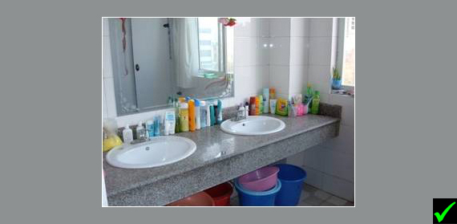
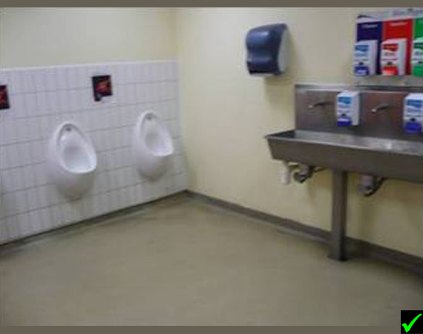
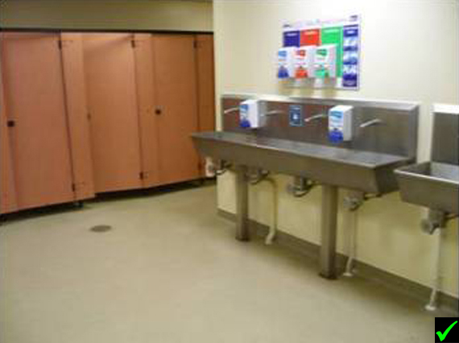
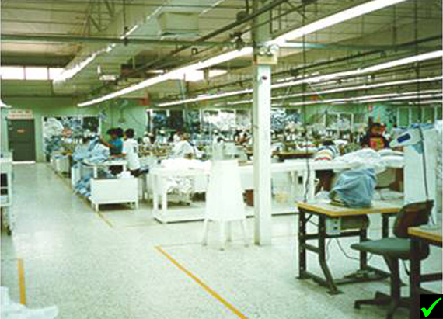
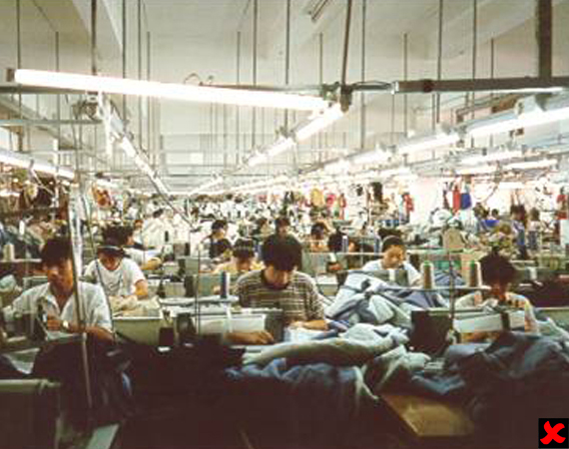
Checklist: Dormitories and Living Areas
Dormitories and Living Areas:
- If accommodation is provided onsite, separate dormitories and sanitation facilities must be provided for male and female workers.
- All workers are provided with their own bed, and a minimum of 3.6 square metres of floor space each.
- Living facilities are cleaned on a daily basis at least, and more frequently if required.
- All sanitation facilities work properly, are regularly maintained and cleaned on a daily basis and more regularly if necessary.
- Workers have access to potable water for drinking at all times, as well as hot and cold water.
- If accommodation is provided for staff on-site, a range of leisure facilities are also be available to staff to use when not working.
- Workers are able to freely access living areas, and their personal belongings at all times outside working hours. If a curfew is imposed to protect workers who need to sleep at certain times, this, and the reason for doing so, must be communicated to all staff.
- Staff must not be charged for travel where accommodation facilities are provided off-site or where the nearest towns are located far from the site and are not easily accessible by public transport.
Checklist: Dormitories and Living Areas TETG
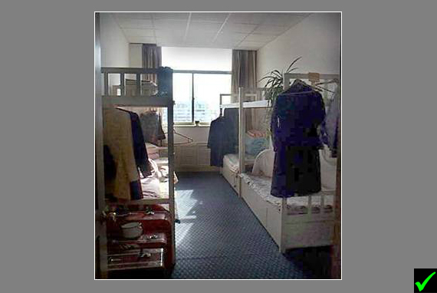
Checklist: General Fire Safety
General Fire Safety:
- All suppliers must meet the requirements set out in Tesco’s Fire Safety Standard. (link to be inserted)
- A sufficient number of regularly maintained fire extinguishers of the correct type are accessible and mounted at regular intervals throughout the site in line with local law.
- Extinguishers are clearly labelled and checked annually, with a tag and/or label indicating when they have been checked.
- Working fire alarms are installed in adequate numbers onsite and are freely accessible.
- Fire alarms are tested and maintained in accordance with local law (and preferably at least once a week).
- Wiring, switch gears, fuses and other electrical installations are safe and checked regularly by a qualified, certified technician. These checks are documented and recorded by the senior manager responsible for health and safety.
- Electrical installations, processes, or sources of ignition (such as sparks from welding) are isoltaed from flammable materials such as wood and fabric.
- On arrival, site visitors receive instruction on what to do if there is a fire, or evacuation is required.
- The number of people in any building at one time does not exceed safe limits, as defined by local law.
Checklist: General Fire Safety TETG
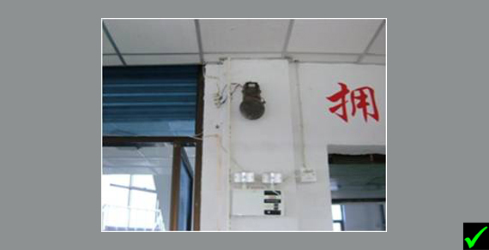
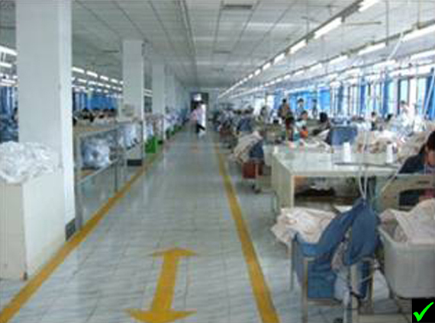
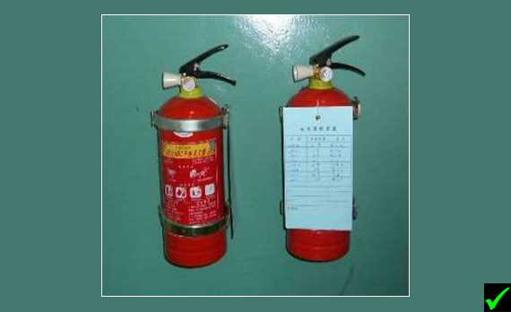
Checklist: Evacuation Planning & Fire Exits
Evacuation Planning & Fire Exits:
- The ability to evacuate according to an evacuation plan is practiced through monthly fire drills to ensure that workers are fully aware of what they need to do to in the event of a fire.
- The senior manager responsible for health and safety ensures records are maintained for all fire evacuation drills, including the names of all participants, and the time taken to evacuate all buildings.
- The time taken for evacuation is monitored. If it is ever considered too long, the evacuation plan is revised.
- Evacuation plans are posted in public places on site with evacuation paths, emergency exits, fire extinguishers and alarm activation points clearly identified.
- Fire safety wardens/marshals are nominated throughout the site, and are trained to ensure all people on site exit the building swiftly and safely in the event of an emergency.
- Fire exits are:
- Fitted with emergency lighting that is checked on a regular basis.
- clearly labelled as fire exits.
- wide enough for safe evacuation.
- kept clear at all times and unlocked whenever workers are in the facility.
- Emergency exit routes are clearly marked (e.g. by yellow lines on the floor), and are wide enough to allow for a safe evacuation.
- There are at least 2 exits per work area, and more for larger spaces if necessary.
- Smoke detectors, fire doors and sprinkler systems should be in place as well as appropriate emergency lighting.
Checklist: Evacuation Planning & Fire Exits TETG
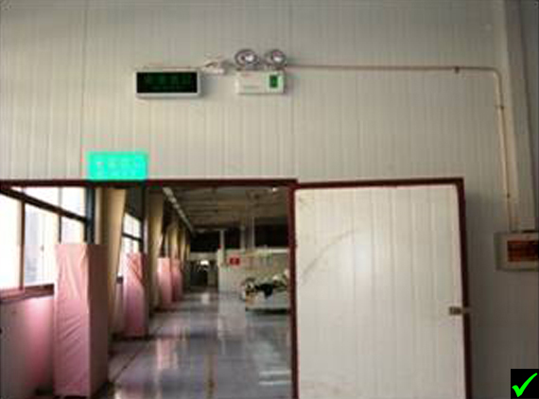
Checklist: Equipment
Equipment:
- There is a training policy in place that covers the use of dangerous equipment in line with local law, and developed in consultation with the health and safety committee. The senior manager with responsibility for health and safety leads regular reviews of the training policy.
- All workers are trained in the use of relevant equipment by a qualified instructor.
- All equipment and associated wiring is checked regularly, by a qualified engineer, to make sure it is in good working order, and the dates and results of these checks are recorded.
- Where specialist maintenance is required, a qualified technician is engaged to service equipment and maintain records of equipment maintenance, including inspection dates and maintenance conducted.
- Workers are trained and instructed to use equipment only for the purpose for which it was intended.
- Training records for relevant training are kept in employee files.
- Machinery is fitted with emergency shutdown switches or safety cut-outs.
- Equipment with moving parts has the appropriate guarding to ensure that nothing gets caught in the moving parts.
- Hazardous machinery is designed such that 2 handed operation is required (i.e. the machine will not function unless both of the operators hands are on the controls).
- "Magic eyes" or other sensors are fitted, which prevent the machine from operating if something (e.g. a part of the operator’s body) intrudes into the hazard area.
- All electrical equipment has safe wiring and is grounded.
- Very hot equipment is marked with a clear, visible sign and is surrounded by a gate, where necessary.
- Covers, or muffling devices, are put on very noisy equipment to dampen the sound.
- Equipment is set up in a way that allows workers to use it in a safe and appropriate manner.
- Hazardous equipment is fitted with a machine guards to prevent access to moving parts.
Checklist: Equipment TETG
Checklist: Personal Protective Equipment
Personal Protective Equipment (PPE):
- The senior manager with responsibility for health and safety must make a thorough assessment of the potential health and safety risks to staff at each site.
- Steps have been taken to eliminate or minimise the identified risks through staff training, good design and safe operating procedures.
- Where potential risks remain, suitable PPE is provided to protect staff, based on the assessment of residual risk and all relevant local and national laws.
- Workers are trained by qualified instructors on how to perform their work while wearing PPE, what PPE is appropriate for the type of work they are performing, when PPE needs replacing, and why it is important to wear PPE while conducting their work.
- Training logs are maintained and include the name of attendees, their signatures, and the type of training received and details of refresher training where appropriate.
- PPE is provided free of charge to all workers, and a safe storage place for this is available onsite.
- A register of the type of PPE issued to each worker is maintained.
- Signs are posted in areas where PPE is required and indicate the type of PPE required.
Checklist: Personal Protective Equipment TETG
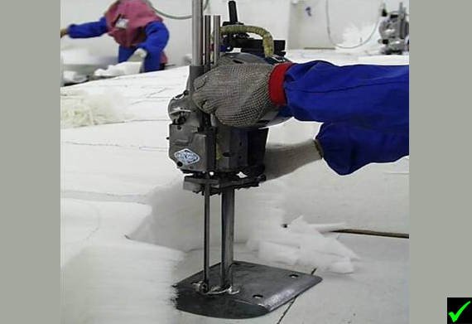
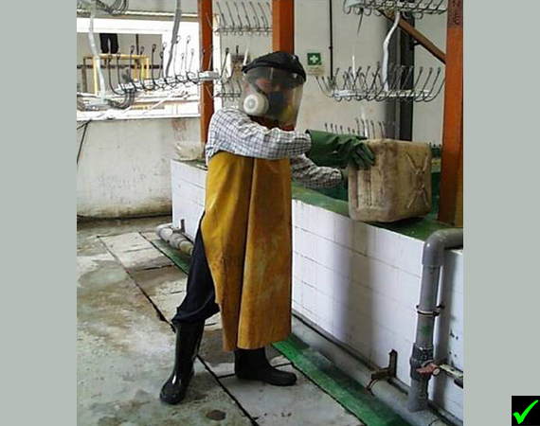
Checklist: Chemicals/Hazardous Substances
Chemicals/Hazardous Substances:
- The Senior Manager in charge of health and safety ensure procedures are developed for the safe use of chemicals and hazardous substances at each site. These must be relevant to the substances used at each site.
- Plans must exist to manage spills and discharges, including gases and liquids. These must cover the evacuation of employee’s, safe methods of containment and disposal for each type of substance likely to be used at that site.
- All workers who may come into contact, or need to handle, chemicals or hazardous substances must be trained by an instructor who is qualified in how to do so safely.
- Workers who come into contact with these substances must be given PPE, see the section on Equipment.
- All chemical and hazardous substance containers must be labelled according to local and international standards.
- Material safety data sheets (MSDS) must be available and must be used to develop safe operating procedures in all languages spoken at the work place, and kept where the chemicals are located. The senior manager with responsibility for health and safety must also keep a copy of MSDS sheets and ensure they are updated in a regular basis.
- Before purchasing chemicals/hazardous substances, checks must be made that MSDS provides clear information on their safe use, handling, storage and disposal. If not, appropriate NSDS must be sourced before chemicals are purchased.
- Risk assessment must be conducted of all operations involving the use of chemicals and hazardous substances, including decanting, pouring, mixing and dilution for further use. These must detail the areas in which such operations are permitted, the training required, PPE to be used and action taken in the event of an accident.
- Chemicals and hazardous substances must be stored in a clearly marked and secure area onsite that is separated in some way from general working areas, with access restricted for authorised personal.
- Hazardous chemicals are eliminated, where possible, and are replaced by safer alternatives where these exist.
- Hazardous waste is stored in a secure and protected area that is inspected weekly.
- Chemicals and hazardous substances must be stored securely and protected from contamination by other substances, such as rain that could combine with them to cause a hazardous and dangerous reaction.
- Chemicals and hazardous substances must be stored in secondary containers/bunds to provide additional protection if the primary container leaks or spills.
- Primary containers must be well sealed, in good condition and appropriate for the chemical they contain.
- Chemicals and hazardous substances containers are not re-used for any purpose.
- The senior manager responsible for health and safety maintains documents certifying that the chemicals and hazardous substances used at the work place are disposed of safely by legally authorised waste disposal companies, in an environmentally acceptable manner, in accordance with local law.
- Adequate ventilation must be provided in accordance with relevant national and local laws.
- Smoking must be prohibited in areas where flammable substances are present, with "No Smoking" signs clearly posted.
- Workers are not permitted to eat or drink in areas where chemicals or hazardous substances are used or stored.
- Eye wash stations must be provided in case of chemical spillages, with showers available where appropriate.
- Health checks must be provided free of charge for all workers exposed to hazardous chemicals, in accordance with local law and at least annually.
Checklist: First Aid & Health Care
First Aid & Health Care:
- A senior manager must be assigned responsibility for health and safety at each site.
- This manager updates, implements and monitors a first aid policy and procedures relevant for the site which meets all local and national laws.
- Each area of the site has a fully stocked first aid kit as defined by local or national law.
- First aid kits are clearly marked, unlocked and accessible to all workers with full instructions in all of the languages spoken at the work site.
- In large work areas, more than one first aid kit is available to ensure easy access.
- Each first aid kit contains a check list and is checked and replenished monthly.
- Nominated workers are trained by staff qualified in first aid, on how to use the contents of the first aid kit, and how to re-stock the kit. There is at least one qualified first aider for every 50 members of staff on each shift, who is easily identifiable by their uniform or other visual indicator.
- Expired first aid products are replaced immediately.
- Workers are trained on where they can locate first aid kits and first aiders.
- Workers know who to contact on and off site in the event of an illness or injury.
- The names, photos and work locations of all trained first aid staff are posted where all staff can see them at each site so they can be identified easily in cases of emergency.
Checklist: First Aid & Health Care TETG
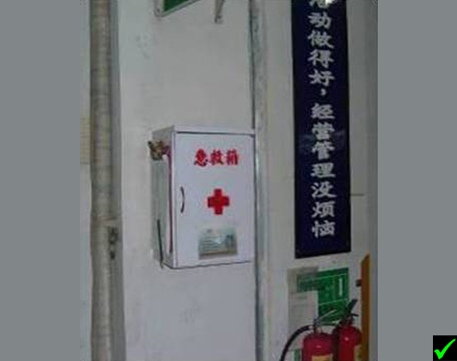
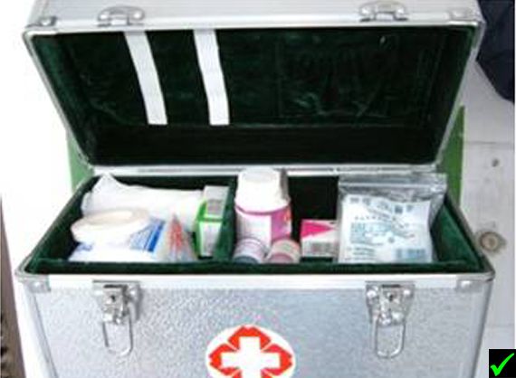
Case Study: Chemical Substances
The Issue:
A shoe company sourcing from China and Vietnam noticed during factory visits that there was a strong smell of solvents in all of the factories they visited.
The source was the glue being used to stick the sole to the shoe. The glue was stored in a pot by each worker and was pasted on to the shoe. Fumes were noxious and workers continued exposure was deemed a risk.

The Solution:
The company worked with a group of suppliers to develop a simple mould to place around glue sticks. It was designed to minimise vapour emissions from open pots whilst also making it easier to use the glue pots.
This solution was so effective that it was adopted by many other factories as it proved to be a simple, cost effective and efficient way to improve air quality onsite as well as reduce wastage through improving the design of the glue pots.
Lessons learnt:
Cost Effective: Following best practice on ethical trade does not always require significant upfront investment. Sometimes the best solutions are the most simple.
Collaboration:If you are willing to share your expertise with others, you may well be able to collectively solve issues more quickly and easily.

Child Labour
Child Labour: The Issues
The Issues:
ILO conventions define a child as any person less than 15 years of age (14 in Less Developed Countries). However, in some cases local law stipulates a higher age for work or mandatory schooling, in which case the higher age applies.
Tesco expects suppliers to follow the appropriate Tescp procedures, which include immediately removing the child from work and implementing a suitable plan to ensure that the child, either moves back into compulsory education or another suitable alternative.
Young workers are people above the legal age of a child but younger than 18 years old. Tesco expects suppliers to protect the rights of young workers by following all relevant laws in this area, including those on hours, hazardous work and medical benefits.
Suppliers must have a process in place for monitoring the age of their workers to ensure that child labour does not take place, and workers under 18 are assigned suitable tasks.
Child Labour: What is my Responsibility?
What is my Responsibility?
A senior manager at each site must be responsible for ensuring that processes are in place to prevent the recruitment of underage workers, and where they are found to ensure Tesco’s procedures on child labour are followed. They must also monitor the type of work engaged in by young workers.
The senior manager, who may also have the responsibility for recruitment, must ensure there is a process for checking workers' ages at the point of recruitment, making sure that the documentation is accurate and valid, and for making copies of, and keeping worker identification documentation in employee files.
For more information, please see the Tesco’s Policy and Procedures on child labour and young workers.

How to Avoid Labour:
- All staff involved in hiring workers clearly understand the legal minimum age.
- During recruitment, applicants are asked: their names, their date of birth, and confirm their age.
- Where recruitment agencies are used they operate robust processes for confirming and recording the age of potential recruits.
- Prior to commencing work all workers must provide valid photo identification, which are kept in employee files.
- In countries where valid photo identification is not available alternative evidence must be obtained.
- If accommodation is provided for workers and their families onsite, this is separate from areas where work takes place.
- Workers children must not be allowed to enter work areas at any time or be allowed to help their parents’ complete work, either on or off site.
- Young workers must not be hired for full time work before they have completed their compulsory education.
- Part-time work by young workers must not interfere with their compulsory education.
- Young workers must not be employed to perform any night work, heavy lifting or physically hazardous work.
Checklist: Remediation
Remediation:
- Suppliers must follow the steps outlined in Tesco’s policies on child labour and young worker (link to documents), which include;
  - Immediate action to ensure the child stops working and is kept safe
  - Ensuring the children's parents are notified
  - Ensuring Tesco is notified and informed of the name and age of the child and the circumstances of the discovery
  - A remediation plan is agreed with Tesco, to address the issue
- Robust remediation plans should include;
  - Steps to remove the child from work and transition them to formal education
  - An investigation into how the child was hired initially
  - Full payment of wages and benefits owed to the child
  - Agreement on the possibility of re-hire once the child has completed schooling and
has reached the age of work
  - The possibility of hiring a parent or family member of legal age to replace
the child
  - Identification of suitable accommodation if the child is living away from home or
does not have family
  - Identification of appropriate training or school programmes
  - Agreement on who will cover remediation costs and carry out on-going monitoring
Checklist: Young Workers
Young Workers:
- Suppliers must be aware of workers who are under the age of 18, and have systems in place for monitoring their hours and the type of work they are allowed to do in accordance with local and national laws.
- Suppliers must maintain clear and accurate records for all young workers in their employee files stating:
The worker's name
The worker's age and date of birth
The type of work assigned to the worker
The worker's contracted work hours
Confirmation that required permits have been obtained
Records of all medical examinations
- Suppliers must have a system in place for verifying all of the above information .
- Young workers must not perform overtime or nightshifts, and work must not interfere with hours dedicated to their compulsory education.
- Young workers must receive health checks from a registered doctor both at the time of recruitment and annually. The doctor must sign a certificate stating that the young worker is fit for the kind of work she or he is doing and a copy of which must be kept in the employee file.
- Suppliers must have conducted a risk assessment to determine what types of work are appropriate for young workers.
- Suppliers must document and recorded risk assessments and appropriate work tasks for young workers.
- Young workers must only assign work that they are physically and mentally capable of performing, in accordance with risk assessment results and the law.
- Young workers must not work with hazardous substances, heavy machinery or perform heavy lifting.
- Young workers are properly trained to perform their work safely.
Case Study: Child Labour
The Issue:
In October 2006 Channel 4 Television News in the UK reported allegations of the existence of child labour in the Bangladesh garments industry. An undercover team filming in factories recorded images of children alleged to be as young as 12 producing clothing for Tesco.

The Solution:
Tesco carried out its own investigation to verify the content of the film, visiting the factory and speaking to the workers. Although age verification in countries like Bangladesh can be difficult (not everyone has a birth certificate or passport), Tesco were able to satisfy themselves, through medical examinations and other testimony, that all of the workers they themselves interviewed were legally entitled to work.
Many of the young-looking workers were in fact married with children and above the industry imposed minimum age of 18 (the legal age for full time work is 14). There was, however, one boy shown in the news footage who they believed to be much younger, around 10 years old according to the news report.
This boy claimed to be visiting his cousins who worked in the factory in order to deliver their lunch. Regardless of whether this was true or not the factory should not have allowed him to be in the area of the factory in which he was shown in the footage. Tesco's response therefore, was to treat him as a child labourer in the factory, and implement a remediation plan to ensure his interests were best served.
Tesco's remediation plan required the factory to immediately remove him from the factory premises. The incident had happened several weeks before the programme was shown, and there was no evidence of the boy at the factory. The child's mother was contacted (in this case the boy's father had died), and the circumstances of his presence in the factory investigated. The boy did not have any proof of age documentation, and so the mother was interviewed and the boy was examined by a doctor. It was concluded that the boy was around 12 years old.
After talking to the mother and the child, it became apparent that the boy was the main carer in the family, looking after his brothers and sisters while his mother went out to work. Therefore, it was finally agreed that the boy's family would need a stipend (a sum of money given on a regular basis) to enable the mother to stay at home and look after the family so that the boy could attend school. On top of the stipend a sum was needed to cover schooling costs fees and books.
The factory agreed that to pay a monthly stipend and schooling costs for the boy up until his sixteenth birthday. Tesco then set up a monitoring programme and supplementary support through a locally based consultant. This consultant reports to Tesco on the boy's development every quarter, through visits to his school and home.
Lessons learnt:
- Production Areas: No one under the legal age of work should be allowed in production areas at any point.
- Recruitment Process: Make sure there is an effective process in place to accurately determine the ages of people applying for work so that you can avoid recruiting and hiring underage workers.
- Remediation Plan: When establishing a remediation plan for child labour, engage all of the people involved to ensure the reason the child labour exists is understood and addressed.

Wages
Wages: The Issues
The Issues:

A living wage is one that covers the basic needs of a worker and their family (before benefits, bonuses or overtime pay are taken into account), can be achieved within a standard working week, and provides some discretionary income of at least 10% of the basic wage.
Within this definition Tesco requires all suppliers to pay at least the legal minimum. Suppliers must also assess whether a gap exists between the legal minimum wage and the living wage and take steps to ensure that this gap is closed.
Workers must receive pay slips with their payment details in languages and terms they can understand. Deductions must only be made in accordance with local and national laws.
Wages: What is my Responsibility?
What is my Responsibility?
Suppliers must nominate a senior manager to lead on Policy and Procedures in relation to wages. They are responsible for maintaining a policy or procedure on wage payment that is compliant with local law and is developed in consultation with worker representatives (e.g. a trade union or worker welfare committee).
They are responsible for maintaining an accurate time keeping system, as well as ensuring that wages are paid in full.
A system must be in place for training all relevant staff on using time keeping and wage payment systems.
All time records and wage records must be maintained for at least a year.
Wages must be paid directly to workers, preferably into individual bank accounts, and not to other parties.
Checklist: Minimum Wage & Overtime Pay
Minimum Wage & Overtime:
- All workers should understand the local legal requirements on wages, and whether or not they are receiving these.
- Legislation on wages should be posted in common areas onsite where all workers can see them.
- Workers should not need to work overtime in order to earn a wage that meets their basic needs.
- Where possible, workers wages should be paid directly into their own bank account.
- All workers must receive a written pay slip, including payment of all benefits owed to them.
- All workers must be paid on time, including payment of benefits, according to local and national laws.
- Wage rates must be established with workers or worker representatives through collective bargaining.
- All worker pay records must be consistent and complete (see Recordkeeping and Wage Slips section for further detail).
- Each site must nominate a senior manager in charge of wage and hour policies and recordkeeping, who clearly understands and implements the law on wage payment and benefits.
- Suppliers must have a good understanding of their cost base, so that payment terms with business partners can be established, that cover costs, including correct payment of wages to workers.
- All workers must register when entering or exiting the work area (via a manual or electronic system), so that work hours can be accurately recorded and compensated.
- Piece rate wages must meet at least the legal minimum wage. Workers must be consulted in the process of setting piece rates to ensure that they are fair and achievable.
- Any overtime work must be paid at a premium rate, in accordance with local and national laws.
- Any downtime during piece rate work must be calculated, recorded and paid at the normal rate of work.
Benefits:
- The senior manager in charge of wage and hour policies and recordkeeping is responsible for the payment of benefits.
- Examples of benefits include:
  - paid holiday time
  - medical insurance
  - contributions towards a pension scheme
  - bonuses
- This manager clearly understands and implements all relevant laws on benefit payments.
- All workers are aware of all relevant laws on benefits, and whether or not they are receiving them.
- Any agreements with workers on benefit payments are paid on time, and in full in accordance with the terms of the worker's contract.
Payslips:
- All workers receive a payslip on which it is clearly stated:
  - the period of time for which they are being paid
  - the total number of hours for which they are being paid
  - pay before and after deductions
  - the date when they will receive their pay
  - benefits or bonuses paid
  - the number of hours worked
- Payslips must be written in a language that workers understand.
- Copies of the terms of payment for all workers must be updated as necessary.
Checklist: Recordkeeping & Wage Slips
Recordkeeping & Wage Slips:
- The senior manager with responsibility for wage payment must keep up to date with wage and hours legislation.
- Wage rates for all workers are clearly stated in their contract, a copy of which is kept onsite.
- Workers are responsible for maintaining their records of entry and exit from the workplace without interference from managers.
- Complete and accurate payroll records are kept on site for at least 12 months (or longer if required by local law).
- Each payroll record includes: the number of hours worked per day, the regular wage rate (or piece rate if applicable), any overtime hours and wage rates, total payments made, any deductions made or bonuses given.
- All workers sign the payroll to verify that payments made to them are correct.
- Piece rate records include: attended hours, downtime, actual hours worked, units produced, minute value per unit, pay rate per minute, payment for piece work earned, downtime payment, total payment.
- All pay records for agency and contract workers are maintained on site in the same way and with the same information as is kept for permanent workers in employee files.
- Only one set of payroll records is maintained and these are accurate and complete.
Checklist: Deductions
Deductions:
- Any deductions made from workers' pay must comply with local and national laws.
- Deductions must never be used to discipline workers.
- Deductions for late arrival at work strictly reflect the amount of time a worker is late and no more.
- Any other deductions agreed with a worker (i.e. repayment of a loan) must be agreed in writing and a record kept detailing these deductions and the reasons for them in each worker's personnel file.
- No deductions are allowed for the cost of uniforms.
- All workers must be paid in full whilst undergoing training.
- Workers wishing to leave employment receive full payment for work completed.
- No deductions are allowed for access to basic amenities such as drinking water or sanitation facilities.
- Deductions are not permitted from workers who need to leave a shift early due to illness (i.e. workers receive full payments for the hours that they are able to work, and sick-pay in accordance with local law).
- Deductions are not permitted for failing to meet daily work targets or quotas.

Working Hours
Working Hours: The Issues
The Issues:
Working hours must comply with all local and national laws or industry benchmarks,
whichever affords workers greater protection.
Regardless of these, workers must not be required to regularly work in excess of
48 hours per week, on average.
Workers must be free to choose to work overtime, and this should not exceed
12 hours per week on a regular basis.
Working Hours: What is my Responsibility?
What is my Responsibility?
A senior manager must be in charge of maintaining an accurate time keeping system.
This senior manager must develop, implement and monitor procedures on working hours and time keeping in consultation with worker representative to ensure compliance with relevant legislation.
The senior manager must ensure all relevant staff are trained on using time keeping and wage payment systems.
The senior manager must retain time records and wage records for at least a year for all staff.
Hours of work should be defined in written employment contracts, which should be kept in employee files for workers.
Working Hours: What is my Responsibility? TETG
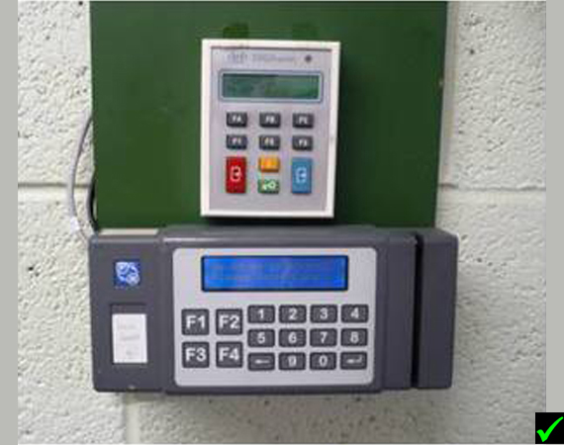
Checklist: Regular Working Hours
Planning:
- Suppliers must have an accurate understanding production capacity so they can ensure adequate production capacity is available to meet production order, within the law and hours permitted in the ETI Base Code.
- All managers with responsibility for negotiating with customers must have a full understanding of production capacity, and must be transparent with customers about their capacity and capability.
- Suppliers must account for peak and low seasons when calculating turn around times and work hours.
- Relevant staff (e.g. production planning department) must be trained in how to plan working hours in line with business demands.
- All workers must know and accept their contracted work hours at least a week in advance.
Hours:
- Workers are not expected to work more than 48 hours per week, on average.
- Workers are able to have at least one day of rest per week.
- Suppliers must meet all local and national laws regarding rest days.
- Workers must have adequate rest periods throughout the day in compliance with local law.
- Workers must be allowed free use of toilet facilities throughout the day, not just during break times.
- Workers must not be rewarded for failing to take a break or penalised for stopping.
Record Keeping:
- Suppliers must have a functioning system for recording work hours at each site, preferably an electronic system.
- Workers are responsible for maintaining their records of entry and exit from the workplace.
- Suppliers must maintain a complete and accurate set of time records for all workers onsite.
- Regular work hours must be agreed with all workers and clearly stated in their contract, a copy of which is kept in their personnel file.
Checklist: Rest Days & Holidays
Rest Days & Holidays:
- The senior manager in charge of wages and hours keeps up-to-date on all relevant legislation in this area.
- You have a policy for rest days and holidays that has been written in consultation with workers or worker representatives.
- You have a clear policy that reflects legal requirements on terms of leave.
- If the law does not specify rest days, workers must have at least one full day off (24 hours) in every seven days, or 2 full days in every fourteen days.
- If the law does not specify holidays, workers should have 3 weeks of paid leave a year (ILO standard).
- If the law does not specify maternity leave, female workers should have 14 weeks of paid maternity leave (ILO standard).
- Workers who work on rest days and holidays must be paid overtime rates according to the law or ETI Base Code (see Wages section), whichever is the greater.
- If workers have to work on a rest day or holiday, they must receive a day off in compensation.
- Sick leave or other types of special leave must not taken out of any paid annual leave entitlements that workers may have.
- Workers must be allowed adequate time off when sick.

Checklist: Overtime & Wages
Overtime & Wages:
- All workers are able to earn a wage that covers their basic needs without working overtime.
- All workers are able to freely choose if they want to work overtime or not.
- You have a policy on overtime hours and wage payment for overtime hours that meets the requirement of local law.
- The senior manager in charge of implementing this policy can demonstrate that all overtime hours are offered fairly and on a voluntary basis.
- In accordance with the ETI Base Code workers do not work more than 12 hours of overtime per week on a regular basis,
- Overtime hours are paid for at a premium rate in line with local laws or the ETI Base Code as a minimum.
- If you employ contract workers, you have an agreement in place that enables you to have oversight of the total number of hours worked per day by each person employed at your site. This agreement should include a commitment from the recruitment agency that they will not allow any of their staff to work excessive hours across a range of different clients.
Case Study: Excessive Overtime
The Issue:
A Turkish supplier to Tesco was facing a problem with overtime hours. When it tried to reduce hours to address audit report findings, the work place union and workers protested as overtime hours were seen as a major source of income for the workers. The facility tried to engage with workers to reduce overtime hours, but they threatened to strike. However, there was also pressure from impending labour laws that required a reduction in work hours. The facility had to reconcile these seemingly opposing positions.
The Solution:
The facility introduced a shift system that was designed to start to gradually reduce working hours over time rather than a sudden cut in workers hours and income.
The unions and management agreed that this approach was fair and communicated the plan to Tesco.
Lessons learnt:
Staged approach to compliance: Whilst immediate compliance may not be possible, a staged reduction in hours may be a more realistic to negotiate..
Collaborate: Some issues are very difficult to solve, but often working with others will help ensure that you can agree a workable solution.
There's always a solution: At first, this overtime problem seemed nearly impossible to overcome, but through working with other interested parties and persevering, this factory fixed the problem.

Discrimination
Discrimination: The Issues
The Issues:
Tesco suppliers will not engage in, support or tolerate discrimination in employment including recruitment, hiring, training, working conditions, job assignments, pay, benefits, promotions, discipline, termination or retirement on the basis of gender, age, religion, marital status, race, caste, social background, diseases, disability, pregnancy, ethnic and national origin, nationality, membership of worker organizations including unions, political affiliation, sexual orientation. This is not an exhaustive list.

Discrimination: What is my Responsibility?
What is my Responsibility?
Because discrimination is a complex issue, it is important that you have a nominated senior manager who is responsible for keeping up to date with legislative requirements.
This senior manager should work with worker committees or worker representatives to develop and implement an anti-discrimination policy or procedure in accordance with local law.
All management and human resources staff should be trained in how to identify and prevent discriminatory behaviour.
You must ensure that all managers and supervisors at each site promote a tolerant and open environment where it is absolutely clear that discrimination is not tolerated regardless of seniority.
Checklist: How to Avoid Discrimination?
How to Avoid Discrimination
- You have clear understanding of the full definition of discrimination (as above)
- You have an equal opportunities policy and ensure that this is communicated to all staff in all relevant languages.
- You have disciplinary and appeals procedures that detail the action to be taken if anybody is found to be acting in a discriminatory way. These procedures are communicated to all workers in all relevant languages.
- You ensure that no discrimination of any kind is practiced in regards to: hiring, salary, benefits, training opportunities, work assignments, advancement, discipline and termination.
- Workers are only assessed on their skills, experience and performance.
- Migrant workers must not be treated differently to local workers.
- There should be equal opportunities for men and women in relation to management positions.
- Men and women carrying out work of the same value are paid the same and are subject to the same terms and conditions of work.
- Employment decisions are not based on pregnancy testing, HIV/AIDS testing, or tests for any other medical condition that cannot be easily passed to other workers or pose a risk to workers.
- Workers and potential workers are not required to provide information not relevant to their ability to perform their work, such as whether or not they have children or dependents.
Checklist: Policies and Procedures
Policies and Procedures:
- You have an equal opportunities policy and procedure developed in consultation with unions or worker representatives, local government, or NGOs.
- This policy is communicated to all workers in a language that they understand, preferably through inclusion in a worker handbook and is permanently posted in a public place onsite where all workers can see it.
- You require all subcontractors, recruitment and employment agencies to have a policy or procedure in place to maintain the same standards on discrimination and equal opportunities.
- You have effective grievance procedures in place that all workers feel free to use without fear of recrimination to resolve discrimination-related concerns.
- Where disciplinary measures against a worker are necessary, the reasons are clearly documented, recorded in their personnel file and acknowledged with the workers signature.
- Work schedules, including holidays, and any policies on work clothing allow for the religious or cultural make-up of the work force.

Regular Employment
Regular Employment: The Issues
The Issues:
Where reasonably practicable, workers should be directly employed by the company on a permanent contract.
Suppliers shall not make on-going use of schemes designed to avoid more permanent employment and therefore deny benefits to workers due as a result of labour or social security laws and regulations. This includes the abuse of apprenticeship schemes and long-term employment of workers under agency contracts.
All workers should receive a written contract or terms of employment.
You must obtain permission from Tesco before using any sub-contract manufacturer or home workers.
Regular Employment: What is my Responsibility?
What is my Responsibility?
A senior manager should be assigned responsibility for employment processes and practices which ensure that contract workers are not being employed in preference to permanent workers as a means of avoiding legal obligations.

Checklist: Employment Contracts
Employment Contracts:
- You have a full understanding of all legal requirements in relation to employment contracts.
- All employment contracts are in writing and signed by the worker and management.
- All employment contracts are in a language understood by the worker.
- All employment contracts should contain:
- Employee and employer contact details, including name, address, phone
number, and an emergency contact.
- Conditions of employment as defined by national law, such as wages, hours
of work, any benefits provided, disciplinary procedures, grievance
procedures, grounds for termination, and fair notice periods.
- There are no clauses in employment contracts requiring a deposit from a worker to secure employment or payments to terminate their contract with you.
- You have a copy of the employment contract for all employees, including migrant and contract workers. Any recruitment agencies also retain copies of employment contracts for all of their employees.
- All trainee workers have a written employment contract that reflects legal requirements for terms of employment for trainees or apprentices.
Checklist: Agency Labour
Agency Labour:
- Where at all possible, you recruit workers directly rather than use third party recruitment agencies.
- Where recruitment agencies are used, you have a process in place to ensure that they:
- Are a legitimate agency that is registered where necessary with all relevant government bodies.
- Pay all workers used at your site in accordance with the law and at the same
rate for an equivalent job.
- Pay all workers in full and on time as agreed in a contract with all workers.
- Do not withhold wages for any reason.
- Do not force employees to work excessive hours and shifts concurrently across a number of different clients.
- Do not retain travel or identification papers to prevent workers from leaving.
- Do not deduct any recruitment costs from pay.
- Can provide you with employment contracts, time cards and pay slips for all
workers used at your site for your own records.
- When audited, you tell auditors if you use agency labour, including the name of the agency used, the number of workers employed, and the names of the contract workers.
- You keep a copy of all contracts that you sign with recruitment or employment agencies of any kind.
- You keep a copy of all contract workers' employment contracts, time cards and pay slips onsite.
Checklist: Home-working & Subcontracting
Home-working & Subcontracting:
- You obtain written permission from Tesco before subcontracting any part of the production process to any other site or to homeworkers.
- Where permission from Tesco exists;
  - you keep written contracts outlining the business relationship with all home-working or subcontracting entities. This must be available for inspection onsite
  - You ensure that all home-working entities or subcontractors uphold the same ethical standards that Tesco expects of you
- You ask them to complete a SEDEX self-assessment questionnaire (SAQ) and/or undergo a social audit where appropriate.
- You have an agreement in place with all home-working entities or subcontractors requiring them to make available copies of their employment registers, payrolls, employee files, and business licenses (if applicable), so you can monitor that they are upholding ethical standards.
Case Study
The Issue:
A salmon supplier based in the Scotland, has been supplying salmon products to Tesco for over five years.

What happened?
During the peak seasons, particularly around Christmas, the company needs to supplement their permanent workforce of 450 people with anywhere between 100 and 300 temporary staff.
The company used to use a labour agency to provide this temporary staff, with the agency providing a manager on-site to oversee that workforce. Whilst this enabled the supplier to respond to short-term labour needs, they found that using agency labour created its own problems:
- The labour agency could not guarantee the supplier the same workforce on a regular basis, which meant training temporary staff was an on-going challenge.
- Whilst the temporary staff were functionally managed by supervisors working for the supplier, the on-site agency manager dealt with discipline and performance issues. This agency manager did not follow the supplier’s central processes or standards.
- Agency staff, perhaps understandably, card less about the product or the company and there were issues in relation to poor product quality.
- Finally, the supplier relied solely on the agency to fill temporary vacancies, they didn't have the opportunity to assess workers before they offered them work. Sometimes they found they had to fill temporary posts with workers who did not have the right skills.
The Solution:
What was their response?
Two years ago the supplier decided to start recruiting temporary workers directly rather than rely on agencies. They did this through open days at job centres and, more informally, through word of mouth using staff and contacts.
Initially they anticipated they'd only need around 100 temporary staff for the first season that they switched to direct recruitment. In the end they needed 200 temporary staff but found that they were still able to find enough people using their own networks.

What was the outcome?
The supplier is very happy with the results and now plan to only recruit temporary staff directly. The business has benefited in the following ways:
- Temporary workers now work alongside permanent workers, both reporting to the same line leaders and managers on all issues.
- The supplier is able to build direct relationships with temporary workers. Good workers are invited back for the next season, and arrive needing little training.
- With the opportunity of future employment (for the next season or full time posts), temporary staff see the benefit of doing a good job and the business has seen standards of work improve.
- Now the company is able to assess workers before they start and so allocate them to the appropriate job.
- Recruitment costs have fallen considerably.
This year the supplier recruited over 350 staff during the peak Christmas period, 40% who had worked the previous Christmas.

Dignity and Respect
Dignity and Respect: The Issues
The Issues:
Workers must always be treated with respect. Employers need to ensure that they lead by example and promote a culture where people treat each other decently. If this culture breaks down, then the likelihood of intimidation, bullying and other bad behaviours increases. These problems are more likely to occur, either between different groups of workers, or between supervisors and workers, when the ground-rules are unclear and where people are under pressure. There is a particularly high risk when there is a multi-cultural workforce and communication in the workplace is therefore more difficult.

Dignity and Respect: What is my Responsibility?
What is my Responsibility?
A senior manager in charge of human resources should be responsible for ensuring that all staff treat each other with dignity and respect, and that no harsh treatment takes place.
This senior manager is responsible for ensuring that dignity and respect are embedded in relevant policies and procedures, that management and staff support an environment and culture where people treat each other decently and the consequences of breaches are clear. This includes implementing a fair grievance process.

Checklist: Policies and Procedures
Best Practice Checklist:
- You have a system in place to ensure that nobody is subject to abuse of any kind including physical, racial, cultural, verbal, sexual, psychological, or otherwise.
- Fines are not used as a disciplinary measure.
- A fair system which respects confidentiality is in place to allow staff to air grievances
- All workers have access to basic services at all times, such as toilets and wash areas, drinking water, chairs, legally mandated periods of daily and weekly rest.
- You have a documented policy in place for the use of security searches and will only use body searches if absolutely necessary.
- Body searches, if necessary, will only be conducted by security staff of the same sex as the worker.
- You have periodic training for all staff that covers the issue of treating co-workers with dignity and respect.
Checklist: Grievance & Disciplinary Procedures
Grievance & Disciplinary Procedures:
- A senior manager is responsible for human resources, including oversight of dealing with management and worker relations.
- All work place rules are fair and comply with local law.
- All workers receive a handbook containing all work place rules in a language they can understand.
- Work place rules are posted onsite in a place where all workers can see them.
- The consequences of breaking a workplace rule are clearly communicated to all workers in a language they can understand.
- You do not put any worker in a position where they may be forced to break a work place rule.
- Each site has an appropriate policy or procedure on disciplinary and grievance procedures in place.
- A grievance process is set up to allow workers to easily and confidentially report issues.
- When required, the grievance procedure is conducted by a senior manager, in a timely manner and includes: a mechanism to protect workers who report issues from reprisal, a fair and documented review of the grievance, the worker has the right to bring a representative of their choice to the review, and formal notification to both management and the relevant worker(s) of the results of the review.
- The disciplinary procedure includes proportional response based on the severity of the issue and any previous disciplinary action. Which may include the following stages:
(1) a verbal warning; (2) a written warning; (3) suspension; (4) termination.
Depending on the severity of the issue disciplinary procedures may start at stage two, three or four.
- All grievances and disciplinary procedures are clearly and thoroughly documented.

Vulnerable Workers
Vulnerable Workers
Vulnerable Workers – The issues:

Vulnerable workers are groups of workers who due to their age or circumstances are more at risk to having their workplace entitlements denied. These include; migrant workers, agency, temporary or seasonal workers, young workers (under the age of 18) and homeworkers.

Vulnerable workers can be subject to low pay, poor conditions and discrimination, because they may be unfamiliar with local customs and practices, or lack social or family support.

What is my responsibility?

A senior manager in charge of human resources should be responsible for ensuring the welfare of all workers including vulnerable workers, who may need additional support..
This senior manager is responsible for ensuring that relevant policies and procedures are developed and implemented to ensure that vulnerable workers are supported appropriately. In addition all workers are paid according to all local laws or industry benchmarks and are paid on time and in full in accordance with the terms of their contract and local law.
Guidelines: Managing the Welfare of Migrant Workers
Managing the Welfare of Migrant Workers:
A migrant person is, whether in a different city, region or country. Migrant workers may have arrived in your area to seek work, or they may have signed up to work at your site before leaving home.
The guidelines cover all migrant workers who work on your site, whether they are:

- directly or indirectly recruited.
- directly or indirectly employed.
- on permanent or temporary contracts.

Checklist: Managing the welfare of Migrant workers
Migrant Workers:
- Migrant workers have a realistic understanding of what the job involves, working hours, pay, living conditions and local living costs to enable them to make an informed decision on whether to take the job.
- Potential workers are interviewed to enable you to decide whether a worker has the skills for the job.
- Workers are provided with copies of clear, understandable contracts in a language that they understand.
- All workers are old enough to work on your site and have the right to work in the country where your site is located and you have verified this is the case.
- Training on site policies is provided for all workers.
- Workers are able to communicate effectively with management and co-workers.
- Workers are comfortable, safe and secure in the accommodation you provide.
- Workers are able safely to come and go as they please after working hours.
- Workers have access to entertainment facilities and fixed line or mobile phones outside working hours.
- When workers complete their employment term they receive all pay and benefits entitled to them.

For further information please see the Migrant Worker Guidelines.
Case Study
The Issue:
Like many of the UK growing sites and pack-houses, a significant part of the workforce at this company was made up of migrant workers who were able to fill the seasonal posts required during harvesting.
The industry has sometimes had difficulty in attracting workers from home or abroad. The high percentage of staff turnover affected productivity and required the supplier to spend a lot of time and money training people who might not return next season.

The Solution:
What was their response?
The company decided to do something about this to try and improve the return rate of their workers from 40% to around 50%.
Firstly, they looked at recruitment. They had a licence to recruit migrant workers directly from Eastern Europe under the UK Seasonal Agricultural Workers Scheme ("SAWS"). They made sure that during recruitment they managed the expectations of potential workers so that they fully understood the conditions in which they would be working through providing information in the workers' own language.
Once recruited, the supplier introduced a range of measures to support their staff during their time in the UK, during and after work, these include:
- Recruiting managers who can communicate effectively with workers of each nationality in their own language.
- Building a hostel for workers to live in, rather than expecting them to find their own accommodation or live in caravans or inferior accommodation.
- Setting up individual bank accounts for workers.
- A social club with leisure, educational and entertainment facilities.
- Facilitating the return travel arrangements of the workers.
- Giving workers the opportunity to return to the same employment the following year, before they depart at the end of each season.
- Wage levels were also set above the legal minimum.

What was the outcome?
In the first year the percentage of workers who returned increased to 60%. This resulted in a saving of £100,000 in one year on one single crop alone. Savings came through reduced training costs (fewer new starters meant refresher training rather than full training was sufficient), reduced recruitment costs, and higher productivity as returning workers are already skilled and therefore able to work faster than new recruits.

How to resolve a non-compliance
Problem Solving: Root Causes
Solving complex problems: some helpful hints
Find the root cause:
The solutions to many of the non-compliances raised in audits are immediately obvious, however some problems are more complex and require a more detailed understanding. In such cases it is tempting to think that fixing the symptom (the issue as it first appears) will solve the problem, but if the underlying cause is not understood and addressed the problem will re-emerge sooner or later. There are a number of techniques for identifying the “root cause” (the real reason for the problem), such as brainstorming, pareto (“fish-bone”) analysis, or simply asking the question “why” until you reach the source of the problem.

Analysing potential root cause is often best done by involving different people with different perspectives on the particular issue e.g. workers, supervisors and department experts , as each may identify different clues that help solve the problem.

How to understand the root cause-the 'Five Whys':
One very simple and powerful tool for understanding root causes is the 'Five Whys'. The number 5 should not be taken literally; the purpose is to keep asking why until you are confident that the real underlying reason has been identified, which may only require asking “why does this happen” a couple of times, or in some cases maybe more than 5 times. Each time you ask why, analyse the answers you receive and consider if this could be the real root cause. What you find may be surprising! Here is an example:

The fire exits are locked – why?
- Nobody checked they were unlocked
Why did nobody check?
- Nobody has been made responsible for checking. Action: make somebody responsible for checking every day
The person responsible for checking the doors are open finds that the doors are locked again during the day – why? Action: find out who locked the door and their reason for doing so
- The supervisor locks the door – why? Answer: they are concerned that people will enter the building and steal things.

Problem resolution: fit a push bar opening device to the inside of the door so that it cannot be opened from the outside but opened from the inside at any time and doesn’t need to be locked. Train all staff in the importance of keeping the door closed and only using it in an emergency or fire drill practices.

There are examples below to illustrate this:

Different root causes-different solutions:
Root causes may fall into different types and suppliers may need outside help to solve them:
Investment - the root cause may be a lack of capital for investment - or the need to keep operating costs down, perhaps to meet an agreed price. If this is the case, we encourage suppliers to discuss this with their contacts in Tesco to explore solutions.
Capability and skills - the root cause may be lack of investment in training or poor recruitment practices
Conflicting objectives - the root cause may be a conflict between different requirements, for example the need to meet a short lead time conflicts with requirements on working hours. There may be solutions in making changes to practices - hiring more temporary workers for example - but it may also be that the conflict needs to be discussed with contacts in Tesco to see if one or other of the requirements can be changed.
In all cases, suppliers need to keep Tesco informed of their plans, progress made in achieving these plans, and any significant barriers to progress - particularly of the types listed above.

Five Whys ? examples
Example:Workers report being bullied or harassed
 | Problem | Possible solutions
 | Workers report being bullied or harassed | Investigate this more fully
why? | The workers are not performing their task correctly | Provide more training
why? | The worker doesn't speak the same language as the supervisor and so doesn't understand what they are required to do | Provide training to workers in their own language
why? | There are no managers or supervisors that speak the workers language | Hire supervisors from the same community as workers who speak both their language and yours
why? | Workers from other communities are not given the opportunity to become supervisors or managers | Change recruitment and promotion policy
why? | Managers are not aware of equal opportunities policies | Develop policies and provide training to all managers

Example:Workers are not being paid the minimum wage
 | Problem | Possible solutions
 | Workers are not being paid the minimum wage | Investigate this more fully
why? | Workers are on piece rates and while their weekly wage meets the legal minimum their hourly rate does not | Increase piece rate payments
why? | It is taking a long time to produce each item -longer than planned | Check workers skills are up to the job and provide training if needed
why? | There are lots of short production runs, meaning that the lines need to be set up repeatedly which takes time from production | Look at arrangements for change-overs on the production lines; can it be done more quickly?
why? | There are lots of small orders from clients but few larger contracts | Offer clients good rates to secure some long-term baseline orders - discuss with Tesco buyer

Example:There are repeated problems with unsafe machines
 | Problem | Possible solutions
 | There are repeated problems with unsafe machines | Investigate this more fully
why? | Machines are being used without guards in place to protect workers' hands | Reinstall guards
why? | The guards are fitted when the machines first come into use, but workers remove them | Explain Health and Safety policies to workers
why? | Workers report that the guards get in the way and make production too slow | Change the design of the guards to keep workers safe but allow faster production
why? | Workers are under pressure to meet production targets for each shift | Look again at shift production targets
why? | There is a very short lead time on this production run | Talk with Tesco contact about a possible change to ship date
why? | Product samples were approved late but the shipping date has not changed | Review systems to make sure that sampling occurs on time

Example:Trades unions and other forms of association are not recognised in this workplace
 | Problem | Possible solutions
 | Trade unions and other forms of association are not recognised in this workplace | Investigate this more fully
why? | The supplier management thinks it is better to allow workers to raise problems individually rather than collectively | Allow workers to express their honest opinion, would they like a more formal mechanism for approaching management
why? | They fear that a collective approach would lead to trouble and would damage the plantation's future | Develop a parallel method of collective worker representation
why? | There is a history of bad relationships between unions and management in this country and sector | Facilitate some introductory meetings with union representatives to understand their concerns
why? | The Government has had an anti-union stance from many years, and unions have taken a very oppositional role. | Look for a collective approach with other plantation. Meet with Government to explore the problem and possible solutions
External Resources
EICC (Electronic Industry Citizenship Coalition):
An industry-specific initiative for the electronics industry. It has an auditing protocol and risk assessment tool for the industry: http://www.eicc.info/
ETHICAL TRADING INITIATIVE (ETI):
An alliance of companies, trade unions and voluntary organisations who work in partnership to improve the lives of workers across the globe. The ETI has developed a Base Code of best practice in ethical trade and practical guidance on how this Base Code should be implemented. It is widely used and referenced by companies based in the UK and abroad: http://www.ethicaltrade.org/
PRACTICAL GUIDANCE ON IMPLEMENTING THE ETI BASE CODE:
http://www.ethicaltrade.org/resources/key-eti-resources/principles-implementation
ETI AWARENESS RAISING TOOLS:
A list of ETI tools for suppliers: http://www.ethicaltrade.org/resources/key-eti-resources

Right to Work Guidance

Government Right to Work Guidance
LOCAL RESOURCES NETWORK:
A list of organisations who may be able to provide you with support in your country: http://www.localresourcesnetwork.net/
GSCP RESOURCES:
The Global Social Compliance Programme is a business-driven programme for companies whose vision is to harmonise existing efforts and deliver a common, consistent and global approach for the continuous improvement of working and environmental conditions in global supply chains. The GSCP has produced and published a series of reference tools which define best practice and will be used to benchmark audit standards to reduce duplication in auditing and allow focus on capacity building.
These can be downloaded free of charge from their website:
http://www.mygscp.com/
Additional information resources can be found at:
http://www.mygscp.com/information-resources/gscp-information-kit.html

BETTER WORK:
A joint initiative of the ILO and International Finance Corporation (IFC) developing practical tools to help companies to improve their compliance with labour standards and increase their competitiveness: http://www.betterwork.org

SEDEX:
A membership organisation for businesses committed to continuous improvement of the ethical performance of their supply chains. It houses ethical data collected through self assessment and audit for supplier sites. SEDEX provides a list of other membership bodies on their website at: http://www.sedexglobal.com

INTERNATIONAL TRADE UNION CONFEDERATION (ITUC):
An international trade union that collects information related to trade union activity in countries all over the world so is a robust source of information on the freedom of association and collective bargaining clause of the ETI and GSCP codes. It has affiliates across the world:http://http://www.ituc-csi.org/

Tesco expect their suppliers to meet or exceed the requirements of the ETI Base Code, or National Law, whichever offers the greater protection.
Click here to Download PDF version.

