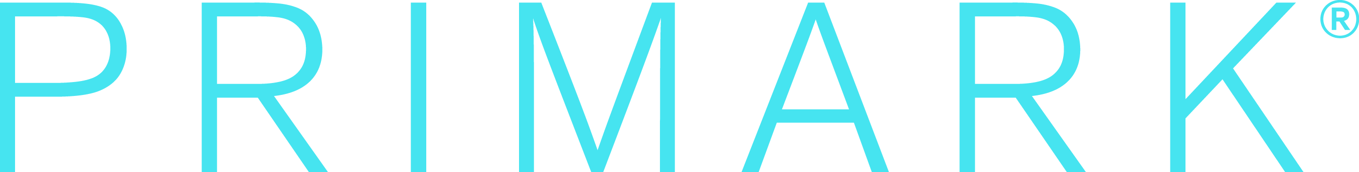

Primark cares about the wellbeing of our employees, those working in our supply chain and our customers. We want everyone who works at Primark to enjoy their job, be treated fairly and for Primark to be an employer of choice in France. In our supply chain we have been working hard for many years to ensure our products are made with respect for workers’ rights and the environment.

Primark cares about the people who work for us; and recognises their contribution to the success of the Primark brand. We can confirm that all Primark’s policies, practices and procedures, including recruitment, contracts and remuneration comply with French legislation. We expect a lot from our people and in return we offer many opportunities for professional and personal growth, to date 63% of Supervisors and Managers in France have been promoted internally.

We take the needs of our employees seriously which is why our ‘People & Culture’ teams are always there to address any questions they may have and ensure our employees have all the appropriate training for their roles. Should issues arise in any area of our business we will always fully investigate the issue and take the relevant measures to rectify it.

As a young company in France, we recognize our responsibility to our people and put great effort in constantly improving our ways of working, and do our utmost to offer our people a supportive and positive work environment every day.

