**\*\*\* Seeking your help with a social media push to support landmark climate change victory\*\*\***   
Dear friends  
   
You may have heard about an incredible victory recently in the fight against climate change. In June the Urgenda Foundation and 900 citizens took the government of the Netherlands to court for failing to protect its citizens against the dangers of climate change – and they won. It was one of those rare moments when people - not only in the Netherlands but around the world – felt genuinely hopeful, that governments could be forced to take serious action on climate.   
   
The government now has until September 24th – three months after the verdict – to file an appeal, and we need to prevent them from doing that. We've heard rumours that ministers are being consulted this week, in advance of a parliamentary debate later in the summer. I'm hoping you can help – I promise it won't take more than a few minutes of your time.  
  
Right after the verdict, a citizens movement spontaneously emerged, communicating on social media under the hashtag #ganietinberoep (Dutch for: don’t appeal). We are therefore working to get as many people as possible from around the world to send messages, photos and video’s calling on the government not to appeal, using the #ganietinberoep hashtag.  
   
Ideally, the social media storm should reach full force starting on 10 August. I'm therefore hoping you can send something out on your social media channels ASAP.   
  
Here are some sample posts - for all of these, it would be fantastic if you could attach a photo of yourself holding a sign with #ganietinberoep, or even better, attach a little video as explained below.):  
   
**On Facebook**:  
·         The court’s verdict is in: the Dutch government must do more to avert the imminent danger caused by climate change. Please don't appeal the verdict, it's time to act! #ganietinberoep #klimaatzaak  
   
**On Twitter**:  
·         Mark Rutte @MinPres and @diederiksamsom - please accept the climate verdict - #ganietinberoep! #klimaatzaak  
  
·         A chance for Dutch leadership in tackling climate change - @MinPres Mark Rutte and @diederiksamsom #ganietinberoep #klimaatzaak  
  
·         Dear @MinPres #ganietinberoep, please don’t appeal in the climate case #klimaatzaak!  
  
And of course on any other social media channels as well.  
   
**Video instructions**: Make a very short video/clip/movie with your mobile phone, in which you call on the government not to appeal. You could say something like “I am [name] from [home city or country] followed by "Ga niet in beroep” (the Dutch like strange accents, your Dutch does not have to be perfect! if it is really impossible, simply say “do not appeal”, but the Dutch version is more fun). Attached is a sample video, sample photo and a recording of the Dutch words pronounced very slowly.  
   
  
  
**Background:**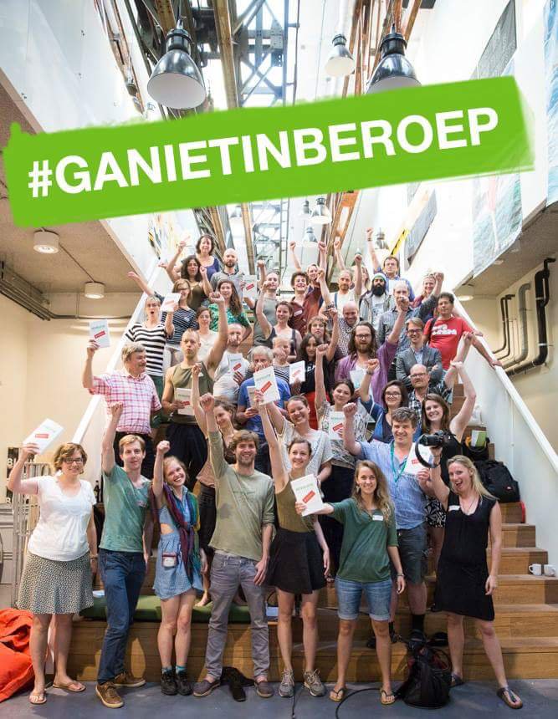   
On 24 June 2015, a court ruled that the Dutch government has put its citizens in danger by failing to address greenhouse gas emissions. In a landmark verdict, the judge said the government “must do more to avert the imminent danger caused by climate change” and ordered it to reduce CO2 emissions by 25 per cent by 2020 compared to 1990 levels. This is the first time that a state has been held responsible for climate change action under human rights law. The case, brought by 900 citizens with Dutch NGO Urgenda, was supported by the recently agreed Oslo Principles, which hold governments responsible for their country’s carbon emissions. It may be the first case of its kind, but it will not be the last - already Belgium has launched a similar case against its government and Norway is planning to do so, while in the Philippines citizens are demanding legal action on fossil fuel companies.  
   
Buoyed by the Dutch verdict, people from all over the world have contacted Urgenda, interested in following suit in their own countries. A special Facebook page has been set up to facilitate the exchange of information <https://www.facebook.com/pages/Dutch-Climate-Case-Lets-follow-suit/480035802159495?fref=ts>    
The power of the verdict lies not only law and politics – it has struck an emotional chord as evidenced by this message – one of hundreds received by Urgenda in recent weeks:  “I only followed the court case from a distance, but I got all choked up when I saw the news. All of a sudden I realized how important this case was, for all of us. Thank you.”  
  
Some more information on the lawsuit:  
<http://www.theguardian.com/environment/2015/jun/24/hague-climate-change-judgement-could-inspire-a-global-civil-movement>  
<http://www.rtcc.org/2015/07/08/around-the-world-in-5-climate-change-lawsuits/>  
<http://www.theguardian.com/global-development-professionals-network/2015/jun/25/hague-climate-change-verdict-marjan-minnesma?CMP=share_btn_fb>  
<http://www.rtcc.org/2015/07/07/what-does-court-ruling-mean-for-dutch-climate-policy/>  
<http://www.huffingtonpost.com/kelly-rigg/seven-far-reaching-findin_b_7656488.html>  
<http://www.huffingtonpost.com/kelly-rigg/landmark-dutch-lawsuit-pu_b_7025126.html>