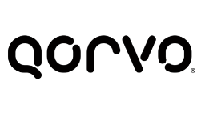
January 13, 2023
Qorvo statement for Business & Human Rights Resource Centre:
Qorvo is committed to complying with all applicable U.S. laws and regulations, including the current sanctions and export controls pertaining to the Russian government. We have strict procedures in place and maintain a rigorous global trade compliance program.
Qorvo does not condone or support the unauthorized sale or distribution of components without a license. In this case, Qorvo never conducted business with Igor Kazhdan, and the Company’s products were exported and used without our permission or knowledge.
We are committed to upholding high standards of compliance and oversight when it comes to the sale or shipment of our products.

