June 22, 2017
To : Mr. Hu Huaibang
Director of China Development Bank
No. 18 Fuxingmennei Street, Xicheng District
Beijing, P.R.China 100031
TEL: 86-10-6830 6789/ FAX: 86-10-6830 6699

ATTN: Credit Risk Management Department, Policy Research Department, International Finance Department, Project Appraisal I and II Department

Re: Second Public Inquiry regarding Environmental and Social Impacts of Proposed Jakarta-Bandung High Speed Rail

Dear Chairman Hu Huaibang:

This is FROM JABAR first letter and also could considered as WALHI’s third letter regarding China Development Bank’s (CDB) investment in our country, the first being in regards to the Morowali nickel mine in Sulawesi and the second regarding the Bandung-Jakarta High Speed Rail project.

Today, we write again to raise our concerns regarding the Bandung-Jakarta High Speed Rail project. On May 14, 2017, we understand that China Development Bank signed a financing agreement with PT Kereta Cepat Indonesia-China, with the first loan disbursement for the $4.5 billion USD project to be issued shortly.

As referenced in our last letter (attached), we strongly urge China Development Bank to delay any loan disbursements until China Development Bank can publicly confirm and guarantee that all Indonesian laws and Chinese policy obligations, such as the Green Credit Guidelines, are met. Until then, we ask that China Development Bank please reconsider the project and freeze any financing until your client can publicly guarantee that no local communities were coerced or forcibly evicted.

We understand that legally obtaining land titles was a major condition for China Development Bank’s Memorandum of Understanding for the project. However, current evidence shows that there has been intimidations to evictions to local communities who do not wish to leave and have not consented to relinquishing their house titles (please see appendix).

Local communities believe the train project will not result in any meaningful development for them as local residents or for Indonesia as a country. According to the problem that mention above, it has occured already in one communities. And we are worried it will happened again to other communities along the high speed rail plan project.

We are very concerned about the way China’s Belt and Road Initiative (BRI) is unfolding in our country. As one of the first, BRI projects in Indonesia, we feel it is important that the project is a success for all sides as Indonesian citizens. Troublingly, there is evidence that the project consortium forcibly displaced, coerced, and intimidated residents into relinquishing their house titles. This manner of conduct reflects a damaging, inauspicious relationship between the people of China and Indonesia, rather than one of mutual consent.

Again, we ask that China Development Bank please assess and disclose to the public how the project has complied with all Indonesian laws and Chinese policy obligations. According to our analysis included in our previous letter, the project fails to meet Indonesian environmental, spatial, land planning, and other laws. It also fails to comply with Chinese environmental and banking policies, such as the Green Credit Guidelines.

We include additional information about recent protests and demonstrations against the project. (please see appendix).

For any additional questions or information, please contact Meiki.W.Paendong at walhijabar@gmail.com and fromjabar@keretaterlalucepat.com .

We look forward to working positively with China Development Bank.

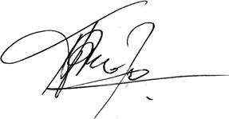
Sincerely,

Dadan Ramdan
FROM JABAR Coordinator
Executive Director of WALHI West Java
Cc :
China Banking Regulatory Commission
Ministry of Environmental Protection
Ministry of Foreign Affairs
Ministry of Commerce

Endorsed By:

- Indonesia Organization (National)
1. Koalisi Rakyat Untuk Keadilan Perikanan (KIARA)
2. Institute for National and Democracy Studies (INDIES)
3. Lembaga Studi dan Advokasi Masyarakat (ELSAM)
4. Jaringan Kerja Pemetaan Partisipatif (JKPP )
5. Aliansi Jurnalis Independen ( AJI ) Bandung
6. Kalyana Mandira (Bandung)
7. Jaringan Anti Tambang ( JATAM )
8. Sawit Watch
9. Serikat Perempuan Indonesia (Seruni)
10.Perkumpulan Inisiatif
11.Forum Komunikasi Kader Konservasi Indonesia - Jawa Barat
12.Ranchunit

- Abroad Organization (International)
1. ULU Foundation - USA
2. Friends of the Earth United States
3. Rivers Without Boundaries Coallition International - Russia
4. NGO Forum
5. Sahabat Alam - Friends of the Earth Malaysia
6. Bureau for Regional Outreach Campaigns (BROC) - Russia
7. Foundation For Environmental Rights,Advocacy & Development(FENRAD)- Nigeria
8. Friends of the Siberian Forest - Russia
9. Assosiation of Journalists-Environmentalists of the Russian Union of Journalists - Russia
10. Friends of the Earth Ghana
11. Center for Environment - Friends of the Earth Bosnia and Herzegovina
12. Lumière Synergie pour le Développement - Senegal
13. Observatoire d’Etudes et d’Appui à la Responsabilité Sociale et Environnementales
(OEARSE) - Congo
14. Biodiversity Conservation Center - Russia
15. Derecho Ambiente Recursos Naturales (DAR) - Peru
16. Ecological center ( DRONT ) - Russia
17. Friends of the Earth Japan
18. BankTrack Netherlands - Netherland
19. Socio-Ecological Union International- Russia

Appendix
- Communities representative of villages of Mekarsari, Cilame, and Gadobangkong file complain and objection to National Human Rights Commission on April 25, 2017

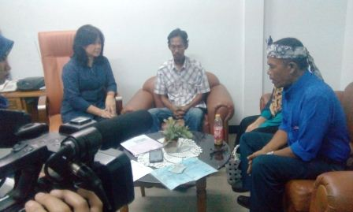
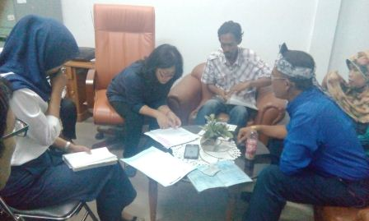

- Communities of villages of Mekarsari, Cilame, and Gadobangkong did protest to first eviction on April 28,2017
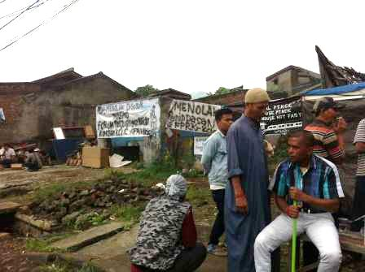
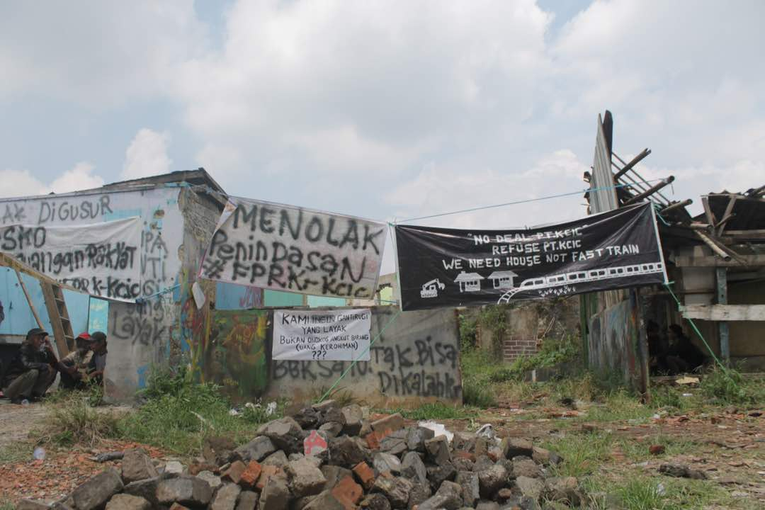

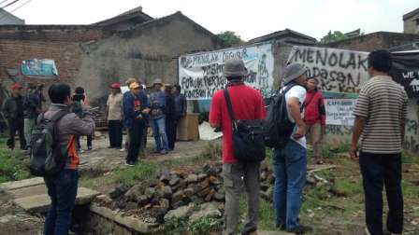

- Eviction process remain on May 4, 2017
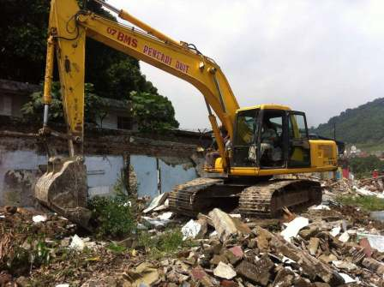
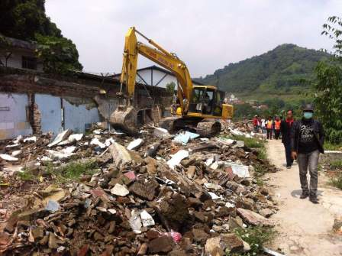

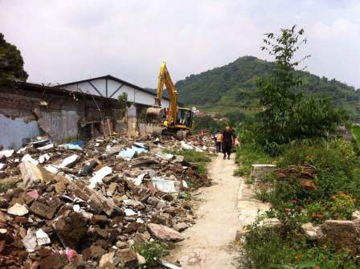
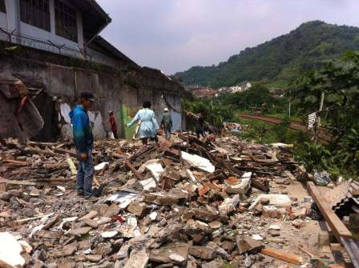

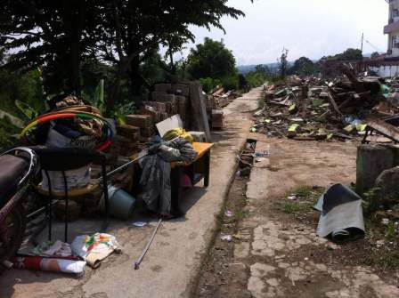
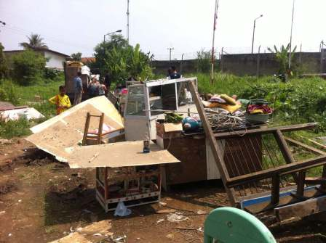

FROM JABAR is an alliance of Affected Community Forum, CSO, and Student Movement Organization in Bandung capital city of West Java province that concern to affected people and environment of Jakarta- Bandung High Speed Rail Train Project. FROM JABAR consist of WALHI West Java, Komune Rakapare, FNKSDA, UKSK, KM ITB.
WALHI is the largest environmental NGO in Indonesia with 479 member organizations and offices in 28 provinces.
You may recall our last letter to China Development Bank in April 2015, where we kindly requested the bank to conduct a formal investigation regarding the environmental and social problems directly caused by the Morowali nickel mine in Central Sulawesi, which does not comply with Indonesian law. It is regrettable that CDB has yet to address our concern that the Morowali project is impoverishing, rather than improving the lives of local communities. We would be happy to resend the letter, upon the bank’s request. We also note we sent another letter to China Development Bank of our concerns in August 2016 regarding the Bandung High Speed Rail project, which went unanswered.
Keith Barrow, “$US 4.5bn loan agreed for Indonesian HS line”, International Rail Journal, May 15, 2017. http://www.railjournal.com/index.php/high-speed/dolus-45bn-loan-agreed-for-indonesian-high-speed-line.html?channel=523
http://www.thejakartapost.com/news/2017/05/10/locals-oppose-evictions-high-speed-rail-project.html https://www.pressreader.com/indonesia/the-jakarta-post/20170510/281616715283486

