**Responsible Renewable Energy: 10 Questions on Human Rights**

**Name of company**: Sarawak Energy Berhad

**Projects registered under UN Clean Development Mechanism (if any):**

Project 2594 :Bintulu Combined-Cycle Project STG Unit No.9, Tanjung Kidurong, Bintulu, Sarawak

**Human rights policy commitment**[*Examples & guidance*](http://business-humanrights.org/en/un-guiding-principles/implementation-tools-examples/implementation-by-companies/type-of-step-taken/human-rights-policy-statements)

1. Does your company have a publicly available commitment to respect human rights? If so, please provide a link.

* At the United Nations Human Rights Council Working Group on the Universal Periodic Review (UPR) of Human Rights in Malaysia, Sarawak state and Sarawak Energy share the State’s strong progress on human rights with respect to hydropower development. At the forum, Director of Sarawak Energy and State Legal Council YBhg. Datuk JC Fong said,

“Sarawak, (and Sarawak Energy) has taken, and continues to take, all the necessary steps to ensure the proper respect for human rights of indigenous and other project-affected peoples in hydropower development for their overall well-being.

 The development of the State’s hydropower and other natural resources supports basic human rights and represents a well-considered strategy designed to maximize the wellbeing of the people and accelerate the rate of economic progress of the State of Sarawak.  The strategy brings the affected native communities, living in remote interior regions of the State and traditionally dependent on subsistence farming or semi-nomadic lifestyle, into the mainstream of Malaysian society, while ensuring recognition and protection of their indigenous rights.

Through this process, affected indigenous communities have secured new opportunities and better educational and health amenities for their present and future generations, whilst preserving their cultural identities and native traditions. To this end, the State provides the directly-affected peoples a level of compensation, the scope and quantum of which exceeds that provided in any similar hydropower project in Southeast Asia and which should ensure the multi-generational welfare of the recipients.

By reflecting on insights derived from exposure to international best practice, and implementing lessons learned from earlier hydropower developments, Sarawak has made steady, and even strong, progress in the application of best practices, including as regards the quality of its constructive engagement with the native communities directly-affected by the implementation of hydropower projects.

Nonetheless, the State acknowledges that it and Sarawak Energy still have much to learn.  In its journey of continuous improvement, Sarawak will continue to be guided by both the lessons learned from previous experience in Sarawak and the standards and procedures developed by countries and institutions engaged in similar endeavours.”

Report on the speech at the United Nations Human Rights Council Working Group on the Universal Periodic Review (UPR) of Human Rights in Malaysia on 24th October 2013: <http://www.sarawakenergy.com.my/index.php/news-events-top/latest-news-events/latest-media-release/474-sarawak-government-team-takes-strong-stand-to-united-nations-in-geneva>

* Sarawak Energy’s commitment to human rights is highlighted as part of our social commitment, our responsibility towards the communities which are directly impacted by our development projects – ensuring their well-being, improving the quality of life and preserving their culture and heritage.
* Sarawak Energy has adopted the International Hydropower Association Sustainability Assessment Protocol in 2011, which is designed to assess and improve sustainability performance by bridging the gap between investors and hydropower project managers - assessing hydropower projects for good practice and identifying potential gaps.
* Sarawak Energy complies with local regulatory requirements and is guided by international best practice at every stage of its project development; planning, pre-engineering, implementation and operations by the following:
* Completion of Environmental Impact Assessment (EIA) and the Social and Environmental Impact Assessment (SEIA) at local level.
* United Nations Declaration on The Rights of Indigenous People (UNDRIP)
* International Commission on Large Dams (ICOLD)
* The protection of human rights is also included in Sarawak Energy’s Tender, Contract and Procurement Process documents under the CSR Management Plan. This is in accordance with the UN Global Compact Principles to ensure our contractors have similar commitments.
* Sarawak Energy has completed its first **Sustainability Report for 2014** (based on Global Reporting Initiatives (GRI) G4 reporting guidelines) and the report will be made public by June 2016 (a link to the report will be provided as soon as it is launched). The report reflects our commitment towards sustainability as the key driver for Sarawak’s economy, our business activities, and our impacts on the social, economic and environment.

**Human rights due diligence**2. Does your company identify its salient human rights issues and does it have a due diligence process to manage them? If so, please list the issues and describe the due diligence process (key steps include: impact assessment, integrating & acting on findings, tracking responses & communicating how impacts are addressed).

**Sustainability Due Diligence Process (at group level)**

* At group level, the **Sarawak Energy Sustainability Material Matrix** is used to identify issues critical to the company’s business operations, from internal and external stakeholders’ perspectives covering:
  + Indigenous rights
  + Local communities
  + Indirect economic impacts
  + Grievance mechanism for impacts on society
  + Customer Health & Safety
  + Supplier assessment for labour practices
  + Human rights grievance mechanisms
  + Labour practices grievance mechanisms
  + Labour/Management Relations
  + Non-discrimination
* The matrix contains an important list of issues which need to be monitored, measured, managed and reviewed. This is part of Sarawak Energy’s due diligence process at corporate level.

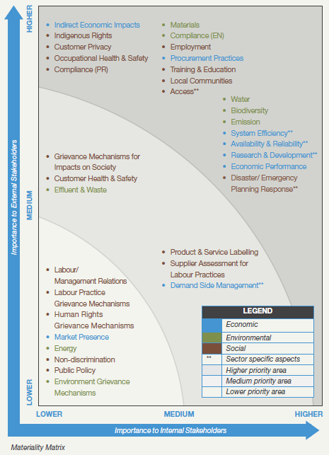

**Figure 1: Sarawak Energy Sustainability Matrix**

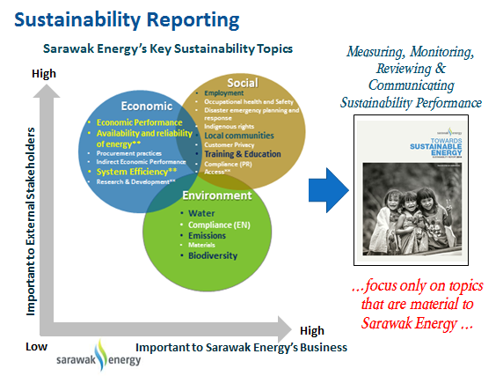

**Figure 2: Sarawak Energy Sustainability Report – measuring, monitoring, reviewing and communicating sustainability performance**

**Sustainability in Hydropower Development**

* In developing a hydropower project, Sarawak Energy sustainability performance is guided by the **Hydropower Sustainability Protocol (HSAP)**. Similar principles are also adopted for non-hydro projects.
* Sarawak Energy goes beyond the State’s statutory requirements by incorporating the HSAP guidelines in the SEIA for our hydropower projects.
* Sarawak Energy incorporates basic good practices in its operations lifecycle in accordance with the HSAP which encompasses the technical, environmental, social, economic and financial, and integrative aspects of sustainability and our aim is to build on this and eventually attain the level of proven best practices.

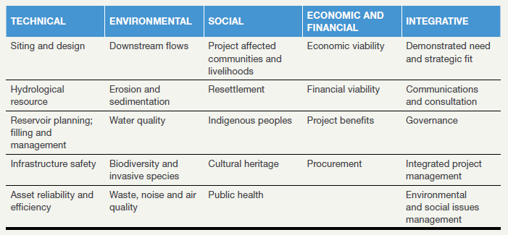

* In addition, the HSAP also addresses the following cross-cutting issues:

|  |  |  |
| --- | --- | --- |
| **Cross-cutting Issues** | | |
| * climate change | * livelihoods | * integrated water resource management |
| * grievance mechanisms | * human rights, | * transboundary issues |
| * legacy issues | * transparency |  |

**Community engagement & consultation**

[*Examples & guidance*](http://business-humanrights.org/en/guidance-community-engagement-0)

3. What criteria does your company use to identify communities that may be affected by renewable energy projects it is involved in?

* The Sarawak State Government requires all major projects to undertake a SEIA which must be endorsed by the Natural Resource and Environment Board Sarawak (NREB). For the social element in all Sarawak Energy projects, we have developed a specific Stakeholder Engagement Plan that consists of the following:
  + Stakeholder mapping and analysis
  + Issues matrix
  + Project brief
  + Stakeholder engagement strategy
  + Stakeholder engagement action plan
  + Frequently Asked Questions

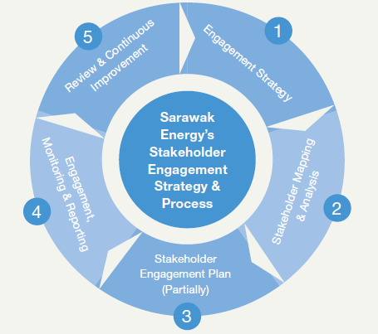

**Figure 3: Overview of Sarawak Energy’s Stakeholder Engagement Strategy and Process (on-going process)**

4. How does your company consult with affected communities (on impact assessments, resettlement, benefit sharing plans, etc.)? Please describe what form consultations take and when they are carried out in a project’s cycle.

* Before a project is implemented, consultations with project affected communities are carried out through meetings, dialogues, talks, community activities and CSR programmes that focus on four areas namely education and young people, environmental conservation and management, culture and heritage and community development and entrepreneurship in order to develop long term, sustainable partnerships to meet real community needs.
* Engagements are done directly with the communities, community consultative committees as well as community leaders which include village headmen to gain an all-round perspective.
* Coordinating these engagements are Sarawak Energy’s community relations officers who cultivate good relations and proactively build the communication link between the affected communities and Sarawak Energy.

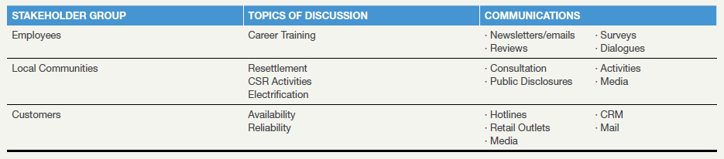

* Consultations with project affected communities begin from planning stage and continue even after the project’s completion through Sarawak Energy’s CSR programmes and various other community engagement activities.

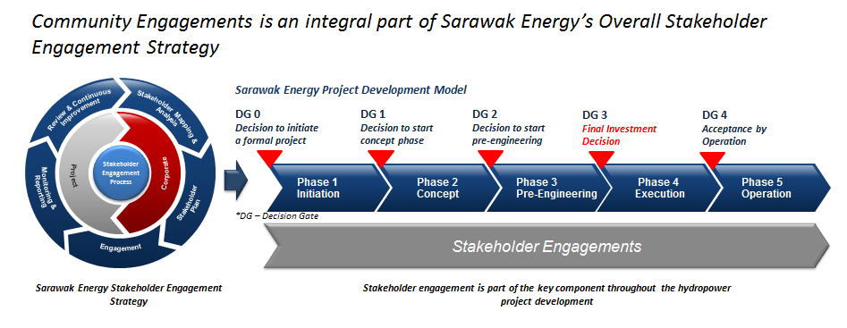

5. Does your company ensure its consultations include the perspectives and respect the rights of all affected community members (including those who may be marginalised for reasons of gender, social status, age, religion, wealth or income or other considerations)? How is this ensured?

* Sarawak Energy together with relevant State Government agencies namely the State Planning Unit (SPU), Natural Resources Environmental Board (NREB), Resident Office and District Office will carry out active community consultations with the directly affected communities prior to and when undertaking the SEIA.
* The SEIA study comprises three major reports:

1. **The SEIA on the proposed HEP**

Key topics covered in the SEIA study:

* existing environment
* potential impacts and mitigation measures
* residual impacts and project risks
* environmental management plans
* monitoring and auditing program
* socio-economic profile
* socio-economic situation
* perceptions of families
* potential impacts – community assets
* vulnerable groups
* socio-economic impacts on the project-affected communities
* recommendations for mitigation measures and stakeholders management
* consultation and communication
* dwellings, land and community structures
* human history in the catchment
* the communities in the catchment
* the population
* community hierarchy, governance and decision making
* community territories and rights
* cultural heritage
* the household economy
* the garden economy
* the river and forest economy
* community health
* education

**2. Contemporary Ethnography Study**

* Key Topics Covered In Contemporary Ethnography Study

• Household Register

• Existing culture

• Current living conditions

• Current social conditions

• Current economic

• Expectations regarding resettlement

* Cultural Heritage and Archaeological Survey

• Survey, record and describe sites and artefacts of cultural and archaeological value to the affected communities and the State;

• Assess the impact on the cultural and archaeological heritage;

• Propose a plan to manage the cultural and archaeological heritage.

* Economic Study - economy of the affected communities:

**3. Resettlement Action Plan (RAP) Study**

Relocation and livelihood restoration of the affected communities, as well as socio-economic development, taking into account the findings of the Contemporary Ethnography Study and the Economic Survey:

* Confirmation of resettlement sites;
* Confirmation of community layout and amenities;
* Confirmation of housing layout;
* Confirmation of individual house floor plan;
* Confirmation of livelihood restoration;
* Confirmation of economic development;
* Proposed Schedule for Relocation;
* Establishment of Grievance Mechanism;
* System for monitoring and reporting;
* Estimated costs of relocation and livelihood restoration.

**Free, prior and informed consent**

6. Under what circumstances does your company commit to seeking an affected community’s free, prior & informed consent to a project? Please provide examples of projects where free, prior & informed consent was sought (if applicable).

* A comprehensive SEIA study provides a clearer picture on what to expect and to better assess the impact our HEP projects may have on the local communities and environment. In addition, embedding the HSAP best practices into our project cycle can minimise the risk of negative impact. HSAP best practices for the different stages of HEP development (preparation, implementation and operation) focus on social impacts, resettlement, welfare of indigenous people, cultural heritage and public health.
* The completed SEIA reports are submitted to the NREB for approval prior to project implementation. The report is made public for review and comments as part of the requirements by Sarawak environmental laws.
* This is also aligned with HSAP standards and International Finance Corporation’s (IFC) “Handbook on the Preparation of a Resettlement Action Plan” for stakeholder engagement, which prescribes the “Free, Prior and Informed” principle to allow communities the right to give their opinion and voice their grievances on the proposed projects that may affect them directly or indirectly. The community engagements carried out are an integral part of Sarawak Energy’s overall stakeholder engagement strategy.

7. What is your company’s process for obtaining and evaluating free, prior & informed consent?

* The process is incorporated in the overall stakeholder engagement strategy, where community engagement is an integral part of the process.



8. Has your company faced any challenges in its process to seek free, prior & informed consent for renewable energy projects? If so, please describe what steps your company has taken to overcome these challenges.

* Sarawak Energy has encountered a number of protests from anti-development movements against hydropower developments at local and international levels.

* While Sarawak Energy respects the rights of individuals and organisations in expressing their point of view, it should be done in a manner that is lawful and does not jeopardise the safety of others. The rule of law prevails in how Sarawak Energy conducts its business.
* There has been an extensive global campaign that aims to discredit the company and give a negative perception that Sarawak Energy is doing injustice to indigenous affected people in the implementation of its hydropower projects. This has resulted in inaccurate information being disseminated online and through traditional media, creating an unbalanced picture of Sarawak Energy’s long term plan for the people of Sarawak.
* It is to be noted that indigenous people from affected communities are employed by Sarawak Energy and their positive views are seldom taken into account. It is also to be noted that members of the affected communities’ consultative committees who speak out in support seldom get the media traction.

• Active consultations and engagements with the communities on the ground have proven to be the best approach for Sarawak Energy in finding solutions and arriving at a consensus to achieve a win-win situation.

* In addition, Sarawak Energy has also organised site tours to other HEP sites and resettlements to show representative of affected communities a first-hand view.
* As a responsible corporate citizen, Sarawak Energy sees it as top priority to ensure its projects are implemented in accordance with international best practices and this extends to the contractors it engages as well.
* Key steps in handling challenges in obtaining free prior, inform and consent:

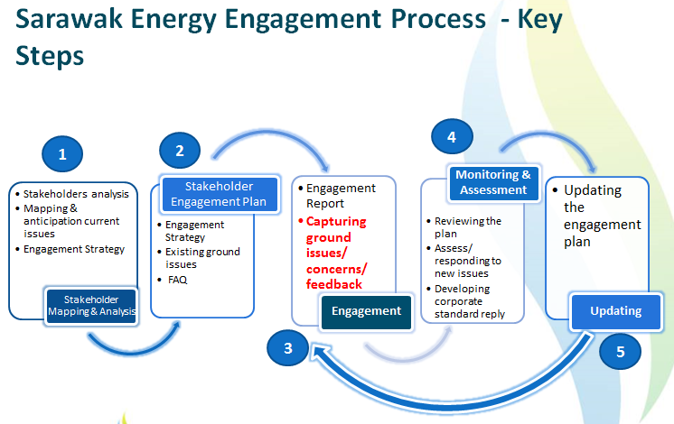

**Security**[*Examples & guidance*](http://business-humanrights.org/en/security-issues-conflict-zones-0)

9. What steps does your company take to ensure that its own personnel, private security companies it contracts with, and/or government forces providing security to its projects, respect the rights of workers and community members, including those who may oppose its projects?

* Sarawak Energy personnel are bound to the company’s code of ethics, values and standard operation procedures.
* Community engagements and consultations are done on neutral ground to ensure the process of free, prior and informed
* For our contractors, the contracts require them to:
* Comply with all applicable laws;
* Pay wages and ensure working conditions to a level that is at least equivalent to that established for the relevant trade or industry;
* Develop a site security plan
* Ensure that its employees and subcontractor's comply with a Code of Conduct;
* Develop a CSR Management Plan that takes into account, amongst other things, the protection of human rights in accordance with the UN Global Compact Principles.
* In a situation where our personnel and/or contractors receive threats, confrontations and aggressions, a police report will be made to ensure they are protected by the law.

**Remedy**[*Examples & guidance*](http://business-humanrights.org/en/un-guiding-principles/implementation-tools-examples/access-to-remedies-grievance-mechanisms/non-judicial-grievance-mechanisms/company-based)

10. Does your company have a grievance mechanism in place at each project site for affected communities and workers to raise concerns about local impacts, including human rights abuses? If so, were affected communities involved in the design of the grievance mechanism, including its set-up and the types of remedies it provides?

* For every project, Sarawak Energy assigns Community Relations Officers as point of contact between the company and the project affected communities.
* This is part of the stakeholder engagement strategy which begins from the planning stage of the project and will continue on even after the project’s completion for Sarawak Energy looks to establish a long-term partnership with the stakeholders.
* Below is a process flow on the grievance mechanism for a proposed project:



**Other information**Please provide any further information regarding your company’s policies and practices on human rights that you think is relevant.

* Sarawak Energy believes that as a responsible and sustainable operator, there is a requirement to meet local legislation as well as best practices based on international standards. We are guided by the following principles:
* Where it is viable, options assessment to avoid involuntary resettlement will be taken.
* Where resettlement is unavoidable, resettlement plans will be developed following transparent consultation and partnership with Project Affected People (PAP) and relevant State institutions.
* Compensation and resettlement will be carried out in a fair and equitable manner and SEIA and Resettlement Action Plan (RAP) will take place prior to a project Final Investment Decision (FID).
* Where resettlement is unavoidable, an RAP will be developed specifically for the affected communities which will address their needs and incorporate strategies that would improve their livelihood in a sustainable manner. ENDS.