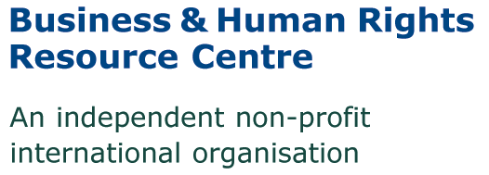
CONFIDENTIAL
Application form: Research & Projects Internship - NYC

Please type or write in black ink – Please answer all questions, and do not attach a CV.
Please return the completed form to us by email by 8 September 2017, to Christen Dobson at dobson@business-humanrights.org

* Note to those returning the application by e-mail: The end of the form asks for “Signature of applicant” -- you may simply type your name there. The successful applicant will be asked to sign the form before starting.

Personal details
Surname:
Forename(s):
Address:
Telephone:
Email address:

Position details
If appointed, when would you be able to start?

How many hours per week are you able to commit? (Note: We are seeking someone that can commit at minimum 12 hours per week)

How many months are you able to commit to the internship? (Note: We are seeking someone that can commit to at least 4 months part-time, preferably for the full academic year)

Do you plan to seek academic credit for this internship? (Note: We are happy to support with information required from us in order to seek academic credit)

General information
Nationality:
Do you already have the right to work in the USA? (Please specify) Please note that due to lack of resources we are only able to take applicants with a valid work/internship permit, and are unable to offer sponsorship.
Where did you first learn about this intern position?

Do you have any criminal convictions? A conviction will not necessarily exclude you from employment, but will be taken into consideration when assessing your suitability for this position.

Languages
Please indicate level (Fluent, very good, good, intermediate, basic). Start with first language (“mother tongue”)
Language | read | write | understand | speak

Issues of interest
Please list your three main issues of interest in business & human rights (Note: This helps us gain an insight into your areas of interest but does not guarantee you will work on these issues. For examples, see our Big Issues)

Regions of interest
Please indicate your top regions of interest (max. 2)

Africa
Asia & Pacific
Europe
North America
South America
Middle East & North Africa

Work experience
Please give details of relevant work experience, incl. voluntary work. Start with most recent and do not exceed one page
Dates | Details (name of employer, job title & brief description of your responsibilities) | Reason for leaving

Education and training
Please give details of your education and training, including courses you have attended and (if applicable) qualifications gained.
Date started | Date finished | Name of institution | Details of course attended | Qualification gained (if any)

References
Please give details of two people, not related to you, who may be approached for references as to your suitability for the post. The first should be your present (or most recent) employer, or professor. The second should be a referee who is able to comment on your work abilities.
Reference 1 | Reference 2
Name: | Name:
Address: | Address:
Company/organization, including position: | Company/organization, including position:
Telephone number: | Telephone number:
Email address: | E-mail address:

Personal statement
Use this section to explain why you believe you are a suitable candidate for an internship post, in particular how you meet our requirements and the experience you have that is relevant (800 words maximum). Please also give examples of particular achievements.

I confirm that the details in this form and any other information relating to my application are correct.

Signature of applicant: Date:

