Responsible Renewable Energy: 10 Questions on Human Rights
Name of company: EPM
Projects registered under UN Clean Development Mechanism (if any):
- Jepirachi Wind Farm
- La Vuelta and La Herradura Hydroelectric Power Station

Human rights policy commitment
Examples & guidance
- Does your company have a publicly available commitment to respect human rights? If so, please provide a link.
Yes. EPM has made a public commitment to fulfil and promote human rights through its institutional human rights policy, which was approved in 2012 by the Board of Directors, the institution’s highest governing body. Policy compliance is constantly tracked and monitored. The policy is available at
http://www.epm.com.co/site/Portals/0/Sostenibilida%20EPM/politica-derechos-humanos-epm.pdf

Human rights due diligence
Examples & guidance
- Does your company identify its salient human rights issues and does it have a due diligence process to manage them? If so, please list the issues and describe the due diligence process (key steps include: impact assessment, integrating & acting on findings, tracking responses & communicating how impacts are addressed).
As part of its approach to human rights, EPM has developed an institutional working model based on a study to identify current and potential risks, adhering to the United Nations Guiding Principles. Since 2012, this study has been conducted on an institution-wide basis.
In addition, whenever the construction of an infrastructure project involving an intervention with significant impacts begins, EPM does an assessment to define specific strategies for dealing with the risks identified in the affected territories. For long-term building projects, assessments are done repeatedly to ensure that findings are up to date.
These assessment exercises include:
- The identification and weighting of vulnerabilities common to all of the company’s operating environments.
- The identification of threats, including the internal and external risk agents thereof, and the different types of damage or harm that could be caused.
- The categorisation of human rights risks within the framework of the EPM risk model, defining the assessment criteria.
- Integration into management through action plans setting out the objectives, people in charge and specific actions.
Issues that have been identified as critical to business operation are related to:
- Guaranteeing respect for human rights in the supply chain.
- Security practices implemented through private surveillance contracts and agreements with the Colombian State for the accompaniment of public security forces.
- Respect for the human rights of communities located in areas affected by the development of infrastructure projects.
In order to monitor the impacts that business operations might have and to take corrective actions when such impacts materialise, EPM has three human rights complaints and claims mechanisms in operation.
Finally, the company accounts publicly for its human rights actions through the sustainability report that it publishes annually. The report is produced in accordance with the parameters set out by the Global Reporting Initiative.

Community engagement & consultation
Examples & guidance
- What criteria does your company use to identify communities that may be affected by renewable energy projects it is involved in?
Definition of the area of influence with territoriality criteria:
In the project’s study stage, a baseline area of influence is defined for the physical, biotic and social dimensions, taking into account territoriality criteria for that purpose. Communities located in the area where works or activities are planned are identified, as are those located in other areas that might be affected by the project on grounds of economic, social, political or cultural relations, or by rights of way. Chains of impact
Participatory characterisation of communities within the area of influence:
The characterisation of communities that fall within the direct area of influence is done in a joint participatory manner by institutions, communities and the company in accordance with the following steps:
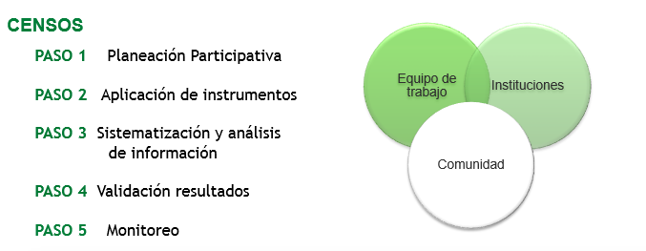
Translation of image text: SURVEYS / STEP 1 Participatory planning / STEP 2 Instrument application / STEP 3 Data systematisation and analysis / STEP 4 Results validation / STEP 5 Monitoring / Work team / Institutions / Community

- How does your company consult with affected communities (on impact assessments, resettlement, benefit sharing plans, etc.)? Please describe what form consultations take and when they are carried out in a project’s cycle.
When project-related environmental impact studies are being conducted (pre-feasibility and feasibility stages), a process of community information and participation is implemented, which includes mechanisms for informing communities and institutions about the project’s studies (the company developing it, policies, study objective, scope, contractors, activities in the field of applicable legislation, power generation process, and consultation on impacts and environmental management measures, the outcome of which forms an integral part of the environmental impact assessment (EIA). This is done through meetings, workshops and educational processes on the power generation process, which includes visits to power stations (under construction and in operation), social mapping and production system workshops, and field trips, among others.
The table below shows the community participation phases with the project development phases.
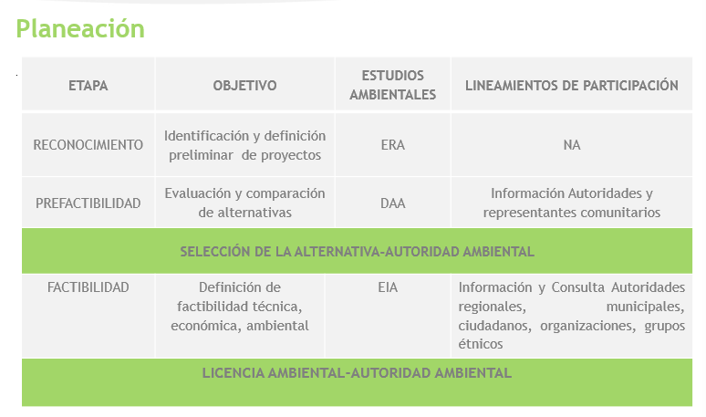
Translation of image text:
STAGE / OBJECTIVE / ENVIRONMENTAL STUDIES / PARTICIPATION GUIDELINES
RECOGNITION / Preliminary identification and definition of projects / ARA / NA
PRE-FEASIBILITY / Assessment and comparison of alternatives / DEA / Information — authorities and community representatives
SELECTION OF THE ALTERNATIVE-ENVIRONMENTAL AUTHORITY
FEASIBILITY / Definition of technical, economic and environmental feasibility / EIA / Information and consultation — Regional and municipal authorities, citizens, organisations, ethnic groups
ENVIRONMENTAL PERMIT-ENVIRONMENTAL AUTHORITY
Key for abbreviations used in this table: ARA = Assessment, recognition, accreditation / DEA = diagnosis of environmental alternatives / EIA – Environmental impact assessment

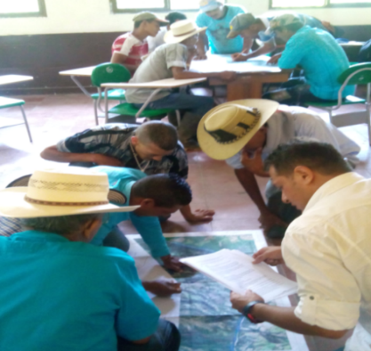
The characterisation of the social environment is also done in a participatory manner, with the social and institutional stakeholders identified in each project. It considers the suitability and validation of instruments that will be applied in the field for gathering data and for agreements to support and monitor those activities.
Written and verbal (by telephone) calls are made and the process is documented through minutes and photographic records when the communities grant authorisation to do so.

- Does your company ensure its consultations include the perspectives and respect the rights of all affected community members (including those who may be marginalised for reasons of race, ethnic origin, gender, social status, age, religion, wealth or income or other considerations)? How is this ensured?
By means of extensive and inclusive calls (which are documented), attempts are made to ensure that the participation spaces involve all of the above-mentioned sectors. However, in active armed conflict areas, broad participation cannot always be guaranteed because some sectors of the population are marginalised for a number of reasons beyond the company’s control.

Likewise, in such calls, the company turns to institutions and municipal attorneys to safeguard the rights of the population, and it considers techniques such as social mapping and data validation spaces that, in many cases, help to appropriately identify some of the stakeholders that should be included in the process.

Free, prior and informed consent
Examples & guidance
- Under what circumstances does your company commit to seeking an affected community’s free, prior & informed consent to a project? Please provide examples of projects where free, prior & informed consent was sought (if applicable).
Although the application for certification of the presence of ethnic groups in the projects’ areas of influence should be made in the feasibility stage (Presidential Directive on Prior Consultation No 10 of 2013), EPM – after the recognition of projects – consults on such presence through secondary information and applies for certification in the pre-feasibility stage (diagnosis of environmental alternatives, DEA) so that it can serve as a criterion for the environmental authority’s comparison of alternatives.

After defining the project alternative to take towards feasibility and specifying the study area, applications for each project’s respective certifications are submitted to the Ministry of the Interior on the presence of communities and existence of legally constituted territory in order to start, in an opportune manner, prior consultation before carrying out any activity involving field work, should it be required.

Examples:

- In the Porce IV project, although the Ministry of the Interior certified the non-presence of ethnic groups in the project’s direct area of influence (DAI), from the start of the studies EPM implemented an information and participation process with the four community councils located downstream from the project. Furthermore, it held social mapping workshops to identify the activities that such communities did in the project’s DAI, such as mining and fishing, considering the notion of territoriality as well as the historic and traditional appropriation of resources by such groups.

- In the case of the Jepírachi wind farm, prior consultation was carried out over a period of three years before the application for certification and the start of prior consultation by EPM.

- In addition, for the weather stations to measure winds in La Guajira, applications for certifications were submitted in good time to the Ministry of the Interior and the respective prior consultations were carried out.

- For the El Sireno hydroelectric project in the feasibility stage, an application for certification was submitted to the Ministry of the Interior, with the following being explained to the Ministry [the text within quotation marks is a translation, for information only, of the original in Spanish]: “Although the presence of ethnic groups in the project’s direct area of influence is not identified, indigenous communities from the Majoré Ambura reservation are located some 12 kilometres downstream from the EL SIRENO project’s discharge site, and Afro-Colombian communities belonging to the Community Council for Mandé Cultural Identity are identified some 20 kilometres from that same site.

“Both communities use a bridle path located on the left bank of the Penderisco River, crossing the project’s direct area of influence, in which the construction of a two-kilometre-long road tunnel is contemplated.

“The use of the way increases monthly during the market fair in Urrao because the ethnic and non-ethnic communities leave their rural areas and make their way to the town centre of the municipality of Urrao to buy and sell products and run personal and institutional errands.

“For all the above reasons, and taking into account the criteria set out in Presidential Directive No 10 of 2013 on the rights of way of ethnic communities in the areas of interest of the project, works or activity (PWA), we are submitting to you the application to consider the need, or otherwise, for prior consultation.”

- What is your company’s process for obtaining and evaluating free, prior & informed consent?

STAGE |  | ENVIRONMENTAL STUDIES | PRIOR CONSULTATION
RECOGNITION |  | ARA | Secondary information consultation on the presence of ethnic groups in the projects’ area of influence
PRE-FEASIBILITY |  | DEA | Application for certification of the presence of ethnic groups in the areas of influence of the alternatives to be assessed: Definition of ethnic areas of influence
SELECTION OF THE ALTERNATIVE-ENVIRONMENTAL AUTHORITY
FEASIBILITY | EIA |  | Definition of areas of influence for the social environment of the alternative selected by the environmental authority, to be taken towards feasibility with territoriality criteria (impact networks)
 |  |  | Application for certification of the presence of ethnic groups in the projects’ area of influence and of legally constituted territories
Application for the start of prior consultation if certification is positive
Application for verification if it is certified that there is no presence yet the company is aware of the existence of ethnic communities
Definition of EPM’s work team participating in the prior consultation (EPM does not delegate social management to consultants; it guides and leads it)

Definition of the terms of reference for contracting environmental impact studies, in which it requests suitable personnel with experience to participate in the prior consultation process

Coordination of the prior consultation process with the Ministry of the Interior (calls, presentations, workshops, etc.)

Conducting technical and environmental studies with the participation of the ethnic communities

Consultation on impact, management and compensation measures, and benefits

Formalisation of agreements

Delivery of the EIA to the environmental authority, which includes the participatory baseline, the consultation, the impact assessment and the design of management and compensation measures agreed with the communities within the framework of prior consultation (PC)
ENVIRONMENTAL PERMIT-ENVIRONMENTAL AUTHORITY
CONSTRUCTION |  | Execution of management measures | Execution of the environmental management plan’s programmes for the construction phase, and of the commitments set out within the framework of prior consultation for each phase
OPERATION |  | Implementation of management and monitoring measures | Execution of the environmental management plan’s programmes for the operational phase, monitoring the programmes’ indicators
Key for abbreviations used in this table: ARA = Assessment, recognition, accreditation / DEA = diagnosis of environmental alternatives / EIA – Environmental impact assessment

- Has your company faced any challenges in its process to seek free, prior & informed consent for renewable energy projects? If so, please describe what steps your company has taken to overcome these challenges.
Although the company has undertaken several prior consultation processes for different projects, works and/or activities, as required by the applicable regulations, of particular note is the prior consultation process carried out with the Wayuu communities of La Guajira Department, which form part of the communities in the area of the influence of the Jepirachi wind project. That consultation lasted for three years and entailed a number of significant challenges and learning processes for the organisation. In general, sharing a negotiation process with the communities located in that territory – the Arutkajüi community belonging to the Epieyuu clan, and the Kasiwolín community belonging to the Pushaina, Uliana and Epieyuu clans. The culture and the unique organisational and legal system that protects them, their own living conditions, the institutional order of the Department, the internal conflicts of the communities themselves, the territorial conditions and the view of development, among many other aspects, compel companies to reinvent themselves in every process of approach, relationship, participation and consultation with the communities. The main lesson was about having enough time to interrelate with the community to undertake the extensive, truthful and opportune information process, in which its was possible to put each project activity into context, clarify doubts and implement the corresponding measures through the communities’ broad and active participation in the identification of impacts and the corresponding management measures. The negotiation of easements was one of the main lessons learned from this project.

Security
Examples & guidance
- What steps does your company take to ensure that its own personnel, private security companies it contracts with, and/or government forces providing security to its projects, respect the rights of workers and community members, including those who may oppose its projects?
EPM develops collaboration agreements with Ministry of National Defence. Explicitly included in them is the obligation to respect international treaties on human rights and international humanitarian law endorsed by the Colombian State, promoting their safeguarding and defence. It is important to highlight that these are cooperation agreements and that EPM has neither the power nor responsibility to give operational instructions to police or army agents.
Regarding private security companies, EPM requires service providers to comply strictly with the legal provisions in force in Colombia, and in particular with the regulation issued by the Superintendence of Surveillance and Private Security, including background checks on staff employed by contracting companies.
Within the strategies for responding to findings in the identification of risks, and for the purpose of strengthening institutional management of the issue, in its contracts with third parties (including private security agencies), EPM includes clauses setting out the obligation to adhere to the institutional human rights policy that, among other things, forbids the use of child labour and favours decent work, that is to say, work that is non discriminatory, well paid and undertaken in a safe, healthy environment.
In addition to the above, in December 2015, a total of 4,141 suppliers signed the code of conduct included in the procurement specifications. What the code seeks is that every supplier and contractor should guarantee that their employees, representatives and stakeholders understand and fulfil the institutional guidelines on human rights, labour standards, data protection, quality and environment, corruption and bribery.
Moreover, in its quest to generate a culture of respect for human rights and as a way of raising the awareness of companies belonging to its supply chain, EPM developed and placed at the service of its suppliers on online business and human rights course, the aim of which is to train them in the issue and make them aware of its importance within business activities.
In order to ensure continuous monitoring of the operations within its areas of influence, the organisation has made available human rights complaints and claims mechanisms, and it is via these that the management of security contractors’ employees is monitored.

Remedy
Examples & guidance
- Does your company have a grievance mechanism in place at each project site for affected communities and workers to raise concerns about local impacts, including human rights abuses? If so, were affected communities involved in the design of the grievance mechanism, including its set-up and the types of remedies it provides?
As mentioned earlier, faced with the practices of third parties with whom the company has commercial relationships, and in general, to monitor the impacts that business operations might have and to take corrective actions when such impacts occur, EPM has three human rights complaints and claims mechanisms in operation.
The institutional human rights mechanism for contractors’ employees is an instrument that facilitates access to remedy or reparation for damages or harm when these occur, and a useful tool for bringing people together to resolve grievances and to define, in conjunction with those affected, the best way to provide reparation or compensation for damages or harm caused.
The Ituango project’s complaints and claims mechanism has seven routes or topics to ensure that the following are independently classified and dealt with:
Inclusion in surveys
Consultation and negotiation
Areas/people affected by the infrastructure, labour claims
Environmental and sociocultural impacts
Relations with contracting officials and stakeholders
Public and private surveillance and international humanitarian law (IHL)
Sustainable territories
Finally, the complaints and claims mechanism for the Nueva Esperanza project became operational in 2014 and is aimed at community, supplier and contractor, and State stakeholders.
All of them were developed on the basis of needs expressed by the target stakeholders and have routes of operation for the situations denounced, which include response times for people.

Other information
Please provide any further information regarding your company’s policies and practices on human rights that you think is relevant.

