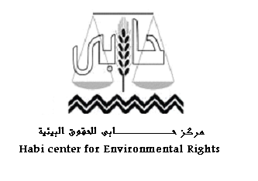
"Habi" Demands Cement Multinational Companies to Stop Violating and Commit to Local and International Law
Nine NGOs are in solidarity with the Demands
ـــــــــــــــــــــــــــــــــــــــــــــــــــــــــــــــــــــــــــــــــــــــــــــــــــــــــــــــــــــــــــــــــــــــــــــ
- Cement companies press to use coal without environmental impact assessment study.
- Cement companies violate environmental rights of citizens.

After the cement companies have pressed on the officials to use coal (the most dangerous fuel) instead of gas to double their profits, among which are the multinational companies, they still violate environmental rights of citizens disregarding the local environmental laws, the international human rights charters and the United Nations Guiding Principles to commit companies to respect human rights.
Throughout Habi's pursuing to violations minutes and reports by Environmental Affairs Agency against some of these companies "Lavarge Company and Suez Group for cement" in court because of lacking environmental impact assessment study for the changes resulted from using coal, mismanagement of dangerous dumps and pollutants emerged from their smokestacks. So it has been found that there are many criminal sentences against these companies.
These companies violate the environmental rights of citizens especially their right to health, healthy clean environment, right to information and participation.
In response to these violations, on Wednesday corresponding 3rd September 2015 Habi sent group of demands to these companies including:
- Committing to local environmental legislations and relevant international charters.
- Publishing environmental impact assessment studies or their summaries regarding changes done by these companies by using coal instead of gas.
- Publishing listening sessions concerning environmental impact assessment studies especially those regarding using coal as an alternative to gas. Those minutes should be available on the website of the company.
- Considering transparency rules that require the necessity of publishing violations committed by the company on its website, in addition to publishing the agreed upon plans to avoid these violations in future according to what stated by international human rights charters and United Nations Guiding Principles regarding business and human rights.
Nine NGOs are in solidarity with Habi by signing the demands; are:
- The Egyptian Foundation for the Advancement of the Childhood Condition "The Egyptian Coalition on Children's Rights".
- The New Woman Foundation.
- Center for Egyptian Women Legal Assistance (CEWLA).
- Specific Union for Environment in Aswan.
- Association of Canal People.
- Egyptian Against Religious Discrimination.
- Earth Center for Human Rights.
- The Egyptian Association for Social and Economic Rights.
- Group of Legal Assistance for Human Rights.

