PUBLIC STATEMENT – TO CEASE THE JUDICIAL PERSECUTION AGAINST MILLER DUSSÁN AND ELSA ARDILA AND IN SUPPORT OF THE ASSOCIATION OF THOSE AFFECTED BY THE QUIMBO DAM PROJECT (ASOQUIMBO), IN COLOMBIA.
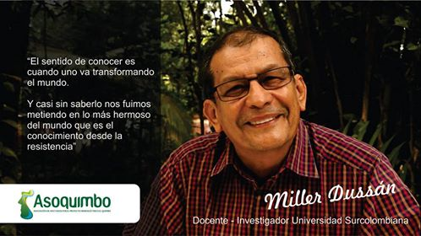

“True wisdom comes when we are transforming the world”. “And almost inadvertently, we went deeper in to the beauty of the world - the height of which is the wisdom of resistance”. Miller Dussán.
BACKGROUND:
Miller Dussán is a Colombian university professor and President of the Association of Those Affected by the Quimbo dam (ASOQUIMBO). El Quimbo is a mega-dam built by the Italian corporate energy giant ENEL-EMGESA, on the Magdalena river in the Department of Huila in southern Colombia.
ASOQUIMBO has been resisting this hydroelectric project for several years, highlighting its social and environmental impacts as well as a series of legal irregularities on the part of EMGESA (an Enel subsidiary in Colombia). They have also called into question current energy and mining policy in Colombia, demanding in its place the construction of a policy based on national sovereignty and local control of renewable energy sources to meet the needs of local communities.
Miller Dussan now faces up to twelve years in prison as a result of two legal charges being brought against him based on accusations made by Emgesa.
In the first case, Dussan and his co-accused Elsa Ardila, ex–president of ASOQUIMBO, face charges of ‘blocking public roads in ways that affect public order’, in relation to a series of social protests in 2012. These charges carry a sentence of up to 4 years in prison.
In the second case, Dussan is accused of instigating the occupation of land owned by the corporation, a charge that carries a sentence of up to 8 years. According to his defence, these charges relate to land occupations by small farmer communities in 2013 as part of a protest against forced displacement and in order to demand just compensation from the corporation.
FORMAL CHARGES AND THE REQUEST FOR THOSE CHARGES TO BE DROPPED.
During hearings on the 10th August 2016 in the municipal court in Gigante, Huila, the public prosecutor brought formal charges for the alleged offences of blocking public roads. Nevertheless the 27th October 2016, defence lawyers requested the charges to be dropped, arguing among other things the absence of any criminal conduct, given that any damage of transport routes occurred as a result of construction work by EMGESA as part of the QUIMBO dam project. The legitimate protests that followed were in response to these impacts on local infrastructure. (More details here)
Now the Municipal Court in Garzon, Huila has convened a public hearing to make a decision on the request by lawyers to drop the charges against Dussan and Ardila. The hearing, which was originally scheduled for the 9th of December 2016 is now due to be heard on the 6th of February 2017.
ASOQUIMBO has declared that the hearing is the result of both the serious concerns raised regarding the criminalization of social protest and the broad recognition by social and environmental organisations, national and international NGOs, state institutions and the International Commission of Jurists of the legitimacy of protests against the building of the Quimbo dam and in defence of territory and life itself.
More info: http://www.quimbo.com.co
WE DEMAND:
As a result of the above stated, the signatories below demand that:
- Garzon Municipal Court in Huila to drop the charges brought as a result of accusations made by EMGESA against Miller Dussán and Elsa Ardila for the supposed crime of ‘blocking public roads in ways that affect public order’. We firmly believe that the legal cases being brought against these two environmental leaders are part of an overarching strategy of judicial intimidation, the final aim of which is to repress local resistance to mega-dams and other extractivist projects across the region.
- The Corporation, ENEL-EMGESA, immediately desist from the judicial persecution of leaders of ASOQUIMBO; withdraw the two charges it has brought; and withdraw its plans for building of any further socially and environmentally destructive megadams in Latin America.
- Multinational corporations and Latin America governments stop using court proceedings as a way of criminalising protest and respect the legitimate right of people to defend their resources, their lands and life itself against the voracious capitalist model of development currently upheld – one that promotes the destruction of the environment and the killing of environmental defenders across the entire region.
The signatories below also express our most fervent support for the fight of ASOQUIMBO, and their struggle to defend their territories and life itself.

TO SIGN-ON TO THE LETTER, PLEASE GO TO THE FOLLOWING LINK

The letter complete with signatures will be delivered ahead of the hearing on the 6th of February to :
- Garzon Municipal Court, Huila.
- The CEO of ENEL, Francesco Starace, as well as to Lucio Rubio Díaz, director of EMGESA in Colombia.
- A copy will also be sent to members of ASOQUIMBO as well as to Miller Dussan and to Elsa Ardila.

ABOUT ENEL-EMGESA: Despite engaging in bullyboy tactics across South America, the Italian energy giant presents a caring image of sustainability and climate action through its slick public relations campaigns and greenwash. In order to ensure ENEL-EMGESA is allowed to do what it does best - burn coal and gas and build socially and environmentally destructive megadams in South America - Enel and co. deploy a sprawling lobbying operation both at national and international level. More information about ENEL in Corporate Conquistadors.

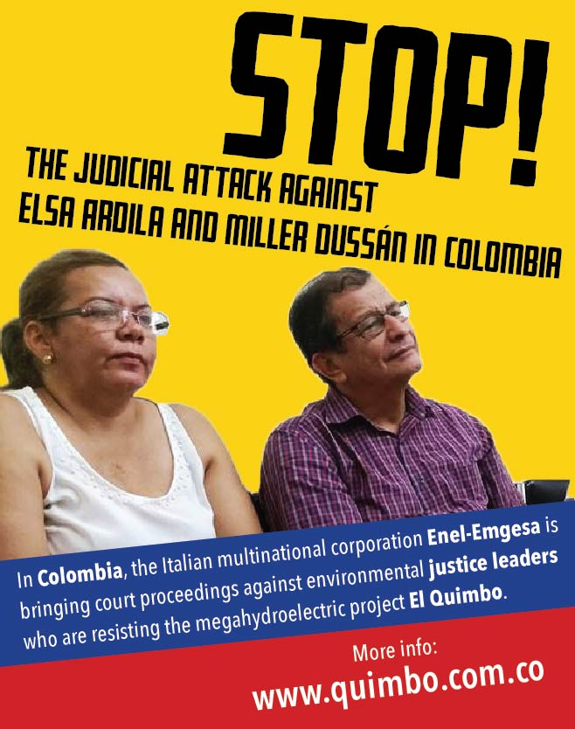

SIGNATURES:
- Maude Barlow, Council of Canadians
- Nnimmo Bassey, Health of Mother Earth Foundation (Homef)
- The Democracy Center
- Global Justice Now
- Corporate Accountability International
- Corporate Europe Observatory (CEO)
- Observatorio de la Deuda en la Globalización
- Observatorio de Multinacionales en América Latina (OMAL)
- Frontline Defenders
- Un Ponte Per
- Re:Common
- The Transnational Institute (TNI)
- Greenpeace
- Wecan - LAC
- International Rivers
- Movimiento Ríos Vivos
- London Mining Network
- Plataforma Interamericana de Derechos Humanos, Democracia y Desarrollo (PIDHDD Regional)
- Plataforma Boliviana frente al Cambio Climático
- Asamblea por la paz, Siero
- Centro de Documentación en Derechos Humanos "Segundo Montes Mozo S.J." (CSMM)
- WIDE+
- An Claoimh Glas
- Coordination Climat Justice Sociale, Genève
- Coordinadora de Afectados por Grandes Embalses y Trasvases, COAGRET
- Red Vida (Vigilancia Interamericana para la Defensa y Derecho al Agua)
- TierrActiva, Bolivia
- Entrepobles
- Institute for Intercultural Research and Cooperation, Vienna
- Maynooth University
- Informationsgruppe Lateinamerika (IGLA)
- Institute for Policy Studies, Global Economy Project
- Campaña No al TTIP, Cataluña
- Africando
- Biolife
- Ekologistak Martxan
- Colectivo Educación para la Paz y los Derechos Humanos, A.C.
- Ecologistas en Acción
- Ecoloxistes n´Aiccion
- Ecologistas en Acción, Valladolid
- South Durban Community Environmental Alliance
- Xarxa per la Sobirania Energetica, Catalunya
- ISS, Erasmus University Rotterdam
- Center for International Environmental Law (CIEL)
- CEAR-Euskadi
- Prensa Indígena org
- Université de Montréal
- Comité por los Derechos Humanos en América Latina (CDHAL)
- Salva la Selva
- Comité de solidaridad con América Latina (COSAL)
- Otros Mundos AC/Amigos de la Tierrra México
- Unión Universal Desarrollo Solidario
- La Asamblea Veracruzana de Iniciativas y Defensa Ambiental - México
- LASC
- Informationsgruppe Lateinamerika (IGLA), Vienna,
- Corporacion ecológica y cultural, penca de Sabila
- Associació la ruda amics de Can Deu per a l'agricultura ecològica
- CESTA Amigos de la Tierra, El Salvador
- ECOTROS

